Measuring Citizen’s Satisfaction with key Government Services for Better Performance and Enhanced Trust

Project Public Brief
December 2025

Context
Governments operate in a challenging environment characterised by geopolitical conflicts, social and economic transitions, and environmental crises – all of which contribute to significant fiscal pressures on governments. Public administrations need to adapt and respond quickly to challenges, preparing the green and digital transitions to enhance governments’ resilience and improve responsiveness to citizens and business’ needs. Public administrations in EU Member States are working on addressing these challenges through national reforms and EU-supported mechanisms such as the National Recovery and Resilience Plans. Measures under these plans aim to contribute to increasing the efficiency and transparency of public services, reducing the administrative burden of accessing public services and improving the quality of life of citizens and businesses. To fully seize the benefit of these transformations, public administrations need to continuously change and adapt the way they design and deliver public services to become more human centric and effective.
The OECD Recommendation of the Council on Human-Centred Public Administration Services, adopted in 2024, recognizes that high-quality public administrative services are essential for governments to achieve socio-economic objectives, including economic growth, inclusion and wellbeing, the green transition, and upholding the rule of law. The Recommendation emphasises that governments rely on well-functioning services to deliver public policies, improve wellbeing, and to communicate, engage with and empower the public. The Recommendation highlights the important of considering users’ needs when improving public administrative services, with expectations and convenience taking priority over existing government policies, organizational silos, internal procedures or legacy IT systems.
Within this context, the OECD Survey on the Drivers of Trust in Public Institutions (OECD, 2024_{[1]}) has found that satisfaction with public services, together with the perception of public sector innovation and public services’ responsiveness to people’s feedback are important drivers of trust in the national government and civil service. By integrating user feedback into a continuous service improvement cycle governments can become more responsive to citizen’s needs and expectations. This responsiveness, in turn, can lead to increased trust in government institutions.
A key method for improving service delivery and making them more human-centered is the move towards the ‘Life Event’ approach. A Life Event refers to a change in the circumstances of a user which creates a need to use a public administrative service or services, and that may require coordination and integration between different service providers. While this approach is not new, the greater ongoing shift from countries requires adapting pre-existing approaches to measuring satisfaction with services. Examining the level of satisfaction among users with Life Events can provide performance information to help governments increase user-centricity by replacing compartmentalized ‘silos’ and beige tape with simpler processes. The Life Event has approach has been applied in some form to some public administrative services in 20 out of 28 OECD countries that responded to the OECD Serving Citizen’s Survey as of March 2025. (OECD, 2025_{[2]})

Presentation of Beneficiary Authority
Austria, Croatia, Estonia, Finland, Greece, Ireland, Latvia, Lithuania, Slovenia and Spain (hereinafter the ‘beneficiary EU Member States’) requested support from the European Commission under the Technical Support Instrument.
Figure 1 Coverage of EU Member States participating in TSI Project on Measuring Citizen Satisfaction
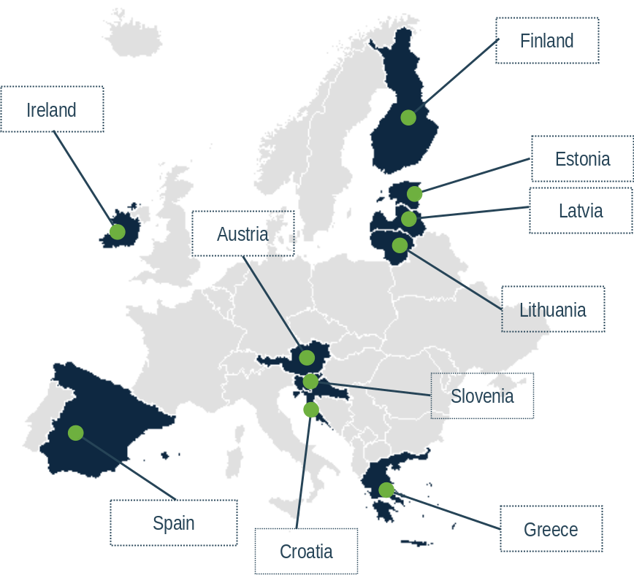
Source: EC-OECD Project on Measuring Citizen’s Satisfaction with key Government Services
The national authorities that requested support and benefitted from the Project are:
- Austria - Federal Ministry for Arts, Culture, the Civil Service and Sport (Bundesministerium für Kunst, Kultur, öffentlichen Dienst und Sport)
- Croatia - Ministry of Justice and Public Administration (Ministarstvo pravosuđa i uprave)
- Estonia – Ministry of Justice (Justiits- ja Digiministeerium)
- Finland - Ministry of Finance (Valtiovarainministeriö)
- Greece – Hellenic Ministry of Interior (Υπουργείο Εσωτερικών)
- Ireland - Department of Public Expenditure, Infrastructure, Public Service Reform and Digitalisation (An Roinn Caiteachais Phoiblí, Bonneagair, Athchóiriúcháin Seirbhíse Poiblí agus Digitiúcháin)
- Latvia - Ministry of Environmental Protection and Regional Development (Vides aizsardzības un reģionālās attīstības ministrija)
- Lithuania - Ministry of the Interior - Public Administration and Local Self-government Policy Group (Lietuvos Respublikos vidaus reikalų ministerija)
- Slovenia – Ministry of Public Administration - Directorate for Quality (Ministrstvo za javno upravo)
- Spain - Ministry of Finance and Civil Service - Directorate General on Public Governance (Ministerio de Hacienda y Función Pública)

Description of needs to be addressed
While countries are shifting towards the use of a Life Events approach, no standardised cross-national approach exists for measuring user satisfaction with public services and understanding the main drivers of satisfaction with the way in which public services are designed and delivered. To address this information gap, the Project supported ten EU Member States (Austria, Croatia, Estonia, Finland, Greece, Ireland, Latvia, Lithuania, Slovenia and Spain) in the development of a common ‘Framework for measuring satisfaction with public services through Life Events’ focusing on the user journey. In addition, the Project aimed to identify organizational enablers for countries to enhance the design and delivery of government services.

Methodology and approach used to produce the final outputs
The Project aimed to deliver several key outputs, as presented in Figure 2 below.
Figure 2 Key Outputs of the Project
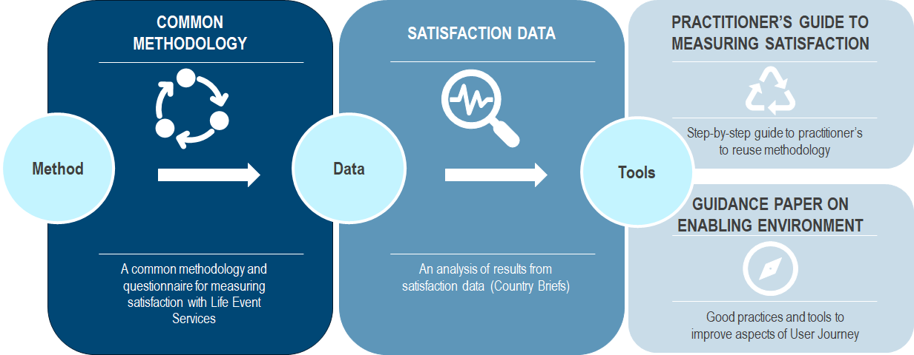
Source: EC-OECD Project on Measuring Citizen’s Satisfaction with key Government Services
In addition to these Outputs, several data collection and stakeholder consultation activities were undertaken including Country Missions and Workshops.
To develop the Outputs for the project, both primary and secondary research was undertaken.
Firstly, to support the beneficiary EU Member States in developing a standardised cross-national approach for measuring user satisfaction with public services, it was necessary to develop a robust conceptual framework. This Framework was developed by undertaking in-depth documentary review of existing Satisfaction Surveys in place across countries as well as literature review of key mechanisms to measure satisfaction. The design of a Satisfaction Survey required the use of survey techniques through the deployment of an online survey using a representative panel of the population in each of the beneficiary EU Member States. The analysis of Satisfaction Survey data required the use of quantitative analytical techniques.
Documentary review was also undertaken to review the existing policies and strategies in place in each of the beneficiary EU Member States for the implementation of human-centred public administrative services. Moreover, primary research was undertaken through interviews with representatives from public administrations in each of the beneficiary countries through Country Missions.
Two Workshops were also held over the course of the Project which focused on the collection of feedback on project outputs.

Key outputs and activities that were undertaken
Output 0.1: Kick-off meeting
A kick-off meeting was held on 19 September 2023. The kick-off meeting officially launched the Project and brought together all members of the Advisory Group. The meeting was an opportunity for the OECD Team to present the approach for the Project as well as the overall Work Programme. Following the kick-off meeting, individual exploratory interviews were held in October and November 2023 with each of the National Contact Points from the beneficiary authorities participating in the Project. The aim of these exploratory interviews was to identify the existing strategies and policies currently in place in countries for the delivery of human-centred public services as well as to identify the level of maturity with regard to the Life Event approach. The exploratory interviews were also an opportunity for the OECD and National Contact Points to discuss their expectations for the Project.
Output 0.2: Inception Report
An Inception Report was delivered to the members of the Advisory Group on 1 December 2023. The Inception Report presented an overview of the desk research undertaken from the Project launch, including presenting an overview of the current Life Event approaches and survey mechanisms in place in each beneficiary Member State. The Inception Report laid out the options for developing a Satisfaction Survey in the countries. Following comments received on the Inception Report, a final version of the Report was published in January 2024.
Output 1.1: A Common Methodology and Questionnaire for measuring satisfaction with Life Event services
This Output focused on the development of a Measurement Framework for measuring satisfaction with public services delivered through Life Events. The Output focused on three key activities:
Activity 1.1.1: Develop theoretical framework and methodology on user satisfaction with public services and survey questionnaire
Based on an in-depth literature review including a review of existing satisfaction surveys in the ten beneficiary EU Member States and in OECD countries, a common measurement framework for measuring satisfaction with public services through Life Events was developed by the OECD. The Framework developed by the Project focused on measuring satisfaction with the performance of public services delivered through Life Events throughout the key stages of the User Journey (1) Access (2) Navigate and (3) Achieve (Figure 3).
Figure 3 Measurement Framework for measuring satisfaction with public administrative services
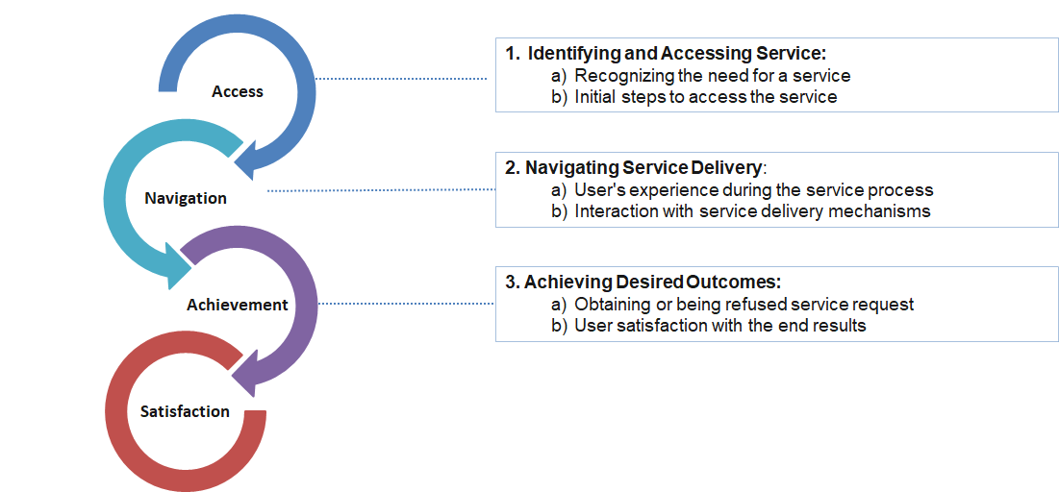
Source: EC-OECD Project on Measuring Citizen’s Satisfaction with key Government Services
The Framework was presented to the Advisory Group, with feedback received as well as tested with a Panel of External Experts. A detailed Satisfaction questionnaire was subsequently drafted in English.
Activity 1.1.2: Identify Life Events to be surveyed
A detailed mapping was undertaken of the Life Events currently being implemented in beneficiary EU Member States. Based on the range of Life Events being developed in the beneficiary Member States, a list of 15 Life Events commonly identified throughout the ten Member States was drawn up. This list of 15 Life Events (Figure 4) was the focus of the Population Survey deployed in the 15 beneficiary Member States.
Figure 4 Life Events selected for population survey
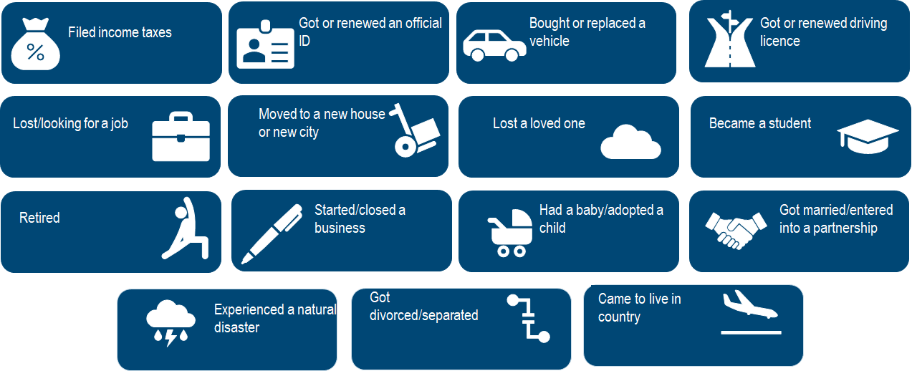
Source: EC-OECD Project on Measuring Citizen’s Satisfaction with key Government Services
Activity 1.1.3: Propose Survey Strategy and Modality
The Project identified the various options for surveying citizens experiencing Life Events across the ten beneficiary EU Member States. A Population Survey, representative of the general population, was selected by the Advisory Group with a view to being able to measure user satisfaction with public services for one of the 15 Life Events selected under Activity 1.1.2.
Output 1.2: An analysis of results of the Satisfaction Survey
Activity 1.2.1: Support data collection
The development of a Measurement Framework and accompanying Survey Questionnaire led to the deployment of a Population Survey between October and November 2024 that measured both user and non-user satisfaction with public services delivered through 15 Life Events. The general Population Survey gathered responses from 15 178 users and 5 081 non-users across the ten participating EU Member States.
Activity 1.1.2: Analyse and draft briefs with survey results by country
The TSI Satisfaction Survey enabled participating countries to gather data on, amongst others, overall user and non-user satisfaction with public services in the country, satisfaction with specific Life Events experienced, types of channels used to access public services, frequency of Life Events over a 12-month period, and areas of improvement identified by users. Moreover, the Survey enabled the identification of nine key drivers of satisfaction with public administrative services (Figure 5).
Figure 5 Key drivers of citizen satisfaction with public services delivered through Life Events
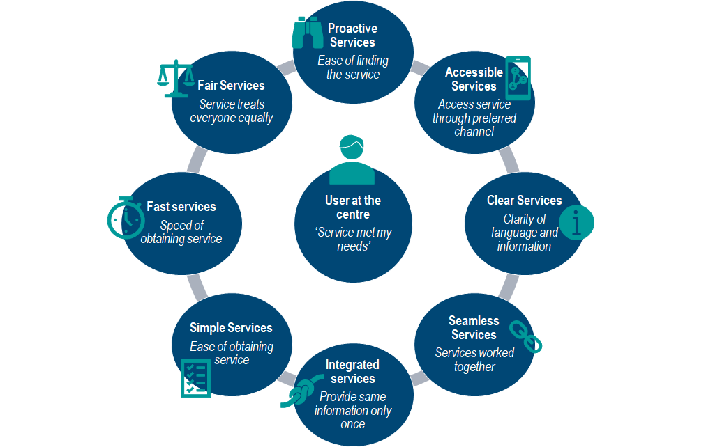
Source: EC-OECD Project on Measuring Citizen’s Satisfaction with key Government Services
Individual Country Briefs were drafted by the Project. Each Country Brief presented the results of the TSI Satisfaction Survey for the EU Member States, identifying the key drivers of satisfaction. Moreover, the Country Briefs provided focused analysis on satisfaction with two Life Events selected by each of the beneficiary Member States. Based on the Survey Results, the Country Briefs also presented a Priority Matrix of key drivers on which the country should focus their public service reforms.
Activity 1.2.3: Prepare a guidance paper outlining how to use the methodology and adapt the questionnaire to carry out new surveys
A Guidance Paper entitled ‘Practitioner’s Guide on Satisfaction Surveys’ was prepared by the Project that aimed to equip public officials with a step-by-step guide on how to design, deploy and analyse a Satisfaction Survey. The Guide was developed to also include lessons learnt from the deployed Satisfaction Survey in Autumn 2024.
The Practitioner’s Guide had three key objectives: (i) Support Countries in developing more human-centred public administrative services through measuring user insights (ii) ensure the reusability of the methodology developed through the Project (iii) share lessons learnt from the TSI Satisfaction Survey as well as sharing good practices with countries.
Figure 6 Key objectives of Practitioner’s Guide on Satisfaction Surveys
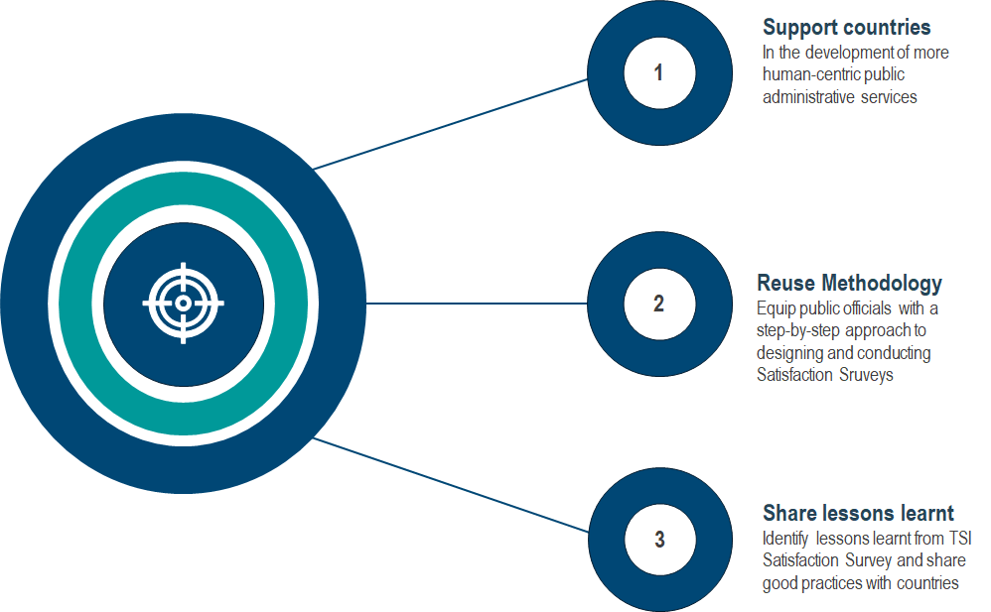
Source: EC-OECD Project on Measuring Citizen’s Satisfaction with key Government Services
To ensure that the TSI Satisfaction Survey could be reused for future Satisfaction Surveys in the beneficiary EU Member States, a step-by-step approach was developed for designing and conducting Satisfaction Survey. Figure 7 below presents the key steps of focus in this Practitioner’s Guide.
Figure 7 Six key steps of User Satisfaction Survey
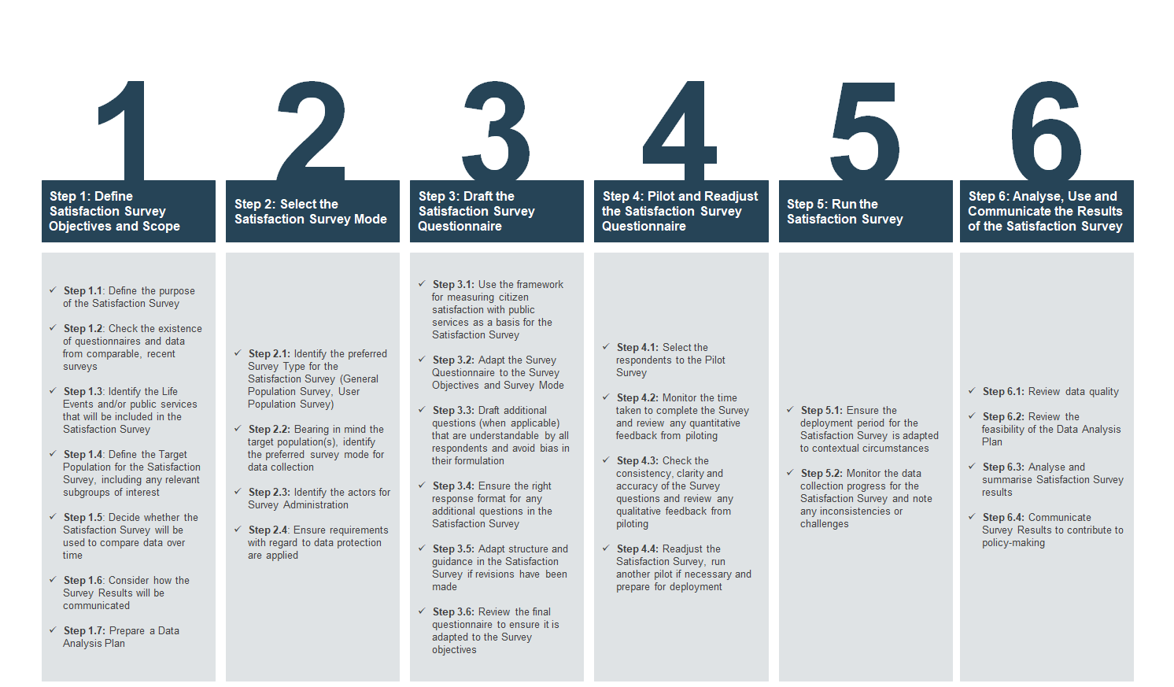
Source: EC-OECD Project on Measuring Citizen’s Satisfaction with key Government Services
Activity 1.2.4: Organise a Workshop on survey results and methodology
A Workshop on Measuring Citizen’s Satisfaction with public services was organised in Paris on 28 April 2025. The Workshop brought together members of the Advisory Group as well as representatives from other OECD and partner countries. The Workshop provided evidence on user satisfaction with key aspects of public administrative services and discussed opportunities to use public feedback to improve the design and delivery of services. Moreover, it provided an opportunity for countries to exchange practices, challenges and achievements in focusing efforts towards more human-centred services, by reorganising design and delivery around the user journey and Life Events experienced by citizens.
Output 2.1: Guidance Paper on establishing an enabling environment within government for making public services more user-centric
Activity 2.1.1: Conduct interviews with beneficiary authorities
In-country missions were held in each of the ten EU beneficiary Member States from March to October 2025. The aim of these country missions was to present the results of the Satisfaction Survey for each country as well as undertake in-depth interviews with representatives from public administrations. Each Country Mission was two to three days in duration.
Activity 2.1.2: Draft a guidance paper on using data for user-centric government services
Based on the results of the data gathered through the Citizen Satisfaction Survey and the data gathered through Country Missions, a Guidance Paper on establishing an enabling environment within government for making public services more user-centric was drafted. This Guidance Paper placed a spotlight on the results of the TSI Satisfaction Survey and focused on practices put in place in countries to deliver human-centred public administrative services, in particular in relation to (i) accessing (ii) navigating and (iii) achieving the results they require from public services.
Moreover, the Guidance Paper presented tools that may be deployed by countries to support in addressing the key drivers of satisfaction, as presented in the figure below.
Figure 8 Tools identified to support Access to Public Services
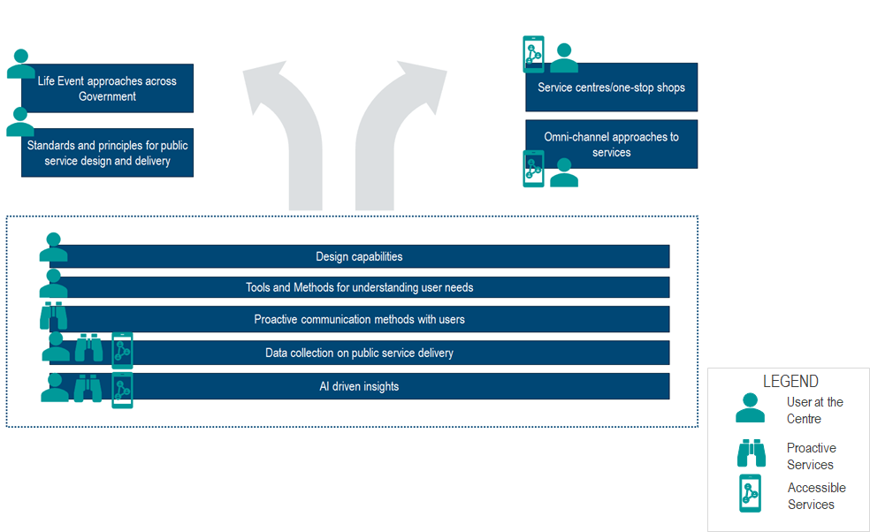
Source: EC-OECD Project on Measuring Citizen’s Satisfaction with key Government Services

Figure 9Tools identified to support navigation of public services by users
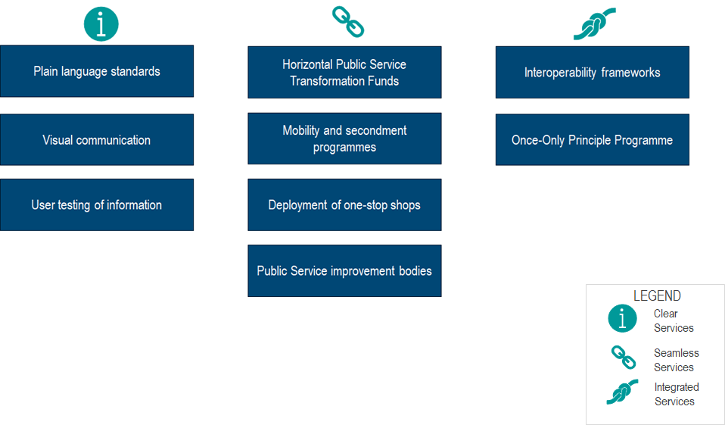
Source: EC-OECD Project on Measuring Citizen’s Satisfaction with key Government Services

Figure 10 Tools identified for achieving simple, fast and fair public services for users
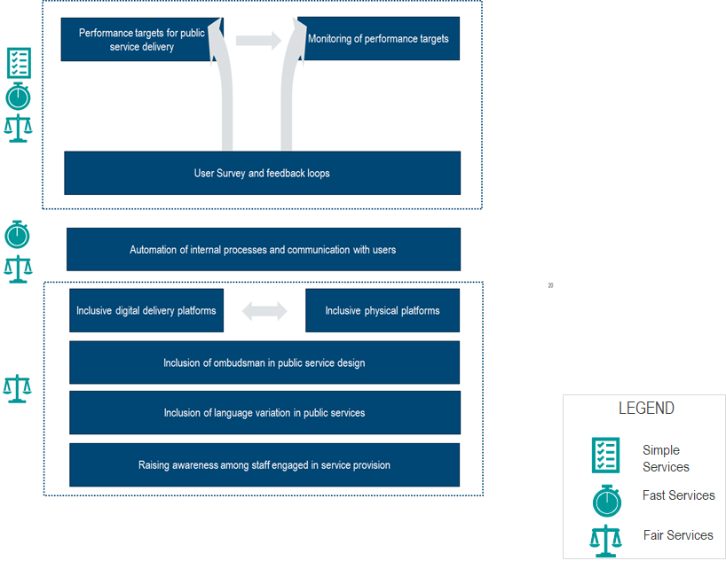
Source: EC-OECD Project on Measuring Citizen’s Satisfaction with key Government Services
Output 2.2: Cross-learning workshop on best practices in measuring user satisfaction and improving delivery of public services
Activity 2.2.1: Organise a Workshop on user-centric services and project completion
A Final Workshop on user-centric services and project completion was organized on 4 December 2025 at OECD Headquarters in Paris. The Workshop gathered National Contact Points from all beneficiary EU Member States as well as additional countries to discuss the use of the project results. Moreover, the Workshop enabled a co-design activity to be undertaken to develop the basis for a Life Event Blueprint aimed at equipping the participating countries in identifying the key phases, steps, tools and actors required to deploy Life Event approaches in their countries.

Consultation with stakeholders
Stakeholders from public administrations within the beneficiary EU Member States were consulted throughout the Project.
Consultation with Advisory Group
An Advisory Group was established for the Project composed of representatives from the beneficiary EU Member States, SG REFORM and the OECD Project Team. Regular meetings were held with the Project Advisory Group with a view to ensuring the strategic guidance for the Project as well as receiving feedback and comments to key deliverables.
Consultation with Public Administrations
The Country Missions enabled consultation with a wide range of stakeholders from public administrations in each of the beneficiary Member States. In addition to consultations with officials within the responsible Ministries for the Project, the Country Missions also enabled consultation with stakeholders from Ministries, Agencies and other service providers responsible for the design and delivery of public services. Specific focus was placed on stakeholder consultation with responsible service providers related to the Life Events of focus in each of the EU Member States.
Consultation with External Experts
External experts were consulted during the development of the Measurement Framework with a view to receiving their expert input on the rationale for the framework’s construction as well as in regard to the key components of the Framework. In addition, external expertise was used in the analysis of the results of the Population Survey.
Key findings and lessons learnt
By understanding what drives satisfaction with public services delivered through Life Events, public administrations can enhance citizen satisfaction and ultimately public trust (OECD, 2024_{[2]}). Moreover, this can support public administrations in improving the overall effectiveness and efficiency of public administrative services around Life Events. Beneficiary Member States have engaged into rethinking, simplifying, streamlining and digitalizing steps and procedures across Life Events identified, including through in-country workshops held with the OECD support.
The Project’s identification of the key drivers of satisfaction with public services can be used as a compass for public administrations when working on public service reform. The data gathered through the project provided the beneficiary EU Member States with robust data to answer key questions.
Figure 11 Key questions addressed through TSI Citizen Satisfaction Survey
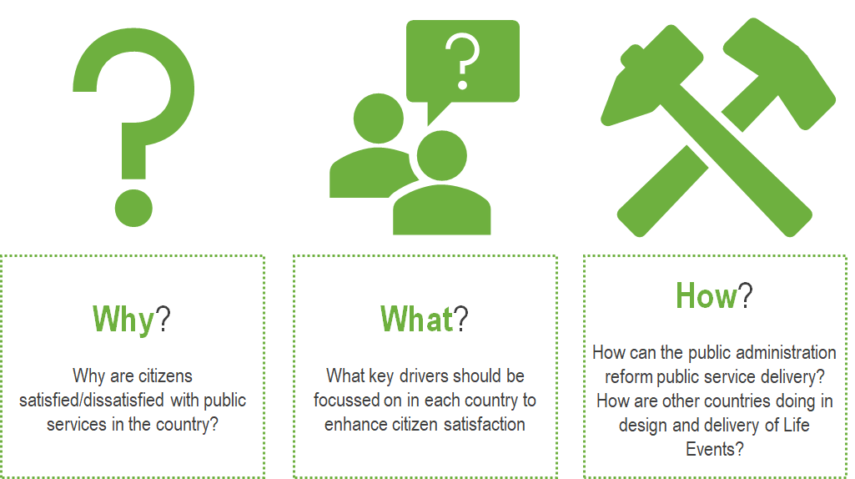

For the purposes of the TSI Satisfaction Survey, a ‘user’ refers to an individual who experienced one or more of the 15 Life Events over the preceding 12-month period and who undertook concrete actions to access and receive services. A ‘non-user’ refers to an individual who experienced one or more of the 15 Life Events over the preceding 12-month period but who did not undertake any concrete actions to access and receive services.

