

Measuring Citizen’s Satisfaction with key Government Services for better performance and enhanced trust
Guidance Paper on establishing an enabling environment within government for making public services more user-centric
March 2026

This Guidance Paper on establishing an enabling environment within government for making public services more user-centric is a final deliverable of the project financed by the European Commission’s Technical Support Instrument on ‘Measuring Citizen’s Satisfaction with key Government Services for Better Performance and Enhanced Trust’. Its purpose is to support public administration in countries by identifying organisational enablers for delivering human-centred public administrative services.

The Guidance Paper is intended to equip public officials with good practice examples and tools to address the key drivers of citizen satisfaction, as identified through the TSI Satisfaction Survey, deployed in October – November 2024.

OFDE

This document, as well as any data and map included herein, are without prejudice to the status of or sovereignty over any territory, to the delimitation of international frontiers and boundaries and to the name of any territory, city or area.
Table of contents
1. Introduction 5
2. Accessing public services 10
2.1. Placing the user at the centre: Users want services to fulfil their needs 10
2.2. Proactive services: Anticipating users’ needs 18
2.3. Accessible services: Providing services to users through the preferred channel 25
2.4. Tools for supporting Access to Public Services for Users 31
3. Navigating public services 34
3.1. Providing clear services to users 34
3.2. Delivering seamless services to users 38
3.3. Fostering integrated services for users to provide information once 48
3.4. Tools for supporting the delivery of clear, seamless and integrated public services 57
4. Achieving results 60
4.1. Simple services 60
4.2. Obtaining services with speed 68
4.3. Achieving results that are fair and treat everyone equally 70
4.4. Tools for achieving results from simple, fast and fair public services 75
5. Country approaches to measuring, engaging and improving public services 78
5.1. User experience surveys 78
5.2. Other user consultation and feedback mechanisms 82
5.3. Definition of performance targets and key data to measure inputs, outputs and outcomes 83
References 89

  - FIGURES
Figure 1.1. Measurement Framework for measuring satisfaction with public administrative services 6
Figure 1.2. Key drivers of citizen satisfaction with public services delivered through Life Events 8
Figure 1.3. Distribution of nine drivers by aspects of the User Journey 9
Figure 2.1. Life Event Approaches in EU-10 13
Figure 2.2. Citizens accessed one or more Life Events over the previous 12 months, EU-10 13
Figure 2.3. Overview of Life Events by age categories 14
Figure 2.4. Share of users accessing digital and physical channels when accessing public services associated with Life Events, EU-10 27
Figure 2.5. Ease of using digital tool is highly associated with satisfaction for life events that are often experienced through online channels 30
Figure 2.6. Interconnection between tools for Accessing Services 32
Figure 3.1. User-facing services 34
Figure ‎3.2. Distribution of service responsibility across levels of government in the EU-10 40
Figure 3.3. When user’s needs are resolved with only one interaction, user satisfaction is 20 percentage points higher 42
Figure ‎3.4. 6 EU-10 countries leverage a body/committee for public service improvement 42
Figure 3.5. A variation exists in the need to use more than one channel to progress with an application, depending on the Life Event 52
Figure 3.6. Contacting different public services to progress with a user’s application varies across Life Events 53
Figure 3.7. Tools for Navigating Services 57
Figure 4.1. Contribution of other drivers of satisfaction to the speed of obtaining the service 69
Figure ‎4.2. Aspects included in service strategy, Serving Citizens 2024 72
Figure 4.3. 69% of users across EU10 agree that they received clear information about why decision was made 73
Figure 4.4. Grouping of tools to support achieving results 76
Figure ‎5.1. Existence of user satisfaction survey, Serving Citizens 2024 78
Figure 5.2. Existence of user satisfaction surveys by service, Serving Citizens 2025 79
Figure 5.3. Demographics collected in national user experience survey, Serving Citizens 2024 80
Figure 5.4. User satisfaction data publication, Serving Citizens 2024 80
Figure 5.5. Availability of complaints/feedback mechanism, Serving Citizens 2024 82
Figure 5.6. Existence of Service Delivery Targets, Serving Citizens 2024 83
Figure 5.7. Agency in charge of setting targets, Serving Citizens 2024 84
Figure 5.8. Incentives for meeting targets, Serving Citizens 2024 84
Figure 5.9. Agency in charge of centralising performance data, Serving Citizens 2024 85
Figure 5.10. Publication of performance data, Serving Citizens 2024 85
Figure 5.11. Use of experience and performance data, Serving Citizens 2024 86

  - TABLES
Table 2.1. Tools for Access to Public Services 32
Table 3.1. Tools for Navigating Public Services 58
Table 4.1. Tools for Achieving results from Public Services 77
Table 5.1. Measuring the burden stemming from complexity and the impact of simplification 86
Table 5.2. Relevant SCM categories in the service design context 88
  - BOXES
Box 1.1. Insights from TSI Satisfaction Survey: Public Services Covered by TSI Project on Measuring Citizen Satisfaction with Key Government Services 7
Box 2.1. Finland - Approaches for understanding User Needs 15
Box 2.2. Ireland - Approaches for understanding User Needs 15
Box 2.3. Estonia - Development of Service Design capabilities for digital public services 16
Box 2.4. Ireland - Development of Service Design 17
Box 2.5. Slovenia - Development of unified standards for digital public services 18
Box 2.6. Use of AI in public service design and delivery 20
Box 2.7. Latvia, Lithuania, Spain - Example of proactiveness of services for Life Event: I filed income taxes 22
Box 2.8. Croatia - Proactive information provision to citizens 23
Box 2.9. Estonia and Slovenia - Proactive issuance of benefits and documents for the Life Event: I had a baby 24
Box 2.10. Finland -Suomi-Piste Local Contact Points for Public Services 28
Box 2.11. Greece - KEP centers Local Contact Points for Public Services 29
Box 2.12. Croatia - Adapting Life Event delivery to types of access required by users 29
Box 2.13. Finland - Enhancement of digital services 31
Box 3.1. Estonia - Providing clear services 37
Box 3.2. Ireland - Human-centred approach for enhancing service clarity 38
Box 3.3. Austria - Committee of the Federal Government, the Länder, Cities and Municipalities 43
Box 3.4. Spain - Initiatives to enhance coordination of services through the Inspecciones Departmantales de Servicios 44
Box 3.5. Ireland - The Public Services Leadership Board 44
Box ‎3.6. Latvia - Co-ordination across government levels in to ensure seamless service delivery 45
Box ‎3.7. Estonia - The Public Service Catalogue 46
Box ‎3.8. Greece - Mitos Registry of Procedures 47
Box 3.9. Croatia - Introduction of a Public Services Catalogue 48
Box 3.10. Ireland - The Public Services Innovation Fund 48
Box 3.11. Austria – Once-Only Platform 50
Box 3.12. Estonia - Simplification via platform technology and digital integration (X road and Once-Only) 51
Box 3.13. Spain - Development of one single portal for citizen’s official data 54
Box 3.14. Latvia - Register of Enterprises 54
Box 3.15. Estonia - Losing a Loved One 55
Box 3.16. Spain - Losing a Loved One 56
Box 3.17. Finland – Losing a loved one 57
Box 4.1. Applying risk-based approaches for simplification 63
Box 4.2. Spain - Simplification initiatives 64
Box 4.3. Slovenia - ‘Stop Bureaucracy’ Portal 65
Box 4.4. Estonia - Learning from Estonia’s strategy to embed simplicity in public service design 65
Box 4.5. Ireland - Shift to Life Events for simple services 66
Box 4.6. Lithuania - State Tax Inspectorate and its innovative e-services and digital transformation strategy 67
Box 4.7. Croatia - Clear definition of processing times for ID cards 70
Box ‎4.8. Finland - Service design and delivery for vulnerable groups 73
Box 4.9. Ireland - Adapting personas to the Life Event ‘I became a student’ to factor in students in vulnerable situations 74
Box 4.10. Slovenia - Local administrative units, closer to user needs 75
Box ‎5.1. Estonia – Comprehensive approach to user satisfaction measurement 81
Box ‎5.2. Latvia - Embedding citizen satisfaction with services indicators into a high-level national plan 82
Box 5.3. The Standard Cost Model 88

Introduction
Governments operate in a challenging environment characterised by geopolitical conflicts, social and economic transitions, and environmental crises – all of which contribute to significant fiscal pressures on governments. Public administrations need to adapt and respond quickly to challenges, preparing the green and digital transitions to enhance governments’ resilience and improve responsiveness to citizens and business’ needs. Public administrations in EU Member States are working on addressing these challenges through national reforms and EU-supported mechanisms such as the National Recovery and Resilience Plans. Measures under these plans aim to contribute to increasing the efficiency and transparency of public services, reducing the administrative burden of accessing public services and improving the quality of life of citizens and businesses. To fully seize the benefit of these transformations, public administrations need to continuously change and adapt the way they design and deliver public services to become more human centric and effective.
The OECD Recommendation of the Council on Human-Centred Public Administration Services (OECD, 2024_{[1]}), adopted in 2024, recognizes that high-quality public administrative services are essential for governments to achieve socio-economic objectives, including economic growth, inclusion and wellbeing, the green transition, and upholding the rule of law. The Recommendation emphasises that governments rely on well-functioning services to deliver public policies, improve wellbeing, and to communicate, engage with and empower the public. The Recommendation highlights the importance of considering users’ needs when improving public administrative services, with expectations and convenience taking priority over existing government policies, organizational silos, internal procedures or legacy IT systems.
Within this context, the OECD Survey on the Drivers of Trust in Public Institutions (OECD, 2024_{[2]}) has found that satisfaction with public services, together with the perception of public sector innovation and public services’ responsiveness to people’s feedback are important drivers of trust in the national government and civil service. By integrating user feedback into a continuous service improvement cycle, governments can become more responsive to citizen’s needs and expectations. This responsiveness, in turn, can lead to increased trust in government institutions.
A key method for improving service delivery and making them more human-centered is the move towards the ‘Life Event’ approach. “A Life Event refers to a change in the circumstances of a user which creates a need to use a public administrative service or services, and that may require coordination and integration between different service providers” (OECD, 2024_{[1]}). While this approach is not new, the greater ongoing shift from countries requires adapting pre-existing approaches to measuring satisfaction with services. Examining the level of satisfaction among users with Life Events can provide performance information to help governments increase user-centricity by replacing compartmentalized ‘silos’ and beige tape with simpler processes. The Life Event has approach has been applied in some form to some public administrative services in 20 out of 28 OECD countries that responded to the OECD Serving Citizen’s Survey as of March 2025 (OECD, 2025_{[3]}).
While countries are shifting towards the use of a Life Events approach, no standardised cross-national approach existed for measuring user satisfaction with public services and understanding the main drivers of satisfaction with the way in which public services are designed and delivered. To address this information gap, the Project ‘Measuring Citizen’s Satisfaction with key Government Services for Better Performance and Enhanced Trust’ was financed by the European Commission’s Technical Support Instrument in September 2021. The Project supported ten EU Member States (Austria, Croatia, Estonia, Finland, Greece, Ireland, Latvia, Lithuania, Slovenia and Spain) in the development of a common ‘Framework for measuring satisfaction with public services through Life Events’ focusing on the user journey as well as on the identification of organizational enablers to enhance the design and delivery of government services. The Framework developed by the Project focused on measuring satisfaction with the performance of public services delivered through Life Events throughout the key stages of the User Journey (1) Access (2) Navigate and (3) Achieve.
Figure 1.1. Measurement Framework for measuring satisfaction with public administrative services
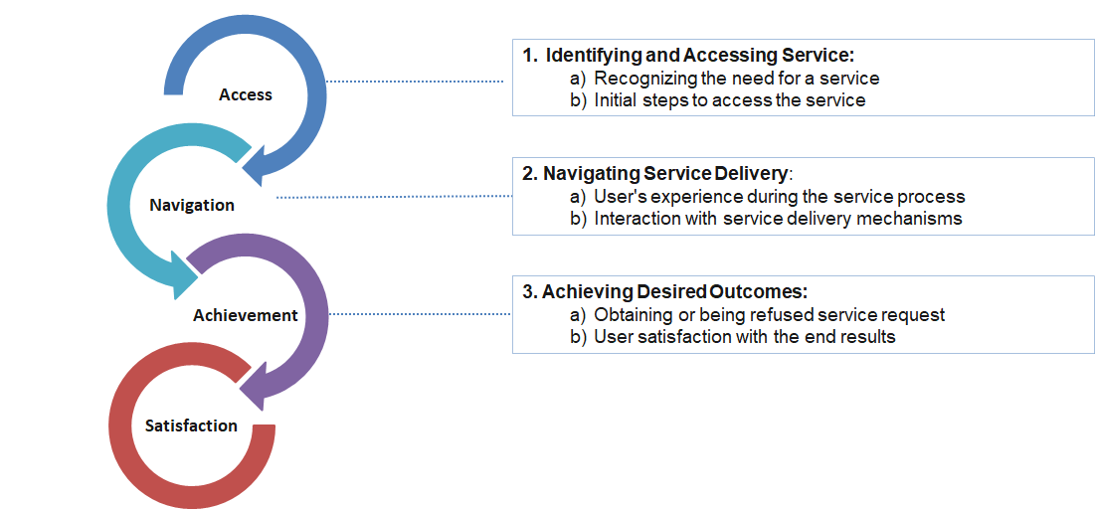
Source: EC-OECD Project on Measuring Citizen’s Satisfaction with key Government Services
The development of a Measurement Framework and accompanying Survey Questionnaire led to the deployment of a Population Survey between October and November 2024 that measured both user and non-user satisfaction with public services delivered through 15 Life Events. The general Population Survey gathered responses from 15 178 users and 5 081 non-users across the ten participating EU Member States. The deployment of a general Population Survey enabled the OECD to test the Measurement Framework and Satisfaction Survey questionnaire and contributed to the development of a common methodology for measuring and managing user satisfaction across countries.
Box 1.1. Insights from TSI Satisfaction Survey: Public Services Covered by TSI Project on Measuring Citizen Satisfaction with Key Government Services
The Satisfaction Survey deployed through the TSI Project on Measuring Citizen’s Satisfaction with key Government Services for Better Performance and Enhanced Trust measures citizen satisfaction with 15 Life Events experienced by users over a 12-month period. This enabled public administrations in ten beneficiary EU Member States to measure user satisfaction with public services falling under the following 15 Life Events:

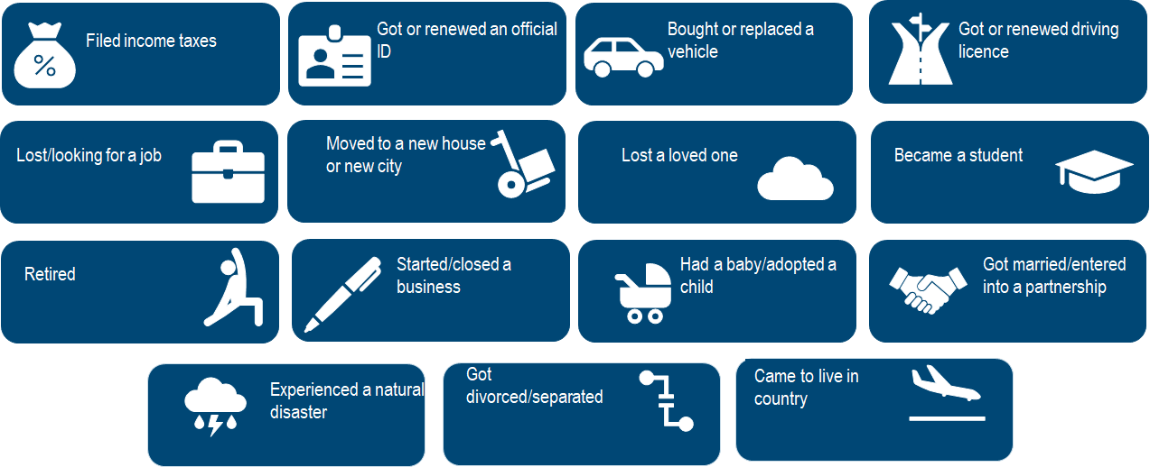
The TSI Satisfaction Survey enabled participating countries to gather data on, amongst others, overall user and non-user satisfaction with public services in the country, satisfaction with specific Life Events experienced, types of channels used to access public services, frequency of Life Events over a 12-month period, and areas of improvement identified by users. Moreover, the Survey enabled the identification of nine key drivers of satisfaction with public administrative services (Figure 1.2).

Figure 1.2. Key drivers of citizen satisfaction with public services delivered through Life Events
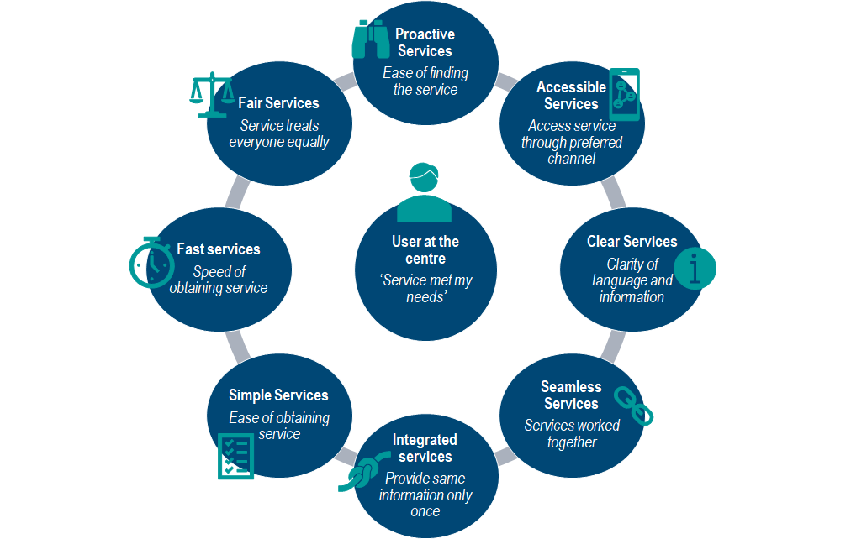
Source: TSI Satisfaction Survey, 2024
By understanding what drives satisfaction with public services delivered through Life Events, public administrations can enhance citizen satisfaction and ultimately public trust (OECD, 2024_{[2]}). Moreover, this can support public administrations in improving the overall effectiveness and efficiency of public administrative services around life events. Participating countries to the project have engaged into rethinking, simplifying, streamlining and digitalizing steps and procedures across life events identified, including through in-country workshops held with the OECD support.
The drivers of satisfaction with public services can be used as a compass for public administrations when working on public service reform. The TSI Project has led to the identification of enablers and bottlenecks across the ten participating countries for contributing to the drivers. This Guidance Paper focusses on practices put in place in countries to deliver human-centred public services, in particular in relation to (i) accessing (ii) navigating and (iii) achieving the results they require from public services (Figure 1.3).
Figure 1.3. Distribution of nine drivers by aspects of the User Journey
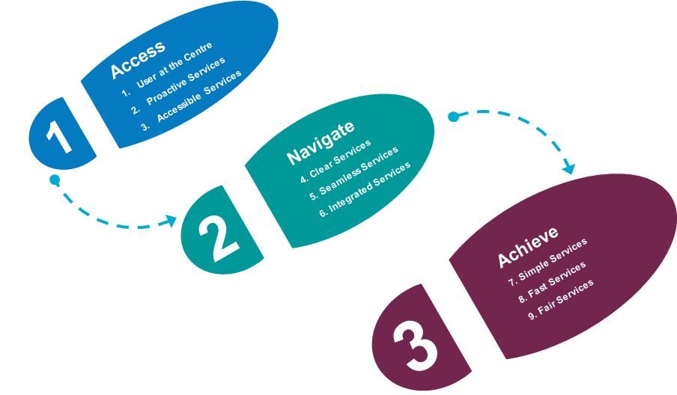
Source: Author illustration

Accessing public services
Access to public services refers to how easily and effectively users can find and utilise the service to meet their needs. The TSI Satisfaction Survey has identified three key drivers of satisfaction relating to the access stage of the User Journey: (i) Placing the User at the Centre, (ii) Proactive Services, and (iii) Accessible Services. These are presented in turn below.

Placing the user at the centre: Users want services to fulfil their needs
Placing the user at the centre requires public services to meet users’ individual needs. A human-centred approach to administrative services focusses on effectively aligning service outcomes with what users need, and ensuring the results are reliable and expected. Services in their essence are to address the needs of their users, not to serve institutional processes or their own internal functions.
The TSI Satisfaction Survey, conducted as part of this project, underscored the perception of services meeting users’ needs as the second most important satisfaction driver across the EU-10, with the probability of increasing users’ satisfaction by 9 percentage points on average. Putting users at the centre of service design, delivery and evaluation is critical to both understanding users and their needs better and increasing their satisfaction with services.


Spotlight on results from the TSI Satisfaction Survey
User at the Centre
- 73% of users in the EU-10 reported satisfaction with how service met their needs.
- Variations in level of satisfaction exist depending on the Life Event.
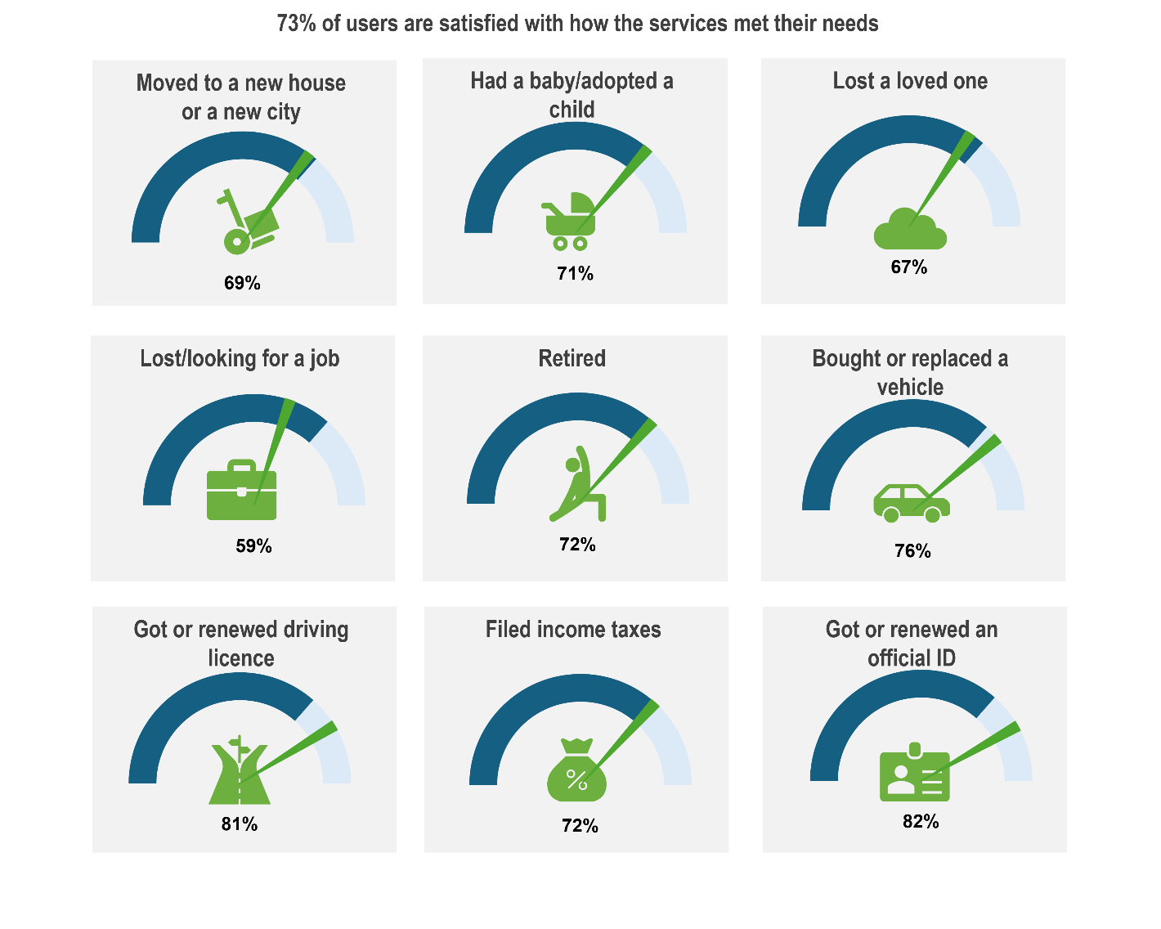
Note: The dark blue arch represents the average satisfaction level with this driver for user of all Life Events across the EU-10. The green pointer represents the satisfaction level of the user for this driver when experiencing the specific Life Event. The pointer position shows whether satisfaction for the specific Life Event is higher or lower than the overall average.
- The variation in satisfaction levels by Life Event may relate to the complexities of certain Life Events and the challenges faced by countries to adapt the user journey to the specificities of each user. Users who experienced Life Events such as having a baby/adopting a child, retiring and filing income taxes have similar levels of satisfaction to the overall EU-10 average. Some Life Events, such as getting or renewing an official ID and getting or renewing a driving license are almost 10 percentage points higher than the average. However, the Satisfaction Survey has shown that user satisfaction with more complex Life Events such as lost/looking for a job (59%) and losing a loved one (67%) are below the 73% average. These Life Events have been identified by countries as more complex to design and deliver due to the multiplication of actors both at central and local levels.
- No significant differences in satisfaction were observed across living area (74% for users in rural areas versus 73% for those in urban areas), gender (73% for both female and male respondents) or education level (72% for respondents with low or middle level of education compared to 74% for those with Bachelor’s degree or higher)
- Younger people and respondents with lower levels of digital skills, on average report lower satisfaction with how services met their needs. As such, 67% of those aged 18-29 are satisfied in contrast to 71% for the 30-49 group and 77% for respondents over 50. Surveyed users with low or middle digital skills report by 9 percentage points lower satisfaction than users with high digital skills. While the reasons for lower satisfaction levels among younger and less digitally advanced users potentially differ across countries, this trend may be rooted in the additional efforts required by these groups to obtain what they need from the services compared to other subgroups. Younger people may lack the experience in navigating public services, while those with limited digital skills may encounter difficulties in accessing the services and obtaining what they look for through digital means in comparison to in-person options.

Country practices and lessons learned

Life Event approaches to take the users’ perspective and meet their needs
A key practice implemented in countries to ensure that public services meet user needs is the enhanced focus by countries in rolling out the Life Event approach. Maturity in the Life Event approach varies across the EU-10, with eight countries already implementing it and the remaining two – Croatia and Ireland - planning adoption. Among the eight, implementation ranges from countries that are grouping information under ‘life events’ categories and others that are actively providing integrated services (Figure 2.1).
While most countries are evolving in the grouping of information on public services through a Life Events lens, challenges have been identified by countries in integrating services and having actors working together to move to the integration of public services delivered through Life Events. The Life Events relating to (i) death of a loved one, (ii) getting married, (iii) retiring (iv) starting a business and (v) loss of employment are covered by seven of the ten countries. The majority of these countries focus on information grouping for their Life Event approaches. Similarly, information grouping is used in six countries for the Life Events ‘death of a loved one’ and ‘getting married’. However, in relation to the Life Event ‘starting a business’ and ‘having a baby’, integrated services have been rolled out in the majority of countries covering these Life Events. Some countries use a variation of approaches depending on the Life Event. For example, Latvia provides integrated services for the Life Events (i) death of a loved one (ii) getting married, (iii) retiring (iv) loss of employment and (v) having a baby.
Figure 2.1. Life Event Approaches in EU-10
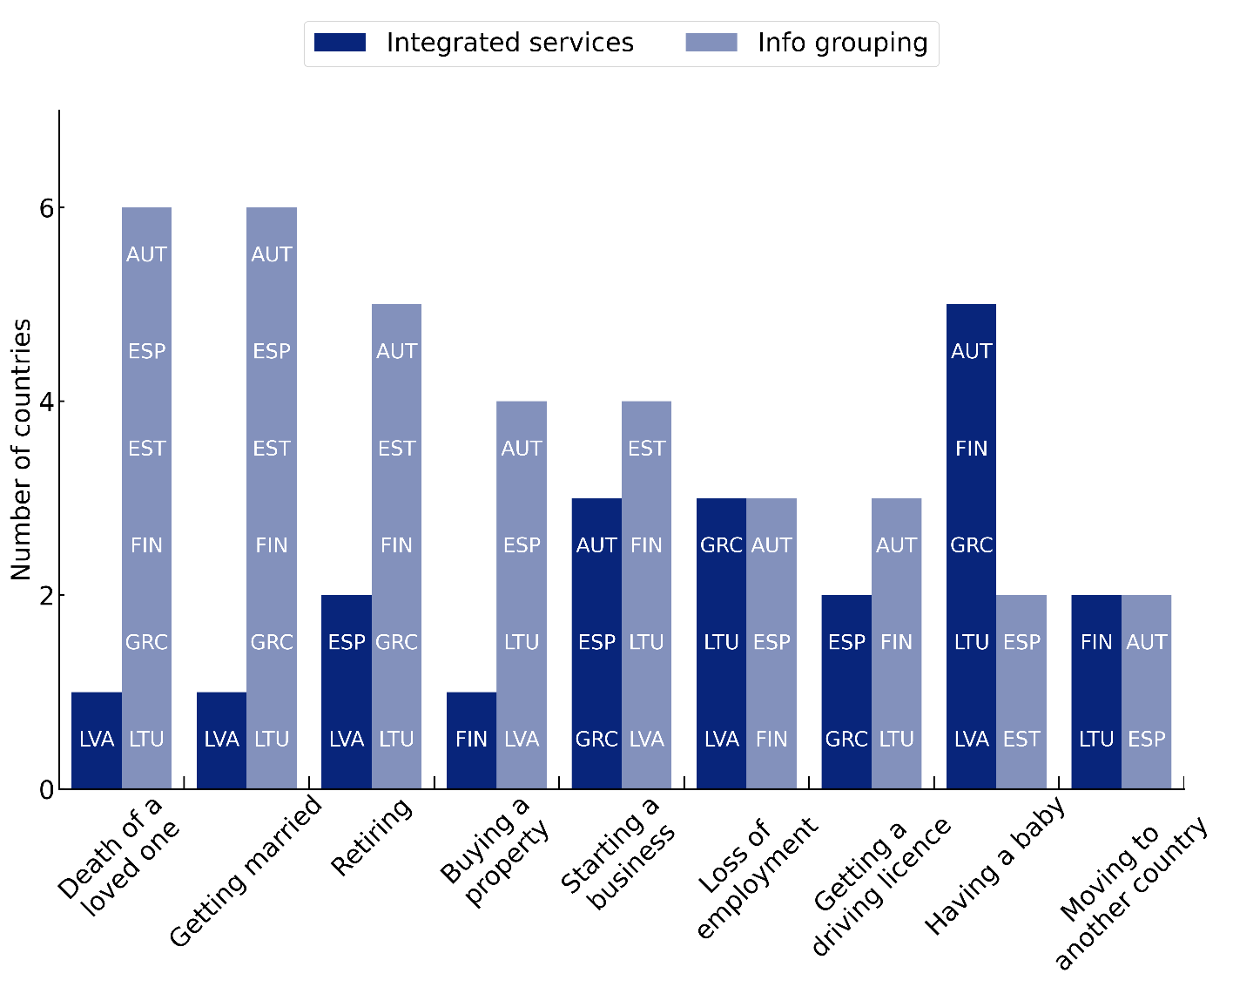
Source: Serving Citizens 2024
In addition to ensuring all relevant public services are identified for Life Events, it is important to also consider the interconnection of Life Events. For many citizens, Life Events do not occur in silo but can often occur in parallel. This can be observed through the TSI Satisfaction Survey data where users reported experiencing one or more Life Events over the previous 12 months (Figure 2.2).
Figure 2.2. Citizens accessed one or more Life Events over the previous 12 months, EU-10
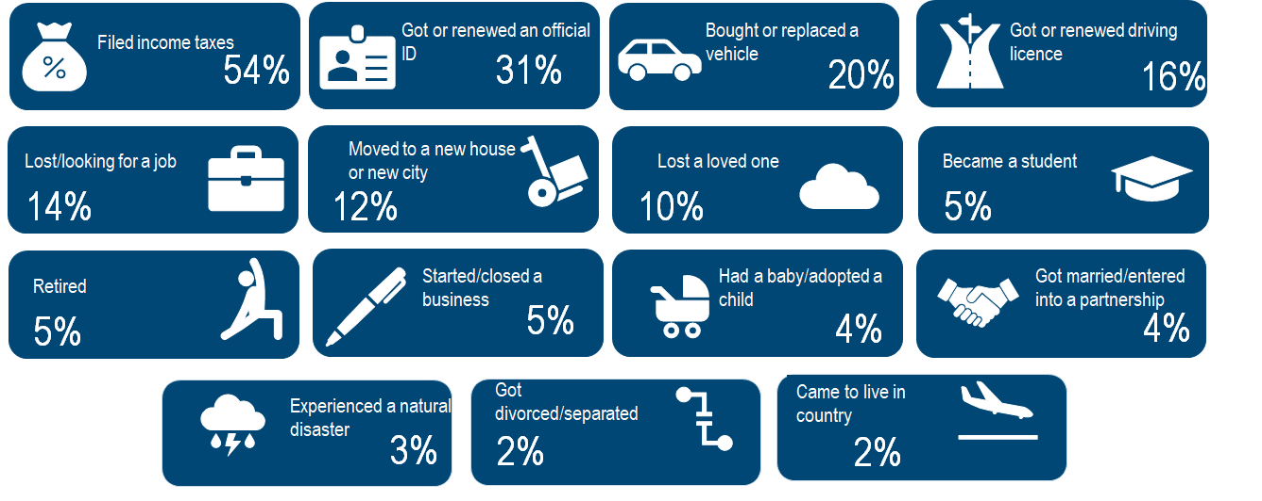
Note: Question: Which of the following Life Events did you experience over the last 12-months?
Source: TSI Satisfaction Survey, 2024
Understanding the frequency of the Life Events can provide further insights to public administrations to understand the regularity of use of specific Life Events. Figure 2.2 shows that the Life Events linked to administrative services that are undertaken multiple times over the course of a user’s life (e.g. filing income taxes, getting or renewing an official ID) were experienced by a large proportion of the sample surveyed.
In addition to understanding the frequency of Life Events, understanding Life Events that tend to occur at specific moments of a users’ life can also contribute to understanding how public services and Life Events can be designed together. Figure 2.3 provides an overview of the 15 Life Events experienced by age categories. As outlined in the Figure, certain Life Events can occur during a specific period of a User’s Life from the age of 18 to 40. It is often expected, for instance, that Life Events such as ‘becoming a student’, ‘getting a driving licence’, ‘having a baby’, ‘getting married/entering in a partnership’ tend to occur between the ages of 18 and 40 years of age.
Figure 2.3. Overview of Life Events by age categories
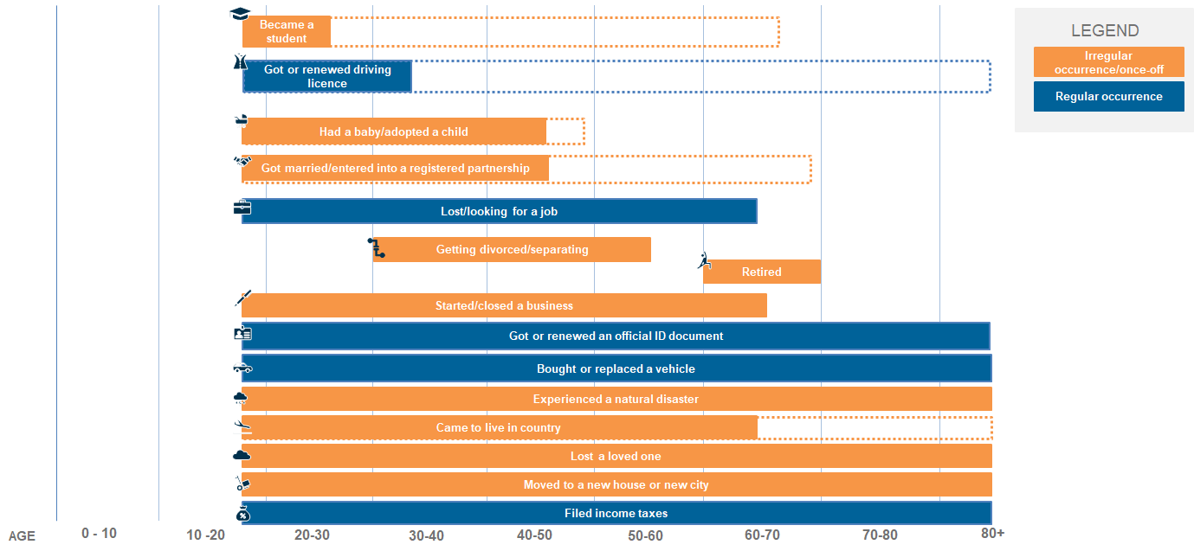
Source: Author illustration
The deployment of approaches for mapping and understanding the user journey along a Life Event has been a key enabler for countries to understand the user’s overall journey and how it should be designed to meet their needs. Dialogue with citizens is key to ensuring that their needs are heard when considering the reform of public service delivery. Across the OECD, design thinking sessions (51%), focus groups (57%) and usability testing (72%) are the most common used methods to capture needs (OECD, 2024_{[4]}). The TSI Project has identified the use of several innovative approaches for consulting with users at the beginning, and during the reform process. This includes the wide consultation of users in Finland (Box 2.1) and the deployment of tools to consult users for the development of the ‘As-is’ situation in Ireland (Box 2.2)

Box 2.1. Finland - Approaches for understanding User Needs
Finland has adopted a National Dialogue Model for understanding user needs. The National Dialogue is a widespread democratic innovation developed to increase social dialogue between citizens, communities and authorities. Between 2020 and 2025, 1000 discussions have taken place, with 390 organisers including associations (NGOs) (140), businesses and individuals (50). 8000 individuals have participated in the dialogues, with their age ranging from 5 to 90 years of age, with 14 languages covered. The Dialogues have been held in 130 locations across Finland.
Source: Information obtained in country mission in May 2025 as part of this TSI.


Box 2.2. Ireland - Approaches for understanding User Needs
In Ireland, for the development of the Life Events ‘I had a baby’ and ‘becoming a student’, specific tools were deployed to understand the needs of users in the definition of the ‘As-is’ situation. The use of social media listening, for instance, enabled Ireland to identify obstacles to accessing public services through online social media sites and forums. The use of Focus Groups and interviews also enabled Ireland to identify specific obstacles faced by future mothers when preparing for the birth of their child.
Collecting data from users’ experiences through the deployment of these tools enabled the identification of specific bottlenecks as well as the creation of ‘user personas’ for the development of the ‘To-be’ situation for Life Events.
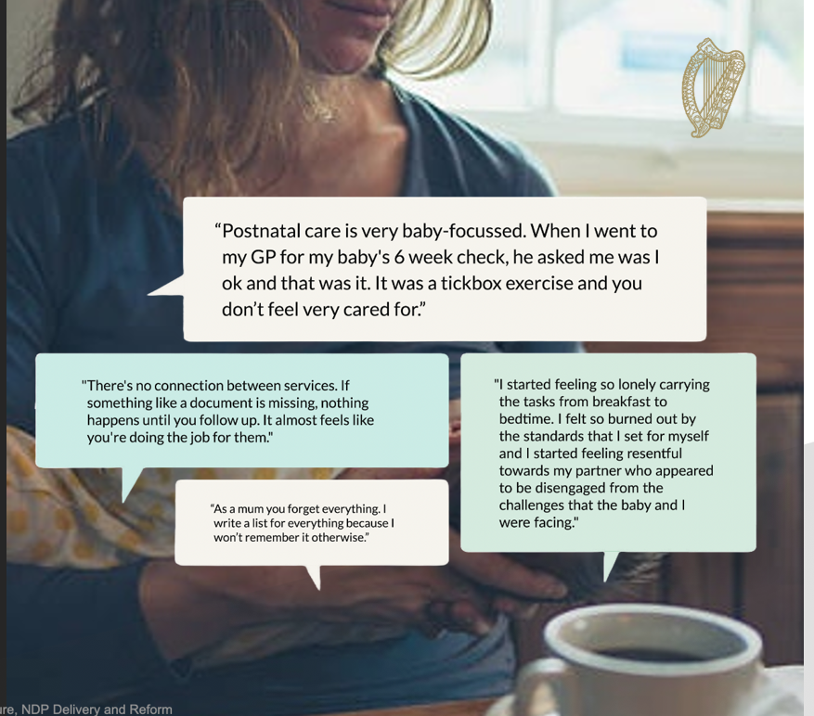
Source: Information obtained in country mission in March 2025 as part of this TSI.

Service design around user needs
To develop public services through Life Events that put users at the centre, several countries have enhanced their capabilities in relation to service design. By placing the user at the centre by default, a design approach to public services facilitates a more comprehensive understanding of users’ experience, challenges and satisfaction, and ensures that services are designed around the needs and expectations of users. This has helped put citizens at the centre from the onset. Ireland and Estonia have developed such capabilities as a core principle across all services’ design in Ireland (Box 2.4) and particularly for digital services in Estonia (Box 2.3).

Box 2.3. Estonia - Development of Service Design capabilities for digital public services
While Estonia has been a recognised leader in digital public services, the strong ambition to move towards a more citizen - and business-oriented service delivery drove the country to invest in service design capabilities.
The publicly available toolbox, developed by the Ministry of Economic Affairs and Communications, introduces every Estonian interested in service delivery “to the process of design thinking and a collection of tools, guidelines and methods that support this process”. The portal emphasises that everyone can be able to design and therefore aims to practically support civil servants in this avenue. The provided information is grouped in seven stages of the process, starting from the preparation to develop a service to testing solutions and sharing the obtained results with others. The information is structured to seamlessly transition civil servants from one stage to the next. Each stage is complemented with different tools, for example, stakeholder mapping, user interviews, and A/B testing, that civil servants can leverage and apply in their processes. The website also assembles all documentation, such as strategies and standards, in relation to service delivery in Estonia.
Source: Information obtained in country mission in September 2025; (Ministry of Economic Affairs and Communications, n.d._{[5]}).

Service standards
A key enabler for supporting service design is the development of service standards. These standards enable public sector organisations to adopt a consistent approach to service design across sectors and institutions, providing users with a seamless experience, whether they access services online or offline, and irrespective of their point of entry. Moreover, service standards also help to respond to, and sometimes shape, expectations from citizens by setting out what citizens can expect from the administration and ensuring that administrations commit to a given level of service. OECD countries are increasingly adopting service standards for the whole government to establish a common approach to design and delivering government services. Of the 10 EU countries participating in the TSI Project six (Estonia, Finland, Ireland, Latvia, Lithuania, Slovenia) have reported adopting whole of government service standards. In 2023, 28 out of 33 participating OECD countries in the Digital Government Index reported having such a standard to guide service teams when designing and delivering public services (OECD, 2024_{[4]}). For instance, Ireland has developed service principles to support in the development of their Action Plan for Designing Better Public Services (Box 2.4).
Box 2.4. Ireland - Development of Service Design
Ireland’s road towards the service design approach in government started with the 10 foundational principles, adopted in 2022. The principles prescribed the simple ways how a design approach can be introduced and embedded into government operations and culture. Particularly principles 1, 2 and 4 highlight the importance of putting needs of all users at the centre.
Building on these principles, the Department of Public Expenditure, Infrastructure, Public Service Reform and Digitalisation developed the Action Plan for Designing Better Public Services that aims to support their practical implementation. The two-years Action Plan is built around three themes - demonstrating design commitment, increasing design capability, and fostering a design culture – with each including practical steps in support. Its overall objective is to integrate the design approach across the public sector.
In addition to the clear service design principles and strategy, Ireland enhances design capabilities through a dedicated unit. The Design Unit in the Department of Public Expenditure is responsible for implementing the plan while also assisting public servants who want to use design thinking in their respective organisations.
10 Design Principles for Government in Ireland
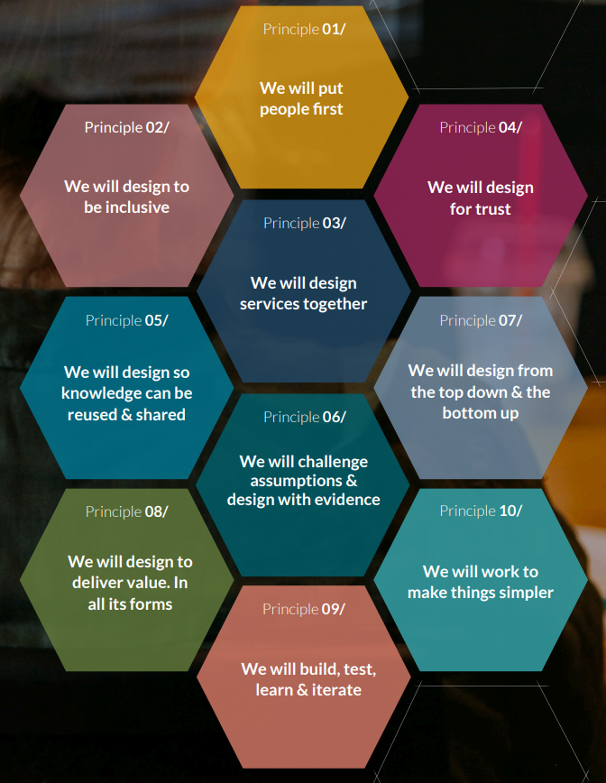

Source: Information obtained in country mission in March 2025 as part of this TSI; (Government of Ireland, 2022_{[6]}); (Government of Ireland, 2023_{[7]}); (Department of Public Expenditure, 2025_{[8]}).
In Slovenia, unified standards have been developed for digital public services through a Pilot initiative (Box 2.5).

Box 2.5. Slovenia - Development of unified standards for digital public services
Within the Recovery and Resilience Facility 2022-2026, Slovenia is currently implementing the project "Development of New Dynamic E-Services". One of the key objectives of the project is to harmonise access to digital services through the definition of common standards for digital public services (for web services and mobile applications). These standards set out specific requirements and recommendations on how digital public services should be designed, developed, and delivered to users in order to comply with common underlying principles. The aim is to standardise the way information and services are delivered, common graphical elements and common functionalities, and to promote the use of common building blocks and common functionalities. A pilot implementation of the standards on selected portals is foreseen to test their practical application.
Source: Information obtained in country mission in June 2025 as part of this TSI.

Proactive services: Anticipating users’ needs
When accessing public services, there is a need to ensure services are proactive. Proactive services relate to anticipating the needs of users and service providers. This ensures that information regarding services is easy to find and that users do not need to spend time navigating multiple steps to access the information they require. Moreover, proactive services relate to providing users with information and support before they ask for it, for instance by informing them of their rights, duties and obligations or by delivering services automatically (OECD, 2024_{[9]}).


Spotlight on results from the TSI Satisfaction Survey
Proactive Services
- Countries are overall succeeding in providing services that are easy to find. 71% of users across the EU-10 are satisfied with the ease of finding the service.
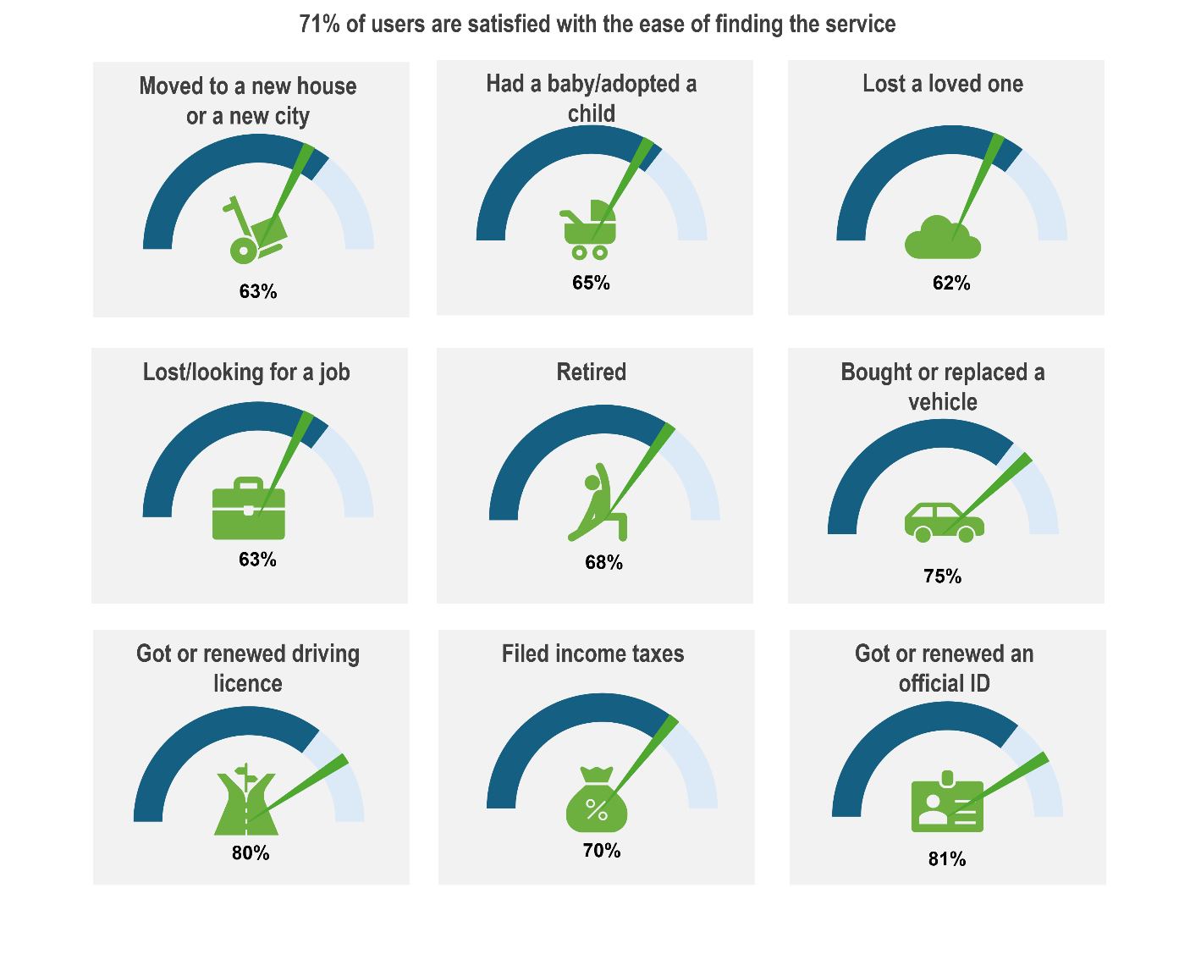
- A variation in satisfaction levels exists regarding the types of Life Events covered.
Note: The dark blue arch represents the average satisfaction level with this driver for users of all Life Events across the EU-10. The green pointer represents the satisfaction level of the user for this driver when experiencing the specific Life Event. The pointer position shows whether satisfaction for the specific Life Event is higher or lower than the overall average.
- A nine percentage points decrease in satisfaction is identified for users who experience the loss of a loved one, with these users 62% satisfied with the ease of finding the services. A similar level of satisfaction (63%) is also identified for users who lost/looked for a job or moved to a new house/to a new city. The lower levels of satisfaction with the ease of finding services associated with these Life Events can be explained by the multiplicity of actors involved in these services as well as the level of public administration involved. For instance, in relation to losing a loved one, the TSI Satisfaction Survey has identified through focus study in Spain, Estonia and Finland that information relating to these Life Events is often dispersed among several central and local government providers. On the other hand, Life Events that require less services, such as getting or renewing an ID document records higher levels of satisfaction than the EU average (+10 percentage points).
- On average, users are more satisfied with public services when they have been informed of the public services they are entitled to. In addition to being able to find the service, proactive services mean users being informed of services they are entitled to. Through the survey, users were asked whether they were informed of their duties, obligations or available benefits prior to using the public service. Users across the EU-10 who reported being informed before using services showed a level of satisfaction that was, on average, 5 percentage points higher than those who were not informed.
The OECD Digital Government Policy Framework highlights six dimensions for establishing a digital government, one of which is proactiveness (OECD, 2020_{[10]}). With the development of AI, the OECD has identified concrete opportunity areas for the government use of AI. This includes the responsiveness of public policies and service through enhanced design and delivery approaches that better meet evolving needs of citizens and specific communities including offering more personalised public services more proactively (OECD, 2025_{[11]}).
Box 2.6. Use of AI in public service design and delivery
The development and use of AI has permeated public service design and delivery in recent years, with 67% of OECD countries using AI to improve this function. AI has important potential in generating predictive analytics and forecasting, allowing public services to anticipate needs and be proactive. AI can help forecast future service needs, optimise resource allocation and enhance responsiveness across various policy domains by enabling the analysis of historical data and trends. AI has also supported countries in developing language translation.
India’s Bashani Platform
Under the National Language Translation Mission, India developed Bhashini, an AI-led language infrastructure project.
- Capabilities: Real-time translation across 22 official languages and multiple dialects.
- Supports multilingual voice assistants and AI service delivery interfaces, making government services accessible to citizens in their native languages.
- Built through a large-scale citizen engagement exercise to ensure linguistic representativeness.
Korea’s SIMTOMI for Healthcare
In Incheon, Korea launched SIMTOMI, an AI-powered medical support service for foreign patients and tourists.
- Functionality: Combines a multilingual AI symptom checker with advanced translation capabilities, enabling accurate communication between patients and healthcare providers.
- Generates anonymised symptom summaries that can be shared via QR codes during hospital visits.
- Achieved high satisfaction (84.4 points) and a 95% intention-to-reuse rate, showing strong impact on accessibility.
Source: OECD Governing with AI, 2025
The OECD Digital Government Index provides insights on how OECD member countries perform in deriving value from data to inform policy and service delivery. In relation to proactive services, the DGI assessed whether data is used to anticipate, plan and monitor. On the initiatives to design and deliver government services based on users’ data, countries are only halfway there, with 34% of countries responding to the DGI having no such initiative at all (OECD, 2024_{[4]}).

Country practices and lessons learned
Actions taken by public administrations to deliver proactive services can be identified through examining the delivery of various Life Events across participating countries in the TSI Project.

Auto filling of information for citizens
The proactiveness of services can relate to the auto-filling of information for citizens, to reduce the time taken to fulfil their duties and obligations. Latvia, Spain and Lithuania invest in service proactiveness with regard to filling tax declarations (Box 2.7).


Box 2.7. Latvia, Lithuania, Spain - Example of proactiveness of services for Life Event: I filed income taxes
Prefilling income tax declaration in Latvia

To make annual income declarations simpler and more convenient, Latvia's State Revenue Service offers a prefilling option through its Electronic Declaration System. The system automatically generates tax forms by pulling in existing data from government entities, credit institutions, and insurance companies, including information on taxable and non-taxable income, pensions and certain expenditures like those for education and healthcare. This streamlines the process, as users are presented with a simplified form that requires them only to review the prefilled data and add any new or missing information. To further assist taxpayers, the electronic form features an integrated “wizard” or help function that asks a series of questions and based on the answers, directs the user to complete only the specific columns and annexes relevant to their situation.
Prefilling income tax declaration in Spain
The State Agency for Tax Administration counts among its main objectives the reduction of the compliance costs that citizens face in their interactions with the Public Treasury. Each year, during the income tax filing campaign, taxpayers are provided with pre-filled tax returns. In addition, they can interact with the administration through their preferred channel, including pre-scheduled telephone or in-person appointments.
The online platform offers all the necessary documentation and a range of tutorials, as well as real-time chat with tax agency representatives while completing the return. Users can also correct errors and access all relevant information, including previous filings and a simulator for estimating the amount owed. The tax agency proactively communicates the campaign calendar not only through its website but also via targeted messages to taxpayers.
Prefilling income tax declaration in Slovenia

The Financial Administration of the Republic of Slovenia automatically compiles and sends an informative income tax calculation to all income taxpayers, regardless of the amount of income received, based on all the data already collected. Taxpayers must only act and file an appeal if they disagree with the information that is already prefilled.
Digitalisation of tax filling in Lithuania
Over the past two decades, the Lithuanian State Tax Inspectorate (STI) has steadily digitised the income-tax filing experience. Central to this effort is the My STI (Mano VMI) platform, built on a unified design system that ensures services are consistent, accessible, and easy to navigate across devices. Each year, the platform provides taxpayers with pre-filled declarations, access to personal tax data, electronic submission forms, and real-time guidance and communication with the tax authority.
To build on this progress, the STI has launched a new data-integration initiative aimed at consolidating information systems, strengthening the use of data to guide operations, eliminating redundant processes, and expanding automation. The project seeks to enhance efficiency, improve service quality, and further reduce the administrative burden for citizens.
Source: Information obtained in the country mission in March (Spain), May (Latvia) and October (Lithuania) 2025; (State Revenue Service, 2025_{[12]}).

Proactive reminders to citizens
Proactiveness of services can also relate to informing citizens of their rights, duties, obligations prior to them having to access the services. In Croatia (Box 2.8), citizens are informed of the imminent expiration of their driving licence in order to encourage them to undertake a renewal request.


Box 2.8. Croatia - Proactive information provision to citizens
An e-citizens (e-Gradani) portal is a central portal available in Croatia for accessing public services. The portal provides citizens with access to over 100 services including health appointments, registration of residence and delivery of official documents. Through the use of an activated digital ID, citizens can submit requests for issuing, renewing or replacing a driving licence online. For citizens who use the e-citizens portal, an automatic notification is provided to them 30 days before the expiration of their driving licence in order to remind them to begin the process of renewal.
Source: Information obtained in the TSI country mission to Croatia in May 2025.

Proactive issuance of benefits and documents
Proactive services can also relate to ensuring the automatic eligibility of benefits. For instance, through the use of data sharing mechanisms that enable integrated digital systems, child benefit allowances can be automatically distributed to parents in Estonia upon the registration of birth of their child, with birth registration also automatically issued in Slovenia (Box 2.9).
While countries are implementing specific approaches to deliver proactive services, challenges arise. The TSI Country Missions identified that the main bottleneck to the delivery of proactive services arise from the absence of interoperability of data across public administrations, service owners and services providers at central and local levels. The lack of data availability and interoperability creates an obstacle for public administrations to be proactive rather than reactive in the delivery of services to citizens.


Box 2.9. Estonia and Slovenia - Proactive issuance of benefits and documents for the Life Event: I had a baby
To facilitate access to public services when having a baby, Estonia has introduced the delivery of proactive services for the Life Event: I had a baby/adopted a child. Upon the birth of the child and the registration of the child’s birth, an automatic ID code for the child is processed without parents needing to complete additional documentation. Moreover, child support is automatically issued upon registration of the child’s birth, with parents not having to complete any additional requests.
Source: Information obtained in the TSI country mission to Estonia in October 2025.
Slovenia – Digitalisation of birth registration
Birth registration in Slovenia has been digitalised. All 14 Slovenian maternity hospitals are now included in the electronic birth registration system. Electronic birth registration includes the assignment of a unique personal identification number (EMŠO) in the central population register, registration of the birth in the birth register, and registration of the newborn's residence in the population register.
The aim of introducing the system is to assign a unique personal identification number (EMŠO) to newborns immediately after birth, i.e. already in the maternity hospital, and to electronically register the birth in the civil registry. The e-birth system enables immediate communication and electronic data exchange between information systems in hospitals (maternity wards) and two registers – the central population register and the civil registry.
The e-birth system enables authorised persons (administrative staff or other employees) in hospitals (maternity wards) to obtain the EMŠO (personal identification number) for a newborn immediately after confirming the data on the birth of the child from the central population register. At the same time, they also obtain other data from the central population register database that is necessary to complete their records and, indirectly, for the health statistics they maintain.
Electronic birth registration brings several advantages for the work of maternity wards, administrative units, and other public administration bodies, which obtain data on newborns in less time than in the past. It also benefits parents and therefore represents a step closer to user-friendly public administration, as parents are spared a trip to the administrative unit, and the time needed to obtain extracts from the birth register, health insurance cards, tax numbers, and other documents for newborns is reduced.
The introduction of electronic birth registration has also improved the quality and timeliness of data for health statistics and analyses, administrative internal affairs, social work centers, the Health Insurance Institute, and all areas where data on newborns is needed as soon as possible after birth.
Furthermore, automation is most advanced in Slovenia in the administration of social benefits, particularly for the renewal of social benefits. In relation to Child Allowance, for example, after the initial application, annual renewals are processed automatically by the Centres for Social Work without the need for a new application. Adjustments to the child allowance, based for example on income thresholds and benefit amounts are updated automatically. For students, renewals for state scholarships are also handled automatically without the need for new applications.
Source: (Government of Slovenia, 2024_{[13]}).

Accessible services: Providing services to users through the preferred channel
Ensuring users can access services through their desired channel is key to ensuring services are thinking of different user characteristics. When designing and delivering a service, it is important to look beyond simple availability. As emphasised by the OECD Recommendation on Human-Centred Public Administrative Services, the goal must be to ensure the service is findable and usable by people across the widest possible range of user needs, means, personal characteristics, and capabilities within their specific contexts (OECD, 2024_{[9]}).

Spotlight on results from the TSI Satisfaction Survey
Accessible Services
- 72% of users are satisfied with their ability to access the service in the way they wanted when experiencing a Life Event.
- User satisfaction with their ability to access the service in the way they wanted is close, or at the level of satisfaction for the Life Events (i) lost/looking for a job (68%, - 4 percentage points), (ii) retiring (69%, - 3 percentage points), (iii) had a baby/adopted a child (70%, -2 percentage points). For some Life Events, the satisfaction level is slightly higher than the EU average (i) getting or renewing an official ID (73%; + 1 percentage point) (ii) getting or renewing a driving licence (74%, +2 percentage points), (iii) filing income taxes (+4 percentage points).
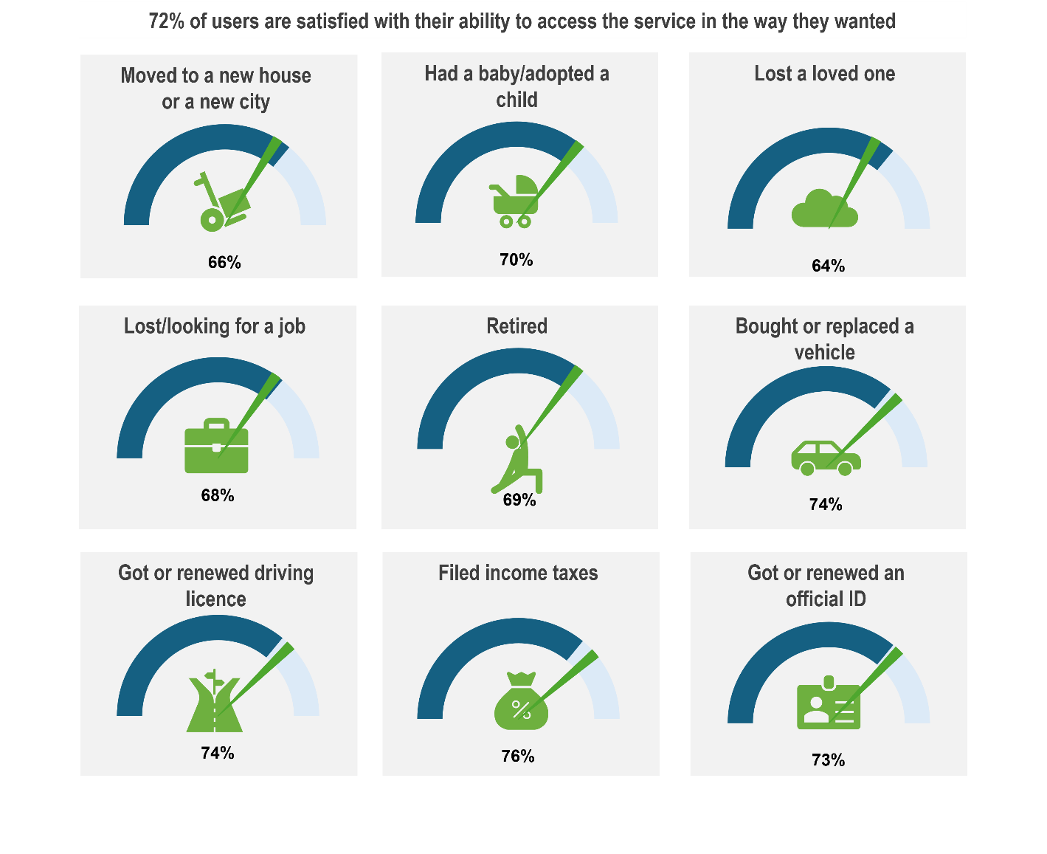
Note: The dark blue arch represents the average satisfaction level with this driver for users of all Life Events across the EU-10. The green pointer represents the satisfaction level of the user for this driver when experiencing the specific Life Event. The pointer position shows whether satisfaction for the specific Life Event is higher or lower than the overall average.
- Satisfaction levels showed relatively small difference across male and female respondents, users with high or low education and across urban and rural areas. However, people over 50 years old tend to be more satisfied with the ease of accessing services in most countries.
- The main channels used to interact with public services over the last 12-months are online channels across the EU-10. The Survey finds that the level of overall satisfaction by channel is slightly higher for users who access services online (75% of users reporting satisfaction with online channels), followed by in-person access (71%) and email (67%).

Country practices and lessons learned

Adoption of the omni-channel approach to accessing public services
Omni-channel refers to the approach to managing service delivery channels in an integrated, interoperable way to enable users to access the services in the way they want seamlessly and with consistent quality across channels (such as websites, physical offices, self-service kiosks, video calls, call centres etc.) (OECD, 2024_{[1]}). To improve user experiences and enable users to achieve their desired outcomes and meet their needs, the OECD recommends countries adopt an “omni-channel and/or cross-channel approach with consistently high standards of quality, effective outcomes, ensuring user choice and accessibility, and ease of navigation across all channels, regardless of the point of entry, and regardless of the context of access and use (e.g., urban or rural areas)” (OECD, 2024_{[1]}).
As part of the EU’s Digital Decade 2030 goals, a target has been sent for 100% online provision of key public services by 2030 (European Commission, 2021_{[14]}). While countries participating in the TSI Project have set the digitalization of public services in their national digital policies and strategies, countries have identified the need to continue to deliver public services through multiple channels.
TSI Satisfaction Survey results show that users across the EU-10 utilise different channels to access services, with online and in-person interaction being the most frequent and the average satisfaction with both being quite high (Figure 2.4). This sheds light on the importance of sustaining and continuously improving an omni-channel access to public services. To achieve this goal, countries can move towards more strategic ways to manage different service delivery channels in ways that make them integrated, convenient and easily accessible, for example through strategies that help manage digital and non-digital channels coherently. Results from the 2023 DGI show that 51% of OECD countries have such a strategy in place (OECD, 2024_{[4]}).
Across the EU-10 average, online channels remain the most common interaction mode across Life Events, with 49% of users using them as their primary channel, followed by 35% who interacted mainly in person. While online channels were identified as the main channel by users accessing services through Life Events for seven of the ten countries (Estonia, Finland, Greece, Ireland, Latvia, Lithuania and Spain), variations exist in these seven countries with regard to the number of users identifying these channels as the preferred access channel when experiencing Life Events. While in some countries, almost two-thirds of respondents identified an online channel (Finland (75%), Estonia (72%)), a difference can be observed in the proportion of users accessing online channels, with a little more than half using online channels in Greece (52%), Ireland (52%), Latvia (52%) and Spain (53%). The large proportion of users accessing services through physical channels in Austria (40%), Slovenia (57%) and Croatia (72%) represents the preferences in these countries for users to continue to access physical channels. The heavy use of physical channels does not represent the lack of digital options but rather a user preference to have in-person contact with individuals. This can be observed through user’s satisfaction with their ability to access the services in the way they wanted, with high satisfaction in Austria (69%), Croatia (64%) and Slovenia (70%). Moreover, user dissatisfaction ranged from 9% in Austria, 10% in Slovenia and 13% in Croatia.
Figure 2.4. Share of users accessing digital and physical channels when accessing public services associated with Life Events, EU-10
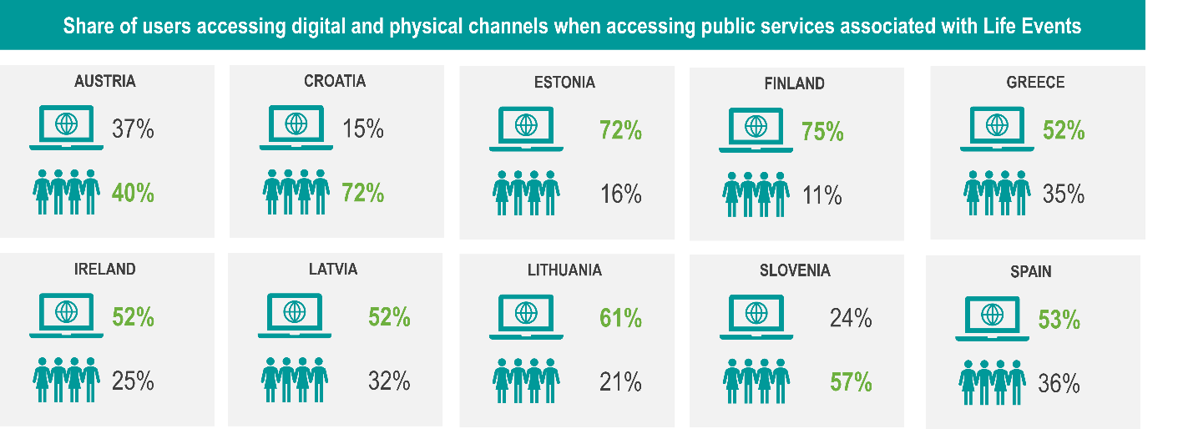
Source: Authors’ own visualisation.
The Survey also finds that satisfaction rates among online and in-person users are similar across most countries, with the exception of Finland and Estonia where users who accessed the service online are 10 percentage points more satisfied than those who primarily accessed the service in person.
Services are more frequently accessed through online channels for six out of nine Life Events: (i) Filing income taxes, (ii) lost or looking for a job, (iii) moving to a new house or to a new city, (iv) having a baby/adopting a child, (v) buying or replacing a vehicle, (vi) getting or renewing an official ID document. Users across the EU-10 predominantly used in-person services only for three life events, namely getting or renewing a driver’s license, retiring, and losing a loved one. This can be potentially explained by the mandatory face-to-face requirements for getting a driver’s license and people’s general preference for in-person services for events like retiring and losing a loved one. Nevertheless, this variation by Life Event also depends on the country in question, with users in Slovenia and Croatia preferring physical channels for all Life Events.
Patterns in channel usage remained consistent across all age groups (18-29; 30-49; and 50+), and respondents of all ages preferred to use online channels rather they were required to do so. The survey respondents were most dissatisfied with accessing services via telephone and post, with 13% of users reporting dissatisfaction with these channels. To this end, analysis of life event data confirms that post is the least popular channel for service access. Its usage is low, reaching 4% only for retirement and remaining under 3% for every other life event covered by the Survey.

Development of physical channels integrating multiple public services in one single point of contact
While digital channels are the preferred channel for accessing services for users in seven out of the ten participating countries (Figure 2.4), countries continue to develop physical access points. For physical access, countries are succeeding in providing service access and points that are close to the users. Across the EU-10, 65% of users agreed with the statement that the distance travelled was reasonable when accessing physical services. Nevertheless, the share is on average higher among urban users compared to rural. To enhance physical access to public services, countries have worked to integrate multiple physical access points together. In Finland, the Suomi-Piste Local Contact Points for Public Services aim to support users in navigating multiple services (Box 2.10).
Box 2.10. Finland -Suomi-Piste Local Contact Points for Public Services
Finland launched the renewal of the central government’s service and premises network in 2020s. The aim of this renewal is to assemble central government’s in-person services into joint service points, where general service counselling and digital support are also available. The aim of enforcing the network is to contribute to equal access to services.
The use of the central government premises aims also to increase efficiency within public administrations, with agencies moving to shared work environments. The first six joint service points were opened between 2023 and 2025, with the objective of the Network covering the whole of Finland by 2030.
Finland’s Suomi-Piste local contact points are a network of walk-in service hubs that provide citizens with in-person guidance for navigating digital and administrative public services. The Suomi-piste model seeks to ensure that everyone – including people in rural areas, newcomers, and those with lower digital skills – can access public services reliably and confidently. By combining human support with Finland’s highly digitalized service ecosystem, these contact points reduce exclusion, enhance usability and strengthen trust in government as well.
Good practices summary:
- Provide in-person assistance for using national and local digital services.
- Help citizens complete applications, forms, and online transactions.
- Offer support with e-identification.
- Bundle services from multiple authorities in one easily accessible place.
- Improve access in remote and sparsely populated regions across the country.
- Ensure consistent, high-quality service delivery through trained staff.
- Act as a bridge between digital government systems and users who need personal support.
Source: Data collected through TSI Country Mission to Finland, May 2025.
In Greece, physical one-stop shops have been developed to offer citizens access with a broad range of services ( Box 2.11).

Box 2.11. Greece - KEP centers Local Contact Points for Public Services
Greece’s KEP are physical one-stop offices where citizens can access a broad range of public services and administrative procedures in person. These centers are extremely useful as they help reduce bureaucratic hurdles experienced by individuals by centralising public-service points and improve accessibility – especially for those who may struggle with digital channels. Through KEP centers, all sorts of administrative tasks are simplified under a unified approach, strengthening strength and trust in government and easing the citizen journey.
Good practices summary:
- Serve as one-stop shop for administrative procedures and public services.
- Provide information, forms and assistance for numerous procedures.
- Allow citizens to submit applications, request certificates, and complete bureaucratic tasks in person.
- Offer both physical offices and myKEPLive videoconference for remote contact.
- Integrate through ERMIS to coordinate data and standardize service delivery.
- Support the EU “Point of Single Contact” concept.
Source: Data collected through TSI Country Mission to Greece, 2025.
In addition to providing physical access across a range of services, Croatia has adapted the access to specific Life Events, depending on the needs of the user (Box 2.12).

Box 2.12. Croatia - Adapting Life Event delivery to types of access required by users
To get or renew an ID card in Croatia, citizens must access one of 118 offices (police administrations) that are located across the country. Clear information is provided online to support citizens in identifying the office mandated to issue the ID card. Where persons cannot access physically one of the 118 offices (e.g. due to illness), the individual can call the local police station to make an appointment for a home visit from the Ministry of Interior. Mobile equipment has been developed to support users who cannot physically access the service to meet their needs.
Source: Data collected through TSI Country Mission to Croatia, May 2025.

Optimising digital services for the deployment of Life Events
While the development of an omni-channel approach is vital to ensure users’ needs are met, the Satisfaction Survey found that the ease of using the digital channel is highly correlated with satisfaction (Figure 2.5). This is particularly the case for Life Events that are mostly online-based such as filing income taxes or lost/looking for a job. The connection is weaker for Life Events that are mainly experienced in person, such as losing a loved one.
Figure 2.5. Ease of using digital tool is highly associated with satisfaction for life events that are often experienced through online channels
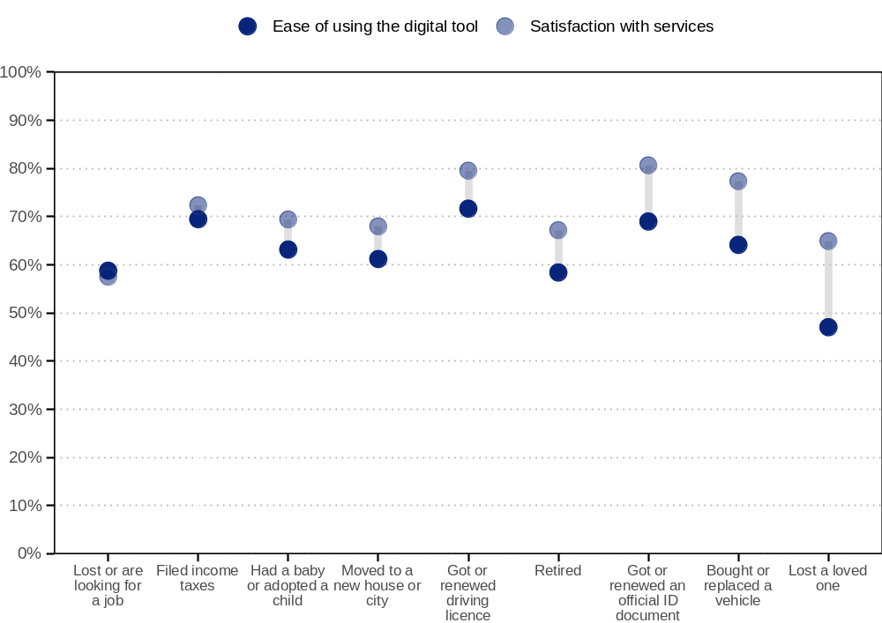
Source: (OECD, 2024_{[15]}).
Countries are at different level of maturity in relation to the delivery of digital public services. Countries have focused on the digitalization of public services through specific Action Plans and programmes, as in Finland (Box 2.13).
While some countries have high maturity levels in relation to digital public services, challenges still exist. For instance, Estonia, a country delivering 99% of public services online, has identified bottlenecks when the business case for delivering digital public services is not thought through before IT development. Needs exist to ensure effective coordination between digital, legal and policy expertise prior to IT development. Moreover, there is a lack of coherent understanding of good digital services and their development.

Box 2.13. Finland - Enhancement of digital services
Programme to promote life-event-based digitalisation in Finland
Finland is taking steps to create more seamless and human-centred digital public services by organising service delivery around key life and business events. Led by the Ministry of Finance and co-ordinated by DVV, the Digital and Population Data Services Agency, the initiative aims to find possibilities to digitalise and automate service processes to make it easier and faster for users to obtain their services, and to reduce administrative paperwork and costs for responsible authorities.
The programme will prepare and support projects that digitalise end-to-end service journeys for major life events, such as starting a business or becoming a parent. Over the course of the current government term, it seeks to generate at least ten scalable project concepts ready for implementation and to establish a long-term roadmap for life-event-driven digital services up to 2030. These actions contribute to the national target of defining and digitalising around 40 key life and business event service packages.
To ensure broad adoption and foster collaboration, the programme will also develop an inclusive cooperation model and launch a developer network for experts across government, wellbeing services counties, municipalities and relevant stakeholders. This community will serve as a platform for knowledge sharing, co-creation and the spread of best practices. A strategic steering group representing key public sector actors will guide and monitor the programme.
Source: Information obtained in country mission in May 2025 as part of this TSI; (Ministry of Finance, n.d._{[16]}).

Tools for supporting Access to Public Services for Users
Several tools have been identified that can support countries in supporting User Access to Services, ensuring that (i) users are placed at the centre in the development of public services, (ii) services are proactive and (iii) accessible. The deployment of the tools proposed cannot be undertaken in parallel, with some tools needing to be introduced before other tools are deployed (Figure 2.6).
A key priority for the delivery of public services is to develop public services adapted to the user needs. By developing Life Event approaches across Government, public services are packaged in a manner that is aligned with user experiences throughout their lives. To support this, it is also necessary to ensure service standards and principles for public service design and delivery are developed across government, ensuring a uniform approach for users. Several horizontal tools contribute to the development of the Life Event approach, and standards and principles for public service design and delivery. These include ensuring design capabilities are in place across government to contribute to the design of public services with the user in the centre. Moreover, tools and methods for understanding user needs must be deployed to ensure that the key obstacles and bottlenecks faced by users are identified to design user-centred services. Proactive communication tools also contribute to ensuring that the actions of the public administration to address the needs of the user are appropriately communicated. To ensure the adequate monitoring of efforts, it is also key to deploy data collection on public service delivery, ensuring key indicators have been defined, collected and are continuously monitored. The use of AI driven insights can contribute to this data collection.

Figure 2.6. Interconnection between tools for Accessing Services
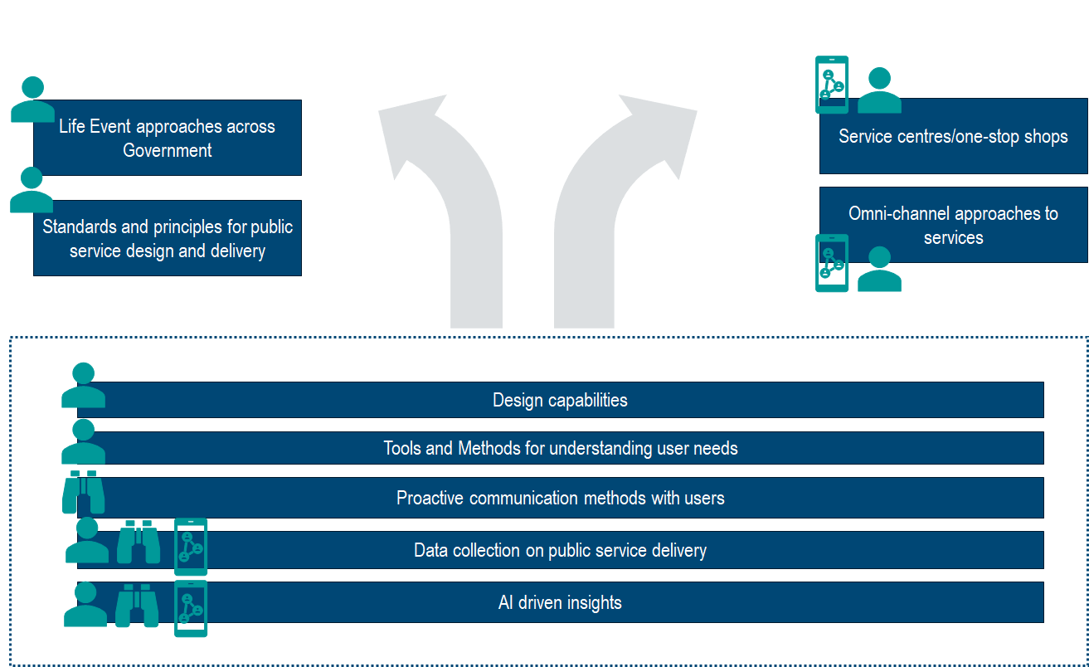
Source: Author illustration.
The establishment of Life Event approaches and service standards and principles can also contribute to the deployment of accessible services to users, particularly through the development of the omni-channel approach and the use of One-Stop shops. The horizontal tools can also contribute to the development of these tools for accessibility. For example, design capabilities can support in developing the omni-channel approach, ensuring that regardless of the channel, services look the same, with the same level of information provided to users. Moreover, tools and methods for understanding user needs can be key in supporting the development of the omni-channel approach and one-stop shops by identifying what services are required by users through different channels. A full overview of the Tools relating to Access to Public Services is presented in Table 2.1 below.
Table 2.1. Tools for Access to Public Services
Tool | Description | Types of Actions
Life Event Approaches across government | Building a life event approach for the country, starting with setting the list of life events, helps frame the country’s methodology and steps towards rolling it out. Disseminating, clarifying and explaining information on Life Event Approaches can be a powerful tool to foster a better understanding and uptake of this approach across public administration. | - Development of the life event approach and toolbox in the country (from defining the list of life events to mapping user experiences on life events and implementing specific actions)  - Life Event prototyping  - Prioritisation tools on life events (surveys, data analysis)  - Dedicated and accessible internal webpages with information, methodology and tools for the adoption and improvement of Life Event Approaches  - Communication on life events - Events, conferences and exchanges on Life Event Approaches across administration
Standards and principles for public service design and delivery | Clear, user-centred standards and principles for service design and delivery establish a shared understanding between civil service and society and provide a roadmap for service improvements. | - Identification of concrete and limited number of principles  - Embedding standards and principles into a strategic document  - Consulting and agreeing standards across the administration  - Communication of these standards to users  - Making organisations accountable and assessing them against the standards
Omni-channel approach to services | Maintaining an omni-channel approach to services (online, in-person, telephone, post) maximises user choice, increasing the likelihood of access through their preferred channel. User patterns and needs for accessing services across various channels change over time. Therefore, it is essential to monitor which channels users utilise most and the specific services or actions they require through those channels. | - Information provision on all available access channels for reaching a service in communication for users (websites, emails, letters)  - Collect and analyse data and satisfaction on access channels and integrate data collection user preferred access and services required
Design capabilities | The development of design capabilities is key to placing the User at the Centre. By integrating service designers in public service reforms, public services can be designed around users’ needs are considered from the beginning of the reform process. | - Recruitment of design experts within government  - Integration of design capabilities within administrations leading public service reforms  - Partnerships with design expertise through universities/specialised institutions/private sector  - Deployment of design hackathons within administrations
Tools and methods for understanding user needs | Several methods can be used to map the journey of users. Understanding the user experience through the eyes of the user enables public administrations to understand the steps taken by users when accessing public services. This can in turn help the public administration to improve and redesign the service according to the pain points and obstacles actually faced by users. | - Development of practices for designing the ‘as-is’ and ‘to-be’ situation for the user  - Deployment of qualitative data collection techniques for mapping the user journey (user interviews, focus groups, workshops, social media listening)  - Design of action plans (and templates) to improve the services based on the user journey mapping  - Establishment of unified web platforms / tool boxes and training for disseminating methods on user needs across public administration
Proactive communication methods with users | Proactive communication in service delivery collects, anticipates the needs and obligations of users before an event or issue arrise. By leveraging such communication, public service providers can motivate users to timely devise solutions, better prepare for using a service and mitigate possible challenges. | - Use of chatbots and virtual assistants to notify users of duties and obligations  - Sending reminders about the need or obligation of public service in advance via either post or digital options (SMS/WhatsApp, emails)  - Deployment of anticipated, regular and recurrent online and/or in-person sessions to inform about services
Data collection on public service delivery | Proactive service delivery relies on data that is high quality, accurate and up-to-date, necessitating sound and timely data collection and processing methods. | - Collect information through regular surveys and feedback mechanisms with users  - Implement systems that gather data in real time  - Apply tools to service delivery that automatically collect performance and user data
AI-driven insights | AI can be deployed in service design and delivery to analyse user experiences, uncovering key trends, patterns and anomalies that inform and allow for proactive, timely communication with users. | - Integration of AI tools in public service analysis
Source: Author illustration

Navigating public services
After identifying and accessing the necessary services, users face the crucial task of navigating the services they require to get what they wanted. Navigating public services entails completing and progressing through the essential steps to receive a service. The TSI Satisfaction Survey has revealed that user satisfaction in this process is driven by three key aspects: 1) how clear public services are; 2) how seamless services appear to users; and 3) how integrated services are. The following sections focus on these three elements, highlighting the most important conclusions from the Survey data analysis and providing country examples to showcase these elements in different contexts and to facilitate idea exchange for service improvements across the EU-10.
When navigating public services, it is important to consider the advantages associated with the Life Event approach. The delivery of public services through Life Events aims to ensure that users only have contact with public services through their selected choice of channel, without having to consider the back office mechanisms associated with dealing with the user’s request, and minimizing interactions with multiple service providers (Figure 3.1). Public services that are clear, integrated and seamless are those that provide users with a streamlined experience without the back-office bureaucracy.
Figure 3.1. User-facing services
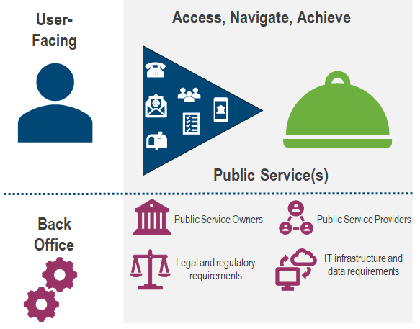
Source: Authors’ own visualisation.

Providing clear services to users
When navigating public services, there is a need to ensure the information (and accompanying language) is clear for users, to avoid time spent on understanding what actions they need to take to receive public services. Clear and plain language in service communication can be fostered by simplifying administrative and legal terms, adjusting and targeting language to different social groups and using visual aids to support the written text (OECD, 2024_{[9]}).

Spotlight on results from the TSI Satisfaction Survey
Clear Services
- 73% of users across the EU-10 are satisfied with the clarity of language and information provided through the process. Satisfaction levels remain consistent across genders, education levels and living areas.
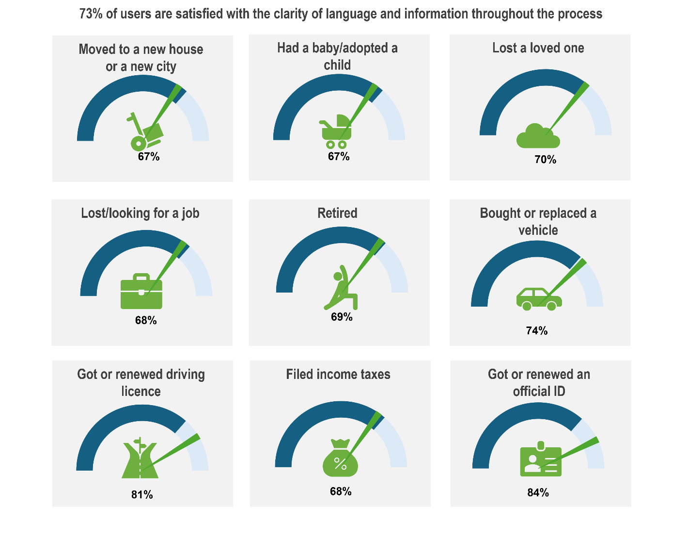
Note: The dark blue arch represents the average satisfaction level with this driver for users of all Life Events across the EU-10. The green pointer represents the satisfaction level of the user for this driver when experiencing the specific Life Event. The pointer position shows whether satisfaction for the specific Life Event is higher or lower than the overall average.
- The share of satisfied users increases twofold when they find it clear what to do to start an application/request.
- The difference in satisfaction can be observed across different age groups. Across the EU-10, users aged 50 and above are, on average, seven percentage points more satisfied with the clarity of language than those aged 18 to 29 (with a satisfaction level of 76% and 69% respectively). The difference in satisfaction across these age groups is particularly visible in Slovenia, Lithuania and Ireland. Satisfaction among the 50+ group is five percentage points higher than the 30 – 39 age bracket (71% satisfied). In addition to the three countries mentioned above, the difference between these two age groups is notable in Latvia and Spain.

Country practices and lessons learned
A public service is clear when:
- The language used is plain and concrete, processes do not require prerequisite knowledge of legal terms, jargon, and acronyms.
- The process is transparent, and it is always clear to the user where they are in the service journey, what comes next, and what the options are.
- Eligibility and user responsibilities are understandable, so potential service users know who can get what, under what conditions, and what they must do (or not do) to access
- Rights and redress are also transparent, and users know what to do if something goes wrong
Several countries have made efforts to simplify the administration language, for instance Estonia (Box 3.1) and to ensure the process and its steps are clear and easy to understand for users, such as Ireland (Box 3.2).

Box 3.1. Estonia - Providing clear services
Estonia treats clarity as an explicit requirement in public service design: services must be understandable to all parties, not just functional. This service design principle is reinforced and supported by the Language Act and Estonian Language Strategy 2021-2035 and the institutionalisation of clear language in the public sector via training, supporting roles (clear language consultants and editors), and model forms and documents. Government portals, letters and forms use plain, direct language, informed by the national strategy.
Examples of clear language in action include the state portal (www.eesti.ee) life-event pages, which explain what to do, when, and why, rather than focusing on institutional mandates. The portal presents services with simple descriptions, clear calls-to-action, and time-ordered guidance. Other good practice examples include the public consultation platform (www.osale.ee), and communications on benefits from the Social Insurance Board.
The tools that underpin clear services in Estonia include not only the plain language strategy but a wider set of governance and design systems. The “Brand Estonia” design system provides shared UI components and visual rules that all public-facing sites are supposed to follow, ensuring clean layouts and consistent structure across services. Furthermore, user testing is focused on comprehension, not only on usability.
Good practices summary:
- Institutionalise plain language by mandating it in service design principles, providing training and in-house editors.
- Treat content design as its own workstream in every service reform and invest in re-writing content.
- Explain processes transparently, showing users the steps, expected timelines, eligibility rules, duties and rights.
- Centralise design systems so users experience consistency regardless of the agency and interaction.
- Test for understanding with diverse user groups and measure clarity during the testing process.
Note: See also the “Building Clear Language Strategy in Estonia” plain language network paper, which describes work to institutionalise clear language in the public sector.

Box 3.2. Ireland - Human-centred approach for enhancing service clarity
Ireland’s clarity agenda sits within a broader move toward human-centred public administration, as set out in Better Public Services and reinforced by Ireland’s design principles—especially people first, design for trust, design to make things simpler, and design services together.
The Digital Public Services Plan 2030 requires services to be intuitive, transparent, and easy to understand, with clear steps, eligibility rules, and documentation needs. This is operationalised through standardised service patterns, a Life Events Portal providing a single, comprehensible entry point, and a focus on clear, actionable guidance rather than dispersed institutional information. Service design methods (e.g. journey mapping, persona work, prototyping) ensure communication reflects real user comprehension, not internal language.
The Action Plan for Designing Better Public Services also emphasises plain language and evidence-based clarity, highlighting the need to challenge assumptions, make things simpler, and support users with amplified needs. Clarity is embedded through co-design, open testing with users, and cross-agency alignment on messaging, steps and responsibilities.
Good practices summary:
- Create a national plain-language and design standard for all service content.
- Replace organisation-centric communication with user-centric narratives: explain the journey, not the agency.
- Use design research to uncover points of confusion, then re-write, re-sequence, or remove steps.
- Publish transparent service steps and eligibility rules in a single, unified view for each user journey.
- Use iterative testing with diverse groups, especially those with amplified needs.
- Ensure governance enforces clarity: senior oversight of content, design standards and user experience.

Delivering seamless services to users
Providing seamless services refers to services working together. This entails the alignment of services across different public service providers to meet user needs in a friction-free manner. In the context of Life Events, this enables users to be unconscious of the back-office administration of public services associated with Life Events, with public administrations working together to deliver the public services for the users.


Spotlight on results from the TSI Satisfaction Survey
Seamless Services
- 61% of users across the EU-10 are satisfied with how services work together. Younger people are less satisfied with services working together, with 55% of respondents between 18 and 29 years of age satisfied, on average. 60% of users from the 30-49 age bracket are satisfied with how services work together, with 64% of users who are 50+. The Survey results for Austria, Estonia and Croatia do not show a large difference in satisfaction with how services work together across different age groups.
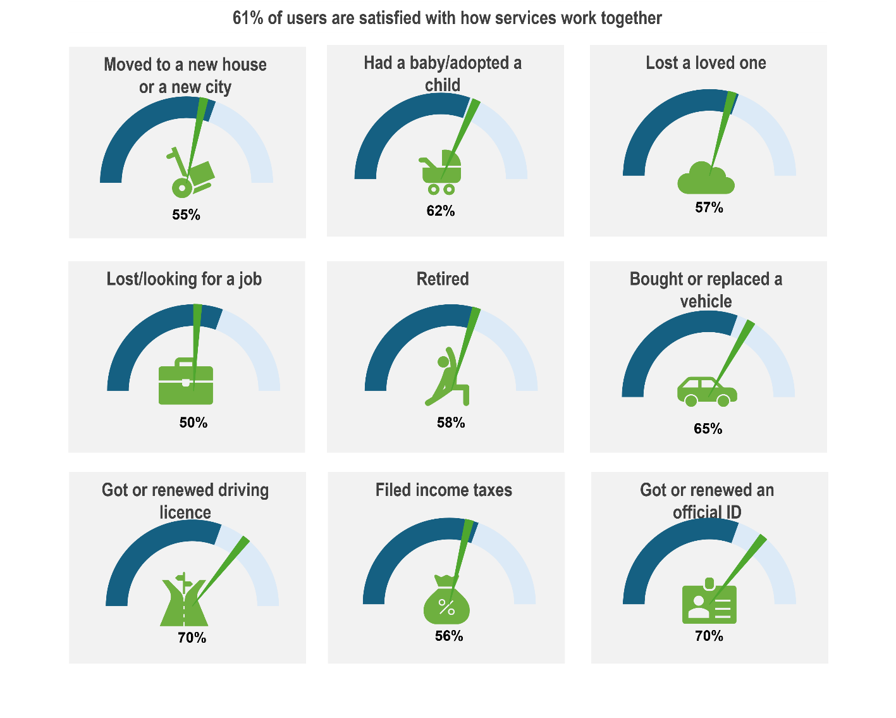
Note: The dark blue arch represents the average satisfaction level with this driver for users of all Life Events across the EU-10. The green pointer represents the satisfaction level of the user for this driver when experiencing the specific Life Event. The pointer position shows whether satisfaction for the specific Life Event is higher or lower than the overall average.
- When user’s needs are resolved with only one interaction, user satisfaction is 20 percentage points higher.

Country practices and lessons learnt
There is significant variation in how the 10 EU countries structure public service delivery across government levels, as revealed by the OECD Serving Citizens Survey (Figure 3.2). Highly centralised services like filing income taxes, pensions linked to retirement and vehicle registration are predominantly delivered at the central/federal level across most countries, while some services such as birth, marriage, death registration and business registration more commonly share responsibility between levels of government or are managed at local and state/regional levels.
Figure 3.2. Distribution of service responsibility across levels of government in the EU-10
Levels of government responsible for specific public services by country.
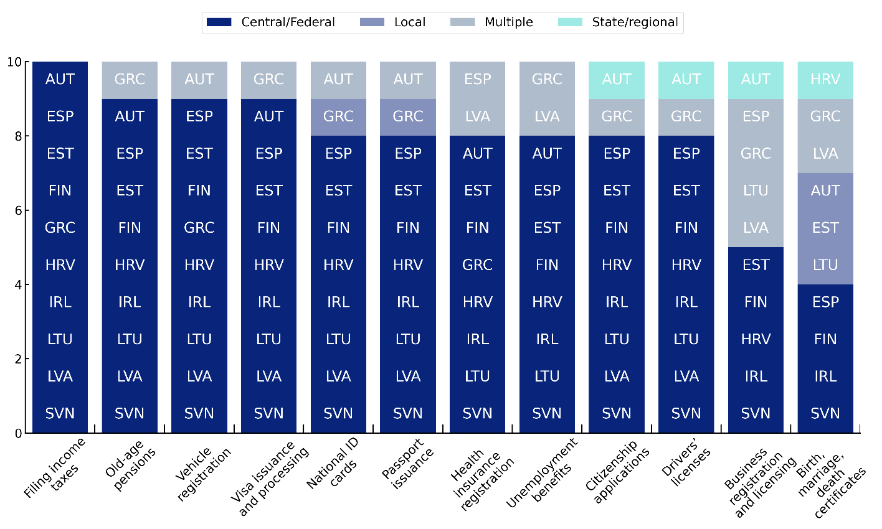
Note: Question asked was “Which level(s) of government are responsible for delivering the following commonly-used public administrative services?”
Source: (OECD, Forthcoming_{[17]}).
Another challenge is associated to limiting the number of interactions between users and the administration during one Life Event. When user’s needs are resolved with only one interaction, user satisfaction is 20 percentage points higher. On the contrary, satisfaction is below 50% when users need to contact more than 5 times the public services (
Figure 3.3). Improved co-ordination between services providers is essential in that regard to avoid unnecessary interactions and give precedence to exchange of information and files between public institutions.

Figure 3.3. When user’s needs are resolved with only one interaction, user satisfaction is 20 percentage points higher
Share of users who indicate different levels of satisfaction based on number of interactions with public services on a scale of 1-5.
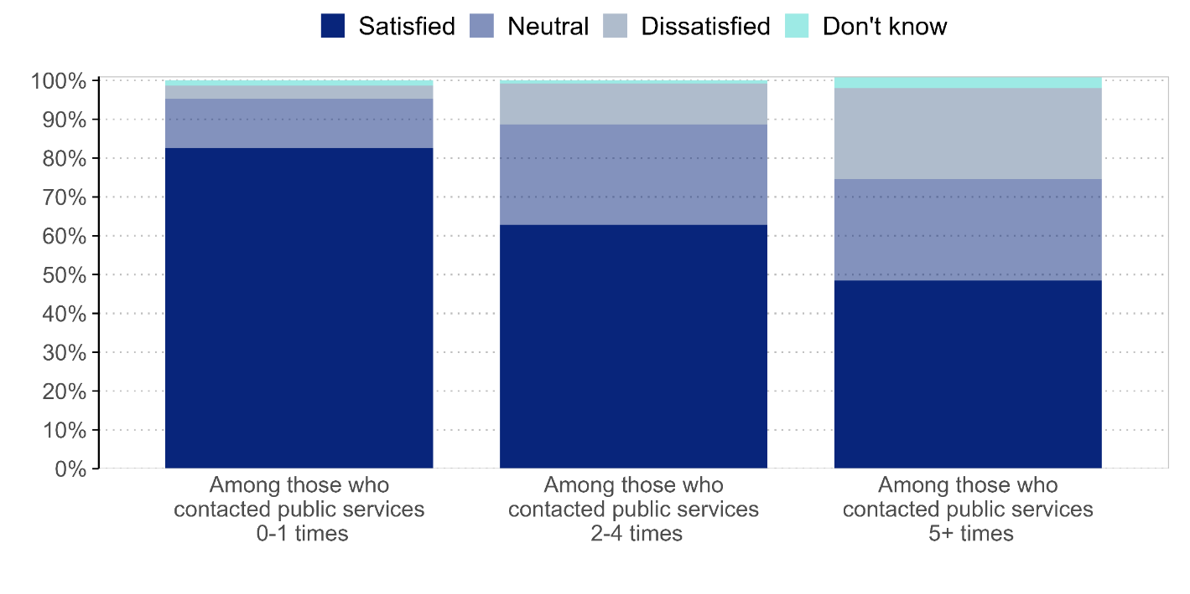
Source: (OECD, 2024_{[15]}).

Governance structures to support public service transformation
A public body or committee tasked with public service improvement can be crucial to foster alignment between different services and providers across government levels, hence ensuring services working together. Figure 3.4 shows that six countries have established such entities for service improvements.
Figure 3.4. 6 EU-10 countries leverage a body/committee for public service improvement
Existence of body/committee responsible for service improvement in the EU-10.
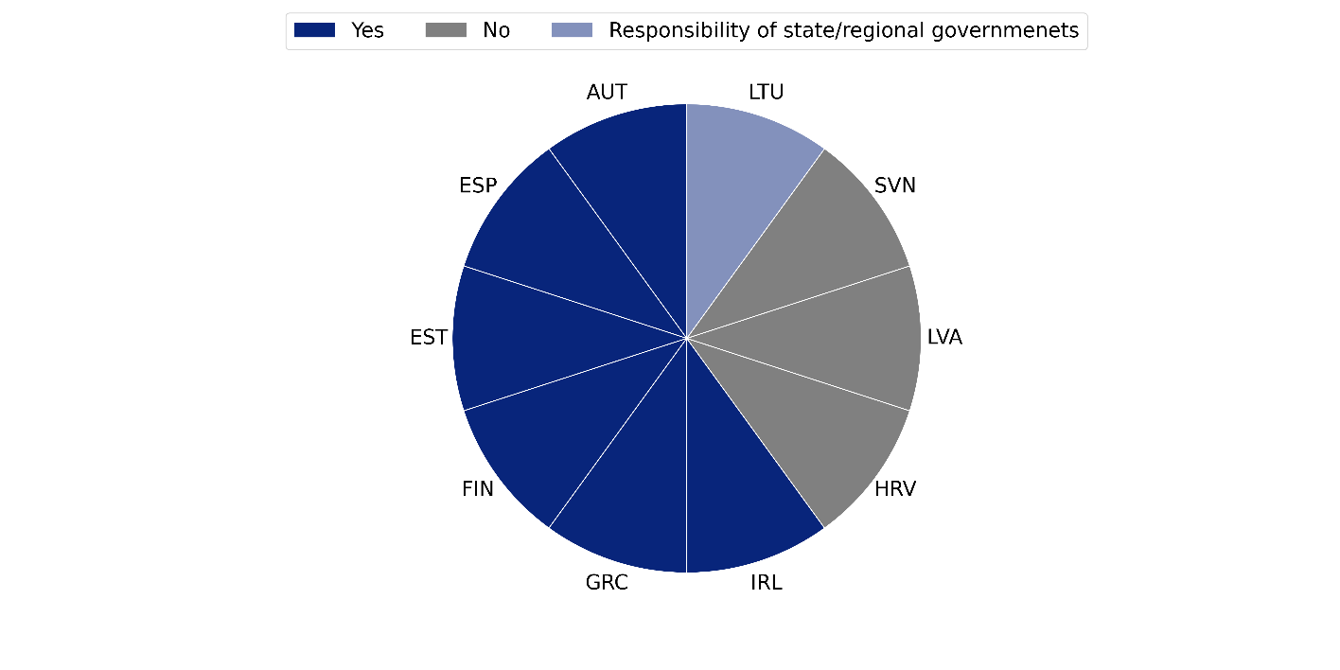
Note: Question asked was “Has a responsible body/committee been appointed to oversee improvement of public administrative services within the central/federal government?”.
Source: (OECD, Forthcoming_{[17]}).
The body/committee responsible for public service improvement varies in countries, both in relation to the actors involved as well as the responsibilities of the bodies/committees. For instance, in Austria, the Committee of the Federal Government, the Lander, Cities and Municipalities ensured cross-organisational cooperation in the e-government sector (Box 3.3).

Box 3.3. Austria - Committee of the Federal Government, the Länder, Cities and Municipalities
Austria’s Committee of the Federal Government, the Länder, Cities and Municipalities (BLSG) ensures cross-organisational, partnership-based co-operation in the e-government sector (Digital Austria, 2025_{[18]}). It works according to jointly defined structures and processes.
BLSG platform is the main coordination group for both strategic and operational aspects in relation to the Digital strategy, chaired by the Bundeskanzleramt (BKA), Austria’s centre of government organ, and gathering both federal and sub-national levels of government. Since public services improvement is part of this strategy, they are the ones overseeing this matter as well. The IKT-Bund is a subordinate body to the BLSG: Gremium Bund, Länder, Städte und Gemeinden (BLSG) und IKT-Bund - Digital Austria.
Finally, the digital section of the BKA, is the main coordination player in relation to Austria’s e-government strategy (Digital Austria). It is complemented by chief digital officers (CDOs) in each line ministry, convening on a quarterly basis in a CDO taskforce at the federal level, and tasked with the steering and implementation of the strategy.
Source: Data collected through TSI Country Mission to Austria, June 2025
An example of cross-cooperation can be seen in Austria through coordination of passport issuance. As a federal country, Austria must pay close attention to co-ordination across levels of government. The highest satisfaction in the country is with passport issuance, with around 64% satisfied. This is despite the fact that applications can only be done in person due to legal obligations: fingerprints must be taken but cannot be stored by government due to privacy concerns. Instead, users make an appointment at their municipality, which is in charge of passport issuance. Appointments are easily available, often without appointment. The applicant needs to be identified by the officer in charge, who oversees the formalities of the application. The municipality then manages the process of interaction with the passport office in central government for issue of the new passport. The main learning is that a simple front-end process, with an integrated back-office system across levels of government, results in high satisfaction.
Source: Data collected through TSI Country Mission in Austria, 2025; (Ministry of Smart Administration and Regional Development, 2025_{[19]}).
In Spain, a Departmental Services Inspectorate has been created to support cross-Ministerial/Agency cooperation for the development of public services (Box 3.4). A similar governance structure supporting cross-Departmental cooperation and alignment of priorities has been developed through the Public Service Leadership Board in Ireland (Box 3.5), while Latvia has set up one-stop-shops for state and municipal services (Box 3.6).
Box 3.4. Spain - Initiatives to enhance coordination of services through the Inspecciones Departmantales de Servicios
In Spain, the Inspecciones Departmantales de Servicios aims to ensure cross-Ministerial/Agency cooperation the oversee the improvement of public administrative services. The main responsibilities include: (i) leading the development of government-wide strategies for improvement public administrative services, (ii) enabling coordination between ministries/agencies delivering public services, (iii) proposing and initiating simplification of services that involve more than one ministry or agency, (iv) integrating services commonly used together during Life Events, (v) approving methodology or guidance for setting service standards, (vi) approving methodology or guidance for measuring citizen and business satisfaction with public administrative services, (vii) collecting and publishing information about performance and satisfaction with public administrative services, and (viii) monitoring the implementation of the government-wide strategy for improving public administrative services.
In addition to the above responsibilities, the Inspectorate organises Awards to recognise best practices in terms of quality management, excellence, innovation and human-centred services within the Public Sector.

Source: Data collected through TSI Country Mission in Spain, March 2025.

Box 3.5. Ireland - The Public Services Leadership Board
The Public Service Leadership Board (PSLB) is a high-level strategic body, established in 2018 in Ireland. The PSLB provides collective and collaborative leadership for public service reform and development. The PLSB includes Secretary General/CEO level participation drawn from the Civil Service Management Board (CSMB) and representation from a broad range of public service organisations. The PLSB is chaired by the Secretary General of the Department of Public Expenditure, Public Service Reform and Digitalisation.
The PSLB provides strategic leadership for public service transformation through Ireland’s Better Public Services Strategy. It aims to ensure alignment on share priorities at central government level and has implementation oversight, leading the implementation of priority national plans.

Source: Data collected through TSI Country Mission in Ireland, March 2025.

Box 3.6. Latvia - Co-ordination across government levels in to ensure seamless service delivery
In Latvia, public service provision is split between two government levels - state and local public entities. To promote service integration between different providers from the two government levels, the Ministry of Smart Administration and Regional Development in collaboration with local governments and the Latvian Association of Local and Regional Governments, has been developing a network of State and Local Government Unified Customer Service Centres. Such centres, established in municipal buildings like city/villages halls and public libraries, provide citizens with the most popular state and municipal services in one place. As of April 2025, there are 254 centres established in 35 (out of 43) Latvian municipalities, with the Ministry planning to open more centres in the upcoming years.
Source: Information obtained in country mission in June 2025 as part of this TSI.

Public Service Catalogues to support public administrations and provide information to users
To support the development of seamless services, the TSI Project has identified the value of developing an inventory or catalogue of public services in countries. A Public Service Catalogue can support users in identifying the services available (e.g. Estonia) (Box 3.14).

Box 3.7. Estonia - The Public Service Catalogue
A Service Catalogue has been developed in Estonia, available on www.eesti.ee. The Service Catalogue aggregates a selection of e-services and information sources related to the Services. The Service Catalogue is grouped by Areas of Service, with the Catalogue also listing all services available.
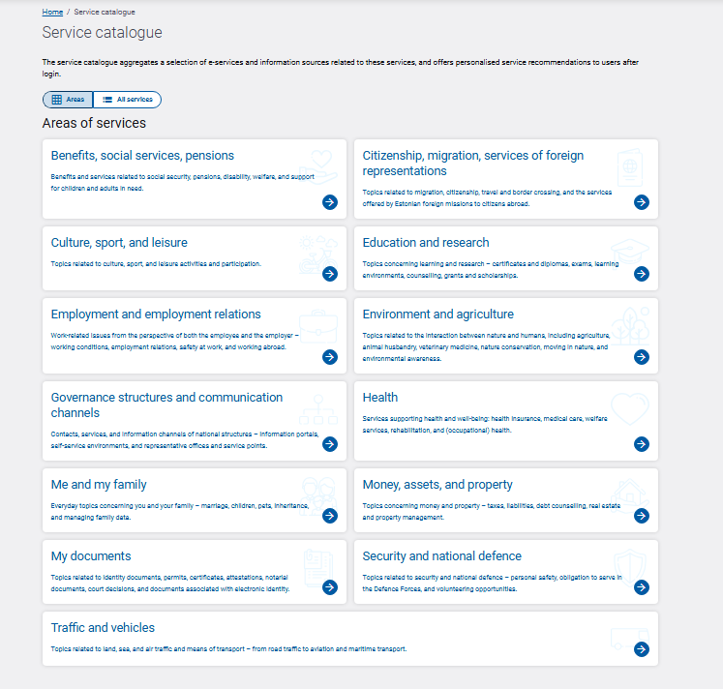
Source: Information obtained in country mission in June 2025 as part of this TSI.

Providing users with an overview of the catalogue of services available to them is also in place in Greece through the Mitos registry of procedures.
Box 3.8. Greece - Mitos Registry of Procedures
Greece’s Mitos Registry of Procedures is a central, authoritative catalogue of administrative procedures of the country. Bringing full transparency to what citizens and businesses need to do, which documents are required, and which authority is responsible, and the flow of procedural steps, it eliminates ambiguity and helps standardise processes, allowing citizens and businesses to proceed with clarity on their respective procedures. Mithos improves legal clarity and certainty, simplifies compliance and supports the simplification and digital transformation of procedures as well.
Good practices summary:
- Catalogue all administrative procedures in a single online registry.
- Describe each procedure clearly (steps, documents, timeframes, responsible authority).
- Identify redundancies and opportunities for simplification.
- Ensure transparency for users to know exactly what is required before applying.
- Provide a stable, authoritative base for legal and regulatory updates.
Source: Information obtained in country mission in June 2025 as part of this TSI.
Public Service Catalogues can also help map and organise services, as well as providing a full vision of the ‘as-is’ situation for the development of the Life Event approach. The development of a public service catalogue also enables central administrations to ensure a record is kept, and frequently maintained, of the public services delivered as well as identifying the responsible authorities in their delivery. Croatia is currently developing its Public Services Catalogue with a view to do so (Box 3.9).
Box 3.9. Croatia - Introduction of a Public Services Catalogue
In Croatia, work is ongoing for the development of a Catalogue of Public Services and Working Procedures. The aim of this Catalogue is to ensure that a comprehensive inventory of Public Services is available that will include the following information. The Catalogue will be developed with Public Service Owners across Croatia, including data on (i) the Groups of users (citizens and business entities), (ii) the names of the Public Service Owners and Managers, (iii) the legal basis for the public service, and (iv) the inclusion of the public service within a Life Event. The Catalogue will also include information on how the public service is delivered by identifying (i) the service provision channel, and (ii) the address and opening hours of physical access as well as other channels existing for accessing the service.
Moreover, the catalogue aims to collect data to support monitoring of performance of the public service including (i) the total financial cost to the user, (ii) the times the user had to visit the official counter, and (iii) the number of transactions/cases in the previous year.
Source: Information gathered through TSI Country Mission in Croatia, May 2025

Horizontal Public Service Transformation Funds
Internal public service transformation funds can incentivise public institutions and servants to pilot and test new ideas, to integrate innovation in service delivery and foster cross-entity collaboration for better public services. Such transformation funds can ensure cross-department/ministry cooperation through the funding of collaborative projects with common priorities.
Box 3.10. Ireland - The Public Services Innovation Fund
The Public Services Innovation Fund 2024 has been established in Ireland to support innovative projects across the public administration that aim to improve service delivery and advance digital transformation.
The Public Service Innovation Fund 2024 is the sixth iteration of the fund with total funding of €500,000. The new fund places a strong focus on cross-organisational digital transformation, to meet the vision for a digital Public Service. The Fund is aligned with Ireland’s Better Public Services Transformation Strategy.
Source: (Government of Ireland, 2023_{[20]}).

Fostering integrated services for users to provide information once
Integrated public services refer to the design and delivery of public services that are interconnected and co-ordinated. Integration enables services to be provided in a manner that is accessible to users through a unified experience.

Spotlight on results from the TSI Satisfaction Survey
Integrated Services
- The TSI Satisfaction Survey finds that user satisfaction is almost 30 percentage points higher, on average across the EU-10, when the user does not have the provide the same information more than once.
- The level of integration of services can vary in complexity depending on the Life Events. The TSI Satisfaction Survey finds that Life Events involving multiple public services had lower levels of users providing the information only once. For example, while over 70% of users across the EU-10 indicated providing the information only once when filing income taxes, just over 40% indicated providing information only once when experiencing more complex Life Events such as having a baby/adopting a child or losing a loved one.
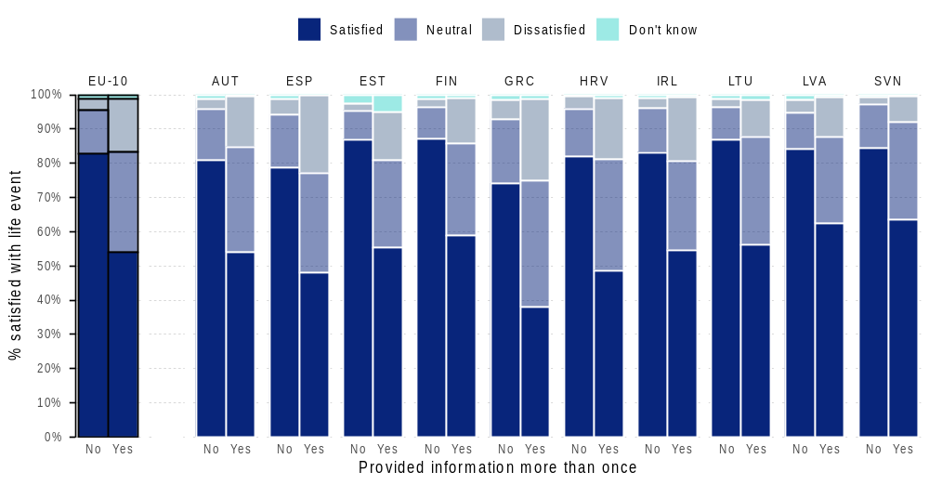
- The Satisfaction Survey also finds that users are more satisfied with Life Events that require fewer interactions. When user’s needs are resolved with only one interaction, satisfaction is twenty percentage points higher.

Country practices and lessons learnt

Once-Only Principle
A key measurement of integrated services is examining the application of the ‘Once-Only Principle’. The Once-Only Principle refers to the precept of not requesting users to supply the same information more than once to any service provider at any level or branch of government, enabled by interoperable data-sharing systems and other arrangements (e.g. user’s consent to the re-use of data). Applying the Once-Only Principle leads to administrations simplifying, streamlining and improving the experience of accessing and using services through the prevention of unnecessary administrative burden and complexity while maintaining administrative obligations and compliance requirements which are simple by default. While there are different levels of application of the Once-Only Principle across Life Events, satisfaction among users who did not have to submit the same information more than once was above 80% for all Life Events.
Some OECD countries have deployed specific Once-Only programmes to test and support their implementation across multiple services and administrations. France and the UK have for instance deployed such programmes. The UK has started to use the programme with specific Life Events, particularly for the Life Event ‘lost a loved one’ to help relieve the pain of providing multiple times information on the deceased.
In relation to TSI countries, efforts have been undertaken to further streamline the Once-Only Principle throughout service delivery. For instance, Austria has created a dedicated data sharing platform to support the implementation of the principle across the administration (Box 3.11).
Box 3.11. Austria – Once-Only Platform
Austria’s Once-Only Platform allows citizens and businesses to submit key data to public authorities just once, after which it is securely reused across services with full transparency and privacy safeguards. By eliminating repeated form-filling, reducing errors, and improving the speed and quality of public services, the platform demonstrates how well-designed data sharing frameworks can make government interactions simpler, more efficient and trustworthy.
Good practices summary:
- Collect core personal or business data at a single time from the user.
- Store and manage this information securely in registers.
- Reuse data across different administrative services when needed.
- Enable seamless data exchange, integrating multiple agencies’ systems.
- Ensure data sharing happens only with user consent and under strict privacy rules.
Source: Data collected through TSI Country Mission in Austria, 2025.
A key bottleneck in relation to the implementation of the ‘Once-only principle’ relates to the need to engage further with Data Protection Commissioners with a view to identifying the key legal bottlenecks to further streamlining the sharing of data across Ministries and Departments. By communicating with legal technical experts at the beginning of the design progress, countries can ensure the alignment of data infrastructure with data protection needs. Data sharing through strong data infrastructure that is interoperable is key for the implementation of the Once-Only Principle. For instance, in Estonia, the ‘X-Road’ data exchange layer is the core enabler for the application of the Once-Only Principle (Box 3.12)
Box 3.12. Estonia - Simplification via platform technology and digital integration (X road and Once-Only)
The X-Road national data exchange layer is the core enabler for “once-only”. It provides a secure, standardised way for databases and information systems to exchange data in Estonia.
From the citizen’s perspective, services are simplified thanks to pre-filled forms (fewer fields to complete), there are no requirements to understand the administrative geography (knowing which registry request data from), and predictability is improved (same log-in, layouts and notifications). Furthermore, by reusing existing components (digital ID, X-Road, authentication) instead of rebuilding, design teams in government can spend time simplifying the user side.
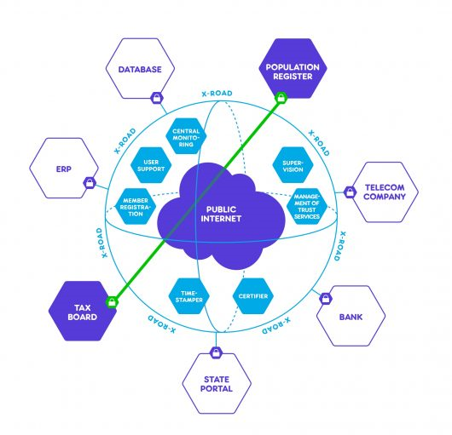
Estonia’s Digital Agenda 2030 and Digital Decade roadmap explicitly commit to common directions, interoperability requirements and reuse of common components to “avoid duplication” and keep services convenient and available everywhere.

Source: Data collected through TSI Country Mission to Estonia, October 2025.

Making user data and documentation available in one place
Integrated services also aim to support users in accessing and navigating information in one place. The use of multiple channels to progress with an application is also an important factor when thinking of the integration of public services. 51% of users across the EU-10 agreed that they did not have to use more than one channel to progress with their application, with 32% having to use more than one channel. A considerable variation in the use of multiple channels exists depending on the Life Event experienced (Figure 3.5). Life Events that require less interactions with administrations and that include less steps require less use of multiple channels. For example, 64% of users who filed income taxes only used one channel to progress with their application, with 59% of users who got or renewed their official ID document also only using one channel. Where Life Events are considerably more ‘complex’ due to the multiplicity of services and providers, users had to use multiple channels to progress with their application. Only 32% of users who lost a loved one and 35% of users who lost/looked for a job had to use only one channel to progress.
Figure 3.5. A variation exists in the need to use more than one channel to progress with an application, depending on the Life Event
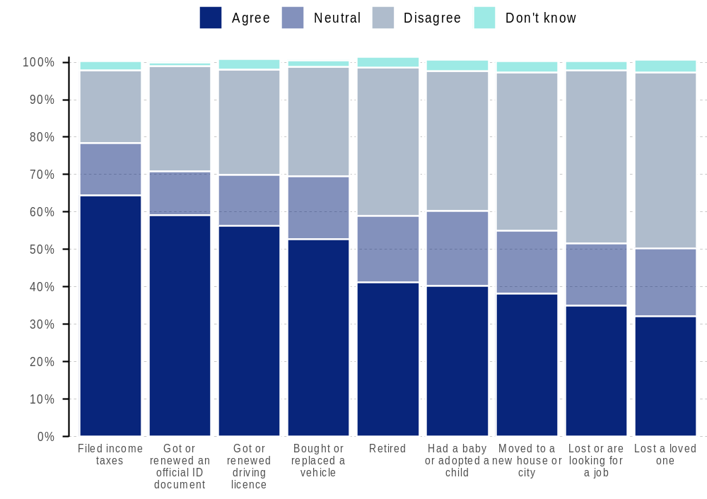
Note: Question: I did not have to use more than one channel to progress with my application
Source: TSI Satisfaction Survey, 2024
By removing the back-office interaction between different services providers, users perceive also a further integration of services. 56% of users on average across the EU-10 did not have to contact different public service(s) to progress with their application, with 26% having to contact multiple services. Similarly to the use of more than one channel to progress with the user’s application, a variation exists in relation to the Life Events experienced. While 70% of users who got or renewed an official ID and 69% of users had to contact one public service to progress with their application, the situation for users experiencing Life Events with several services is quite different. Only 31% of users who lost a loved one and 40% of users who had a baby contacted one public service to progress with their application.
Figure 3.6. Contacting different public services to progress with a user’s application varies across Life Events
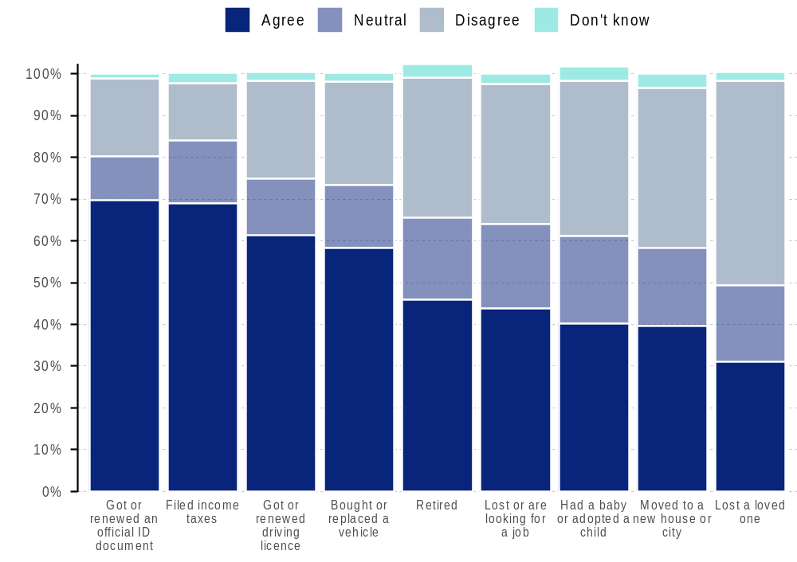
Note: Question: I did not have to contact different public service(s) to progress with my application
Source: TSI Satisfaction Survey 2024
To support users in not having to contact different public services to receive their data, Spain has developed a personalized digital dashboard allowing citizens to access their official records and ongoing administrative procedures in one place (Box 3.13).
Box 3.13. Spain - Development of one single portal for citizen’s official data
Mi Carpeta Ciudadana is Spain’s personalized digital dashboard that allows individuals to access their official records, documents, notifications and ongoing administrative procedures in one unified space. It centralizes information that was previously scattered across different platforms, improves transparency and gives citizens easy, mobile-friendly control over their interactions with the public administration. By integrating data from different levels of government, it delivers seamless and user-centric digital experience.
Good practices summary:
- Aggregate a citizen’s official data, documents and certificates in one portal.
- Display active procedures, deadlines and pending actions in real time.
- Allow users to download official documents without e-requesting them.
- Show notifications and messages from different public bodies in one inbox.
- Provide a mobile app for quick access and identification verification (using Clave).
Source: Data gathered through TSI Mission in Spain in March 2025.
For businesses, Latvia’s Register of Enterprises provides fast, reliable and transparent access to company data (Box 3.14)
Box 3.14. Latvia - Register of Enterprises
Latvia’s digital Register of Enterprises platform is a central, authoritative registry containing verified information about all legal entities operating in the country. It provides fast, reliable, and transparent access to company data, supports fully digital registration and filing processes, and enables seamless data reuse across public services. By acting as a trusted, interoperable source of business information, the registry strengthens legal certainty, reduces administrative burdens, and improve the overall ease of doing business.
Good practices summary:
- Store authoritative, up-to-date data on all registered legal entities.
- Provide a searchable database for verifying a company’s status and details.
- Enable digital submission of incorporation documents and changes.
- Offer electronic access to historical records, filing and official extracts.
- Integrate with tax, licensing, and procurement systems for automatic data exchange.
- Ensure data accuracy through validation and structured digital formats.
- Support transparency and trust by providing reliable, legally recognized information.
Source: Information obtained in country mission in June 2025 as part of this TSI.

The development of seamless services has been identified as a challenge in many countries, particularly in relation to more ‘complex’ Life Events such as ‘losing a loved one’. In-depth analysis of countries’ implementation of this Life Event was undertaken through the TSI Country Missions in Estonia (Box 3.15), Spain (Box 3.16) and Finland (Box 3.17). Challenges particularly arise due to the multiplicity of actors involved in providing services associated with the loss of a loved one, with these actors in some instances being both public and private in nature. Moreover, the existence of actors at central and local levels of government creates complexities in relation to the interconnection of information. Each country has undertaken different actions to address some of these challenges.

Box 3.15. Estonia - Losing a Loved One
When losing a loved one in Estonia, no unified overview of all activities that needed to be completed by the deceased’s next of kin was available. Since Service Providers did not have a uniform process for providing the user with the information necessary for the Life Event and for directing them from one service to another, the user did not have clear information about the process to be undertaken.
Public Services that need to be accessed in Estonia when losing a loved one include the organisation of burials and the application to receive a funeral allowance, inheritance processes such as the transfer of real estate. The public services are distributed between central and local government, with variations in services and benefits (e.g. funeral allowance) depending on the residence of the deceased.
To address the challenges faced by users who lost a loved one, a Life Event approach was developed in Estonia which focussed on the grouping of all necessary information for the user on eesti.ee. A ‘to-be’ vision was defined in 2022 which aims to develop a future state to simplify the process and reduce the workload for all service providers and users. This includes the preparation of an information service to organise the wishes and encourage discussion between the deceased and relatives, the centralisation and personalisation of all relevant service information and the digitalisation of the death certificate. The current state of play includes the grouping of information on eesti.ee to outline to the user all steps associated with the death of a loved one including learning about death and a burial and succession and contracts.
Source: Information gathered through TSI Mission to Estonia, October 2025.

Box 3.16. Spain - Losing a Loved One
The loss of a loved one in Spain involves many different public services. Following the issuance of a medical certificate following the death of an individual, numerous actions need to be taken by the deceased’s next of kin including organizing the administration of the funeral arrangements including burial and the access to legal and inheritance services including the Last Will of the deceased. In addition, several administrative procedures may need to be taken in relation to inheritance tax and property transfer.
The public administrative services that need to be accessed by the deceased’s next of kin in Spain include services provided by the Ministry of Justice through the Civil Registry, services at municipal level (such as the transfer of property, the payment of tax on property) as well as notarial services (through the application of the last Will and Testament). Currently, each of the public administrative services are not interconnected, with the deceased’s next of kin having to complete several different steps to finalise the deceased’s estate.
While an interconnection has not occurred between all public services, efforts have been made, however, in Spain to integrate a fully digitalised Civil Registry with Spain’s notarial system. Spain’s Ministry of the Presidency, Justice and Relations with Parliament has fully digitized the Central Civil Registry Office, which now operates with the new DICIREG electronic system. This modernization enables faster, paper-free processing through electronic files, digital signatures, and a unified database, improving both complex registrations—such as those involving foreign judicial or extrajudicial documents—and routine procedures like certifications or nationality applications. The system is interoperable with all Civil Registry Offices in Spain and abroad, and it is also being integrated with the notarial system, allowing notaries to directly submit and verify registry information through secure digital channels.
This digital transformation reduces delays, eliminates duplications, and enables automatic issuance of digitally sealed certificates, while providing the Ministry with real-time data to improve service management. Overall, it represents a structural shift toward a faster, more efficient, and fully coordinated civil registration service that benefits citizens, including those residing outside Spain.
In relation to Wills, the Registro General de Actos de Última Voluntad (Central Registry of Wills) records all last Wills and Testaments certified by Notaries. This Registry enables all notaries to access the will of the deceased, ensuring an interconnection of information across Notaries.
Source: Information collected through TSI Country Mission to Spain, March 2025.

Box 3.17. Finland – Losing a loved one
Losing a loved one is one of the most emotionally challenging and administratively complex Life Events in Finland. Beneficiaries of the deceased are required to complete a wide range of administrative tasks, contacting multiple authorities and organisations to gather the information needed to form the death estate. This typically includes the time-consuming task of requesting family relationship reports from the Digital and Population Data Services Agency or local parishes. Additionally, the beneficiaries have to collect information on assets and liabilities from banks and insurance companies and to manage separate authorisation processes to act on behalf of the estate. These documents are then used to create the deed of estate, which must be submitted to the Tax Administration for inheritance taxation. Most of these processes are still paper based, with scanned documents sent through one-way communication channels. Because of this administrative burden, losing a loved one consistently shows lower satisfaction levels than other Life Events in Finland, and is therefore a priority area for digitalisation.
Finland’s planned reforms for 2027 aim to significantly reduce the administrative burden on citizens. A new Digital Register for Estate Shareholders, integrated with MyTax, will allow beneficiaries to access a single service where they can view prefilled information on estate assets, create the deed of estate and inheritance tax return digitally, update register information, share documents with all beneficiaries, and receive step-by-step guidance. Data will flow automatically between the Tax Administration, the Digital and Population Data Services Agency, churches, and financial institutions, enabling more streamlined and eventually more automated processes.
Source: Information gathered through TSI Country Mission to Finland, May 2025

Tools for supporting the delivery of clear, seamless and integrated public services
Several tools have been identified that can support countries in supporting the navigation of services, ensuring that services are (i) clear (ii) seamless and (iii) integrated.
Figure 3.7. Tools for Navigating Services
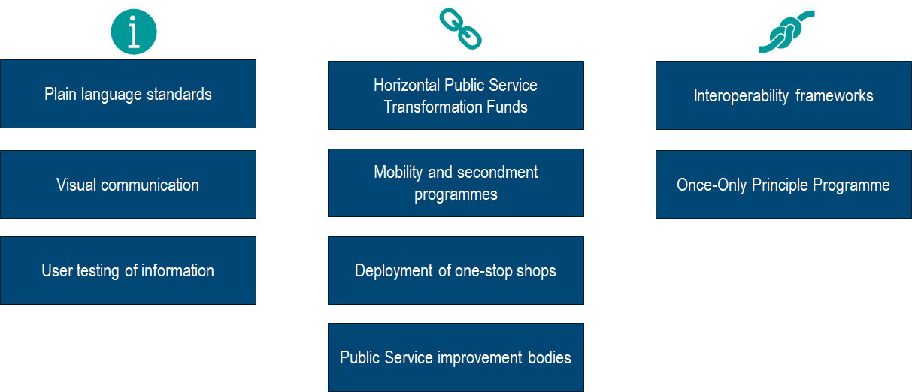
Source: Author illustration.
The description of these tools and the types of actions that can be undertaken are presented in the Table below.
Table 3.1. Tools for Navigating Public Services
Tool | Description | Types of Actions
Life Event Approaches across government | Building a life event approach for the country, starting with setting the list of life events, helps frame the country’s methodology and steps towards rolling it out. Disseminating, clarifying and explaining information on Life Event Approaches can be a powerful tool to foster a better understanding and uptake of this approach across public administration. | - Development of the life event approach and toolbox in the country (from defining the list of life events to mapping user experiences on life events and implementing specific actions)  - Life Event prototyping  - Prioritisation tools on life events (surveys, data analysis)  - Dedicated and accessible internal webpages with information, methodology and tools for the adoption and improvement of Life Event Approaches  - Communication on life events - Events, conferences and exchanges on Life Event Approaches across administration
Plain language standards | Simple language in service delivery can foster a better understanding of service objectives and requirements among users. It ensures all users, regardless of their individual characteristics, can access and effectively navigate through service processes. | - Development of plain language standards and guidelines for the entire public administration  - Redesign of service delivery with language simplification in mind  - Creation of dedicated webpages on services in streamlined language  - Provision of dedicated glossary webpages and materials for users
Visual communication | Visual materials such as images, simple graphs and diagrams support the written text, making it easier for users to quickly grasp the service and its processes. | - Integration of step-by-step progress diagrams to service communication  - Development of infographics and explainer videos  - Collaboration and co-creation of a service presentation with artists and communication specialists
User-testing of information | User-testing of information allows for running the prepared texts through potential service users before this information and support materials are available to the broader public | - User testing of digital platforms  - User testing of leaflets, posters and other physical communication materials  - Focus groups for testing different ways of communicating information
Horizontal public service transformation funds | Internal public service transformation funds can incentivise public institutions and servants to pilot and test new ideas, to integrate innovation in service delivery and foster cross-entity collaboration for better public services. | - Definition of objectives and scope of transformation funds  - Establishment of processes and support entities/units to allocate the funds  - Collaboration with innovators from various fields, including academia and private sector  - Monitoring and evaluation of the use of funds and their impacts
Mobility and secondment programmes | Enhancing staff exchange between ministries and public agencies fosters the critical exchange of knowledge, experience and contacts regarding service design and delivery. This process enables more informed decision-making and strengthens inter-agency collaboration. It helps see constraints and possible improvements in processes and in exchanges between organisations. | - Bilateral/Multilateral agreements between two or more ministries/public agencies about the practice of secondment /mobility  - Publication of mobility offers on civil service recruitment (internal) website
Deployment of one-stop shops | One-stop-shops ensure service delivery that integrates services from various providers across different entities and levels of government. This in turn allows users to receive various services in one place, irrespective of jurisdictional responsibilities, hence saving time and resources. | - Strategy development for a unified and coherent one-stop-shops system within a country  - Performance data use to adjust the quality and selection of services provided in one-stop-shops
Public service improvement bodies | Public entities with clear mandate over public services and their improvement are of great use when it comes to aligning services from different provides across government levels. It helps coordinate and promote efforts across the entire administration and align on the newly agreed principles. | - Establishment of such a body and its responsibilities and scope through strategic documents (e.g., law, decree, public service improvement strategy, or other)  - Creation of ‘champions’ for public services falling under a Life Event across multiple ministries/agencies
Interoperability frameworks | Interoperability frameworks in service delivery foster data exchange that is both efficient for different service providers and seamless for users. | - Definition of institutional responsibilities over interoperability frameworks  - Formalisation of data sharing agreements with clear conditions and responsibilities across service providers  - Reinforcement of data standards
Once-only principle programme | Establishing a once-only principle programme in the entity in charge of public service improvements can help develop the approach and test it in several services, before disseminating it. | - Build a horizontal capacity in the administration to define and supervise the deployment of the once only principle across the administration  - Identify through user feedback which programmes require the most data requests  - Select procedures/life events as pilots.  - Deploy the programme and principle across all services.  - Work on data exchange and interoperability to minimize new data requests from the administration; reassess when the data is absolutely needed.
Source: Author illustration.

Achieving results
The final stage of the user journey is achieving the desired results. This means users have already accessed and navigated public services and their journey has led them to obtain what they were seeking. The conducted TSI Satisfaction Survey has clearly shown that user satisfaction increases when users achieve their desired outcomes in a (i) simple, (ii) fast and (iii) fair manner. This part of the Guidance note focuses on these three elements of the last user journey stage.

Simple services
Achieving results in a simple manner refers to how easy it is to obtain a service. Some services require longer and more complex procedures before users reach their desired result while others involve simpler and more straightforward steps users can follow to obtain what they need. It should also be acknowledged that some Life Events are more complex by nature as they involve multiple players and procedures, for instance ‘losing a loved one’ as it requires interactions with services providing identity, social security, tax and other services.

Spotlight on results from the TSI Satisfaction Survey
Simple Services
- 71% of users in the EU-10 reported satisfaction with the ease of obtaining the service. Life Events that are more ‘common’ for users have a higher level of satisfaction. For example, users who experienced the Life Event ‘I got or renewed an official ID’ reported 79% satisfaction in relation to the ease of obtaining the service across the EU-10. 78% of users who got or renewed a vehicle and 75% of users who bought or replaced a vehicle were satisfied with the ease of obtaining the service. However, an almost ten percentage point difference can be observed in satisfaction in relation to the Life Event ‘I lost/looked for a job’, with 62% of users satisfied with the ease of obtaining the service.
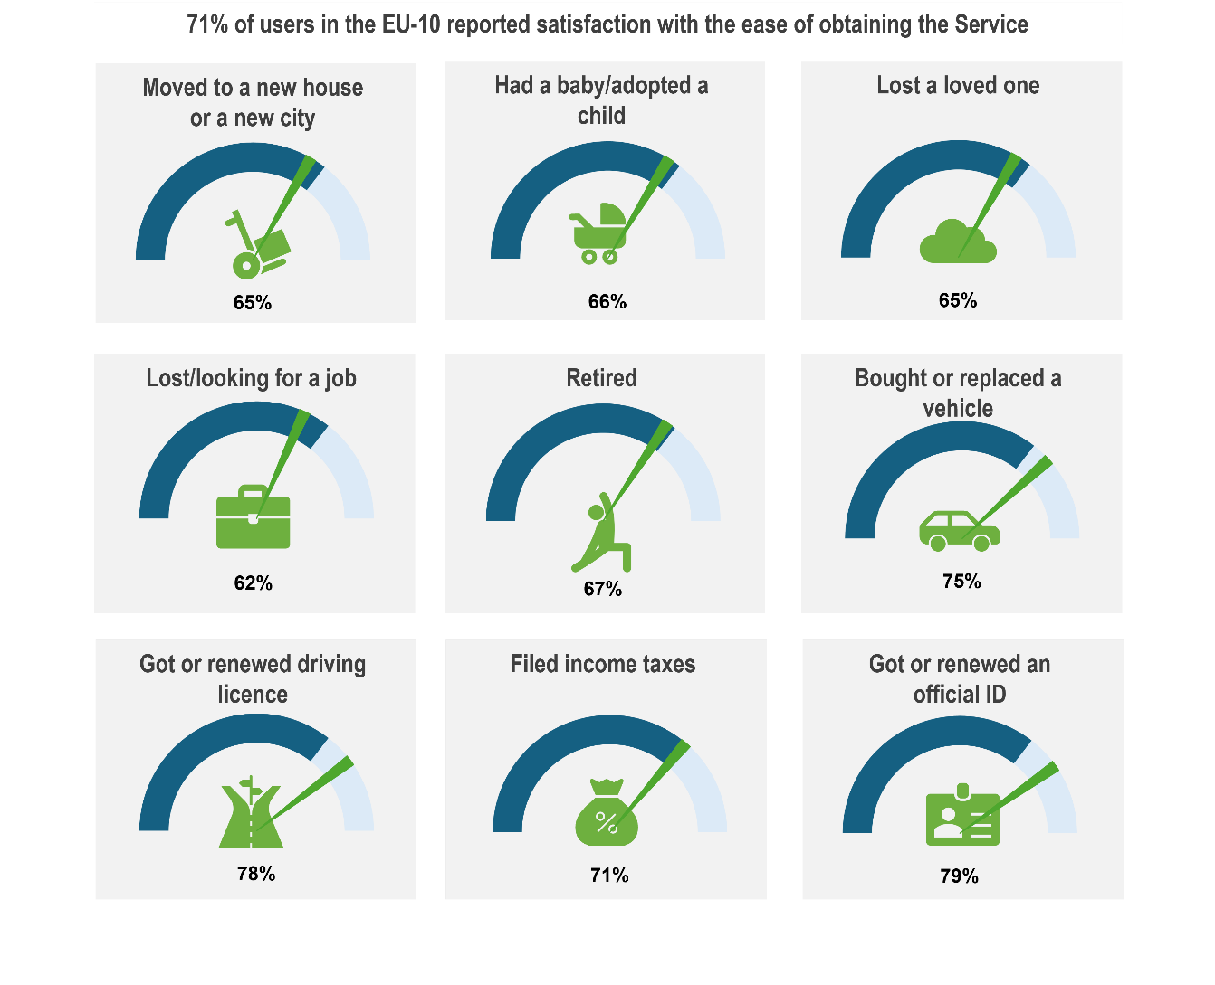
Note: The dark blue arch represents the average satisfaction level with this driver for user sof all Life Events across the EU-10. The green pointer represents the satisfaction level of the user for this driver when experiencing the specific Life Event. The pointer position shows whether satisfaction for the specific Life Event is higher or lower than the overall average.
- Younger users tend to be less satisfied with the ease of obtaining services. Satisfaction with this driver is, on average, eight percentage points lower among users aged 18-29 years of age compared to respondents older than 50. This difference is particularly evidence in Greece, Ireland, Latvia, Slovenia and Spain.

Country practices and lessons learned
A public service is simple when:
- The process consists of a limited number of steps and concepts, and the user can access the service (including the related information) by completing a small number of actions or decisions.
- There is a low information burden attached to the service, i.e., there is minimal data entry required, users are not required to “document-hunt”, questions are not repeated (“once-only” data entry is enabled).
- There is low procedural “noise”, i.e., the service and access process does not embed many exceptions, too many forms, layers of information gathering, or cross-channel processes.
When services are simplified—through clearer rules, fewer steps, interoperable systems, and once-only data use—they become clearer, simpler, and faster, reducing both cognitive and procedural burdens for users. For example, when a family has a baby, a single digital service can register the birth, trigger child-benefit eligibility, and notify the local health authority—without the parents re-entering information multiple times. For students, a unified ‘becoming a student’ service can link admission confirmation to housing, social insurance, and tax registration. These end-to-end journeys turn fragmented bureaucratic steps into one coherent, supportive user experiences.
Reduced complexity and burden for administrators—by streamlining workflows, revising information obligations and data collection, harmonising data systems, and cutting redundant validation—enables integration and seamlessness across life-event services, ensuring that users experience government as one coordinated system rather than multiple disconnected agencies. For example, Greece’s National Registry of Administrative Procedures and Portugal’s ePortugal portal demonstrate how simplifying and mapping processes across ministries creates a single authoritative knowledge base for both officials and users. Furthermore, risk-based service design (Box 4.1) can reduce unnecessary user effort by removing redundant checks for trusted or low-risk users, enhancing convenience and supporting user-centred design interactions.
At the same time, risk-based approaches help maintain fairness, which preserves confidence among the public that simplification does not mean laxity or favouritism. For example, when registering a death, the system can auto-notify linked services (pensions, health insurance) once validated by the civil registry—avoiding extra paperwork but maintaining safeguards.
Simplification has been a key objective for many EU Member States over the previous decades, which has led to multiple initiatives to reduce red tape, cut administrative burden and eliminate regulations or unnecessary procedure and requirements (OECD, 2025_{[21]}). For instance, Spain has implemented a large simplification programme that also tackled services and provided citizens with personalized digital dashboard to track their own procedures and access their information (Box 4.2).

Box 4.1. Applying risk-based approaches for simplification
Applying risk-based approaches is central to the idea of simplification. By ensuring design choices are shaped by risk assessment, and the associated obligations and requirements placed on users (and administrators) are kept proportionate to the level of risk, users will experience a simpler, less complex service environment overall. Detailed risk assessment also enables users to be better understood and targeted, leading to more appropriate, tailored service design, which users are likely to experience as a more straightforward and sensible service that meets their needs (OECD, 2018_{[22]}).
In the regulatory environment, “risk-based” delivery means that the implementation of regulatory processes – the design and operation of monitoring, compliance and enforcement mechanisms – are proportionate to the potential risks rather than uniformly applied, considering various types of risks (e.g., consumer harm, human errors, misuse, etc.). Essentially, taking a risk-based approach entails a shift to a more agile framework and a focus on outcome-based proportionality – verify more where the stakes are higher, and simplify where the risks are lower. This approach has long been the standard in regulatory enforcement and applying the same logic to public service design can deliver targeted, fair and efficient outcomes.
Following this logic, when simplifying and reducing complexity associated with service delivery, designers should avoid removing procedures indiscriminately. Burden-reducing design choices (e.g., automated renewals, pre-filled forms, self-declaration) should be used for low-risk and routine cases. However, procedures that deliver greater accountability and oversight, with an increased level of complexity and administrative burden, would be appropriate for high-risk, high-impact transactions. Most importantly, the principle of proportionality should always apply, and the suitability and impact of delivery arrangements should be regularly assessed.
Examples of applying risk-based principles to public service design and delivery
 | Application of risk-based principles | Examples
Policy and rule design | Differentiate procedures according to risk, cost, and value of error. Avoid “one-size-fits-all” compliance steps. | Basic student grants could be automatically awarded based on verified income data; only unusual or incomplete cases trigger manual review.
Process design and workflow | Use data-driven risk scoring to allocate effort: automate low-risk transactions, escalate high-risk ones. | In birth registration or passport renewals, cross-check digital identity and registry data automatically; manual verification only for anomalies.
User interaction | Tailor documentation and prompts based on profile and history. | Businesses with strong compliance history may face lighter reporting; new entities or those flagged for risk may provide more evidence.
Back-office management | Prioritise staff time for areas with higher risk or public interest. | Caseworkers focus on appeals or exceptions rather than repetitive low-risk renewals.
Continuous improvement | Analyse transaction data to refine risk models and simplify further where justified. | Machine learning tools (as piloted in Italy’s inspection systems) predict non-compliance risk, freeing resources for user support and service improvement.

Whilst OECD guidance (OECD, 2025_{[23]}) stresses that risk-based targeting and data sharing are not just technical tools but enablers of responsive, user-centered governance, there are still several technical pre-requisites and implementation challenges to consider. Integrating risk-based delivery into the phases of service design and delivery involves:
- Data integration and analytics to assess probability of error or misuse.
- Transparent criteria for risk assessment to preserve fairness and accountability.
- Legal frameworks that permit proportionate verification and data sharing.
- Ethical safeguards to prevent algorithmic bias or discrimination.
- Skilled administrators capable of interpreting and refining automated decisions.
Related to the above implementation challenges, there are several risks or pitfalls associated with risk-based service design that need to be anticipated and managed, such as an over-reliance on opaque algorithms or poor data quality, which can reduce fairness, and a lack of transparency, which may undermine legitimacy. Furthermore, inconsistent application across government departments and delivery agencies can confuse users. Finally, care needs to be taken around the allocation and of burden and the creation of ‘cliff-edges’ rather than reasoned proportionality - if all burdens are shifted to the “high-risk” group without explanation, perceptions of bias may grow.

Box 4.2. Spain - Simplification initiatives
Spain’s SimplexESP initiative is a government-wide ongoing programme which aims at simplifying administrative procedures and making interactions with the public more agile and user-centred. Inspired by the Portuguese Simplex initiative, the platform seeks to allow for feedback and higher visibility, identifying burdensome processes, redesign them with a focus on zero bureaucracy and to deliver quick and visible improvement for citizens. By using co-design, regulatory streamlining, the Spanish SimplexESP seeks to show how coordinated simplification can raise service quality and reduce administrative burden.
Good practices summary:
- Review and eliminate unnecessary administrative steps across agencies.
- Coordinate multiple stakeholders around shared simplification goals.
- Use user-feedback and co-design to identify pain points in services.
- Use iterative testing with diverse groups, especially those with amplified needs.
Source: Data gathered through TSI Mission in Spain in March 2025.
Slovenia has developed a platform and initiative ‘Stop Bureaucracy’ in a nationwide effort to encourage simplification across all sectors (Box 4.3).
Box 4.3. Slovenia - ‘Stop Bureaucracy’ Portal
Slovenia’s Stop Bureaucracy portal is a public platform that allows citizens and businesses to report administrative burdens, submit proposals for simplification, and track the government’s response. It institutionalises users’ feedback, strengthens accountability, and turns citizens into active contributors to administrative reform. By making simplification transparent and participatory, the portal promotes trust and continuous improvement in public services.
Good practices summary:
- Collect citizen and business proposals to simplify administrative procedures.
- Provide tools to report unnecessary requirements or bureaucratic obstacles.
- Promote a culture of continuous administrative improvement.
- Serve as collaboration channel between government and users.
Source: Data gathered through TSI Mission in Slovenia in June 2025.

More specifically on services, countries in the TSI Project have been using a wide range of practices and instruments to work on simplifying services and procedures. For instance, Estonia has aimed to embed the principle of simplification into public service design and used it to simplify multiple services (Box 4.4). Ireland has leveraged its Life Event approach to simplify services (Box 4.5). Lithuania has applied to a specific Life Event and services around tax (Box 4.6).

Box 4.4. Estonia - Learning from Estonia’s strategy to embed simplicity in public service design
Estonia simplifies services by designing them to require as few actions as possible from citizens, supported by deep back-office integration. The once-only principle and X-Road data exchange mean users rarely re-enter information; most forms arrive pre-filled. A single state portal (www.eesti.ee) provides one consistent entry point, reducing channel and navigation noise. Estonia also organises services by life events (Having a baby, Death of a relative) rather than by ministry, meaning citizens see a small, logical set of steps rather than multiple institutional processes. Proactive services, like automatic family benefits after birth registration, eliminate entire transactions.
Further examples of simplified services include: tax returns, which are typically completed in minutes because income data is pre-populated by employers and banks; childbirth services, where birth registration triggers pre-offers of benefits and parents are required only to confirm; business creation, which is an online single-step registration leveraging shared registries; and driving license renewal, which is based on a pre-filled application, standardised across agencies and fully digitalised.
The key tools underpinning Estonia’s simple services agenda include X-Road, Digital ID / e-Signature, life-event service design, design systems and common components (to avoid interface reinvention), and the RIHA (registry of information systems).
Source: Data collected through TSI Country Mission to Estonia, October 2025.

Box 4.5. Ireland - Shift to Life Events for simple services
Ireland’s 2030 strategy and plans for digital public services
Ireland is embarking on a transformation of its public services and simplification – making services easier to use, removing unnecessary frictions, and reducing repeated information requests – is a key element. The Better Public Services 2030 strategy commits to delivering digitally enabled, joined up and streamlined services, whilst the Digital Public Services Plan 2030, setting out a whole-of-government roadmap to deliver 100% online accessibility of key public services and ensure that 90% of applicable services are consumed online by 2030, provides the operational roadmap.
The Plan represents one of the most ambitious public service transformation programmes undertaken by the State and is a flagship initiative of Better Public Services. It aims to redesign how people interact with government, making services simpler, proactive, human-centred and fully integrated across life events, embodying the shift towards human-centred, data-driven and integrated public administration, with the ambition that by 2030, Ireland’s digital public services are not only available online but genuinely usable, trusted and designed around people’s needs.
Ireland’s shift to a life-events approach is a core simplification tool. At the core of the Plan is the Life Events approach with a phased delivery model across 17 life events and 189 services, with major redesign cycles occurring every 18 months through 2026, 2027 and 2028. Integrating agency services around life-events will reduce duplication, information requests and the overall number of steps in the user journey. Early prototyping demonstrates the benefits of automated data sharing, consolidated applications and single user portals.
At the same time, Ireland’s Action Plan for Designing Better Public Services aims to strengthen the simplification toolkit by embedding design mindsets, co-design, prototyping, and user journey mapping across the public service. Alongside this service design capability building, the 2030 agenda promotes digital-first, omni-channel delivery (centred on MyGovID, Digital Wallet and a Life Events Portal), and once-only data principles (integrated back-office data flows), and continuous improvement cycles.
Good practices summary:
- Adopt a life-events architecture beginning with the highest-volume events, map user journeys across agencies, design one integrated front door for each.
- Create central design and digital building blocks (digital ID, common form components, data standards, event-triggered notifications).
- Invest early in simplification through service design, use co-design, discovery research and prototyping.
- Prioritise back-office integration before scaling digital front-end.
- Use iterative delivery cycles to continually simplify and refine.
- Make simplification a governance priority with accountability and cross-agency working groups.
Source: Data collected through TSI Country Mission to Ireland, March 2025; (Government of Ireland, 2025_{[24]}).

Box 4.6. Lithuania - State Tax Inspectorate and its innovative e-services and digital transformation strategy
Lithuania’s State Tax Inspectorate (VMI) has developed a structured approach to designing public services, as its methodology puts the emphasis on understanding taxpayers’ needs, simplifying interactions, and developing digital tools that are proactive, intuitive and easy to use. The approach reduces administrative burdens, increases compliance through clarity and ensures that services are built around real user journeys. By continuously testing, measuring and improving service experiences, the institution has become a leader in citizen-focused service delivery in the country.
Good practices summary:
- Conduct research to understand taxpayer behaviors, pain points and needs.
- Use service-design techniques, such as user-journey mappings and co-creation exercises (target groups).
- Simplify language, forms, processes to make tax obligations easier to understand. Develop digital services with intuitive interfaces and step-by-step guidance.
- Strengthen communication channels, such as the call centre, which provides assured advice to citizens.
- Apply pro-active service principles (reminders).
- Test new services before rolling them out.
- Continuously monitor feedback and performance indicators to improve service quality.
Source: Data collected through TSI Country Mission to Lithuania, October 2025.

Obtaining services with speed
Users are more satisfied if they get the results they need fast. While the speed of obtaining the service usually varies depending on the complexity of a service, individual situations and government institutions involved, users expect the delivery and achievement of the desired results that are fast and with no further delays.

Spotlight on results from the TSI Satisfaction Survey
Fast Services
- 68% of users in the EU-10 reported satisfaction with the speed of obtaining the service. The highest level of user satisfaction in relation to the speed of obtaining the service is found in Estonia, where 82% of users are satisfied. Countries who have implemented reforms on the interconnection of services and data also register a high level of satisfaction, with 76% of users satisfied in Lithuania and 73% in Latvia. This higher level of satisfaction may be attributed to users’ ability to access services quickly through digital channels.
- As with other drivers, there is a variation in satisfaction in relation to the speed of obtaining the service, depending on the Life Event. Life Events that are more common and require less steps such as getting or renewing an ID (71%), getting or renewing a driving license (75%) are registering the highest satisfaction levels.
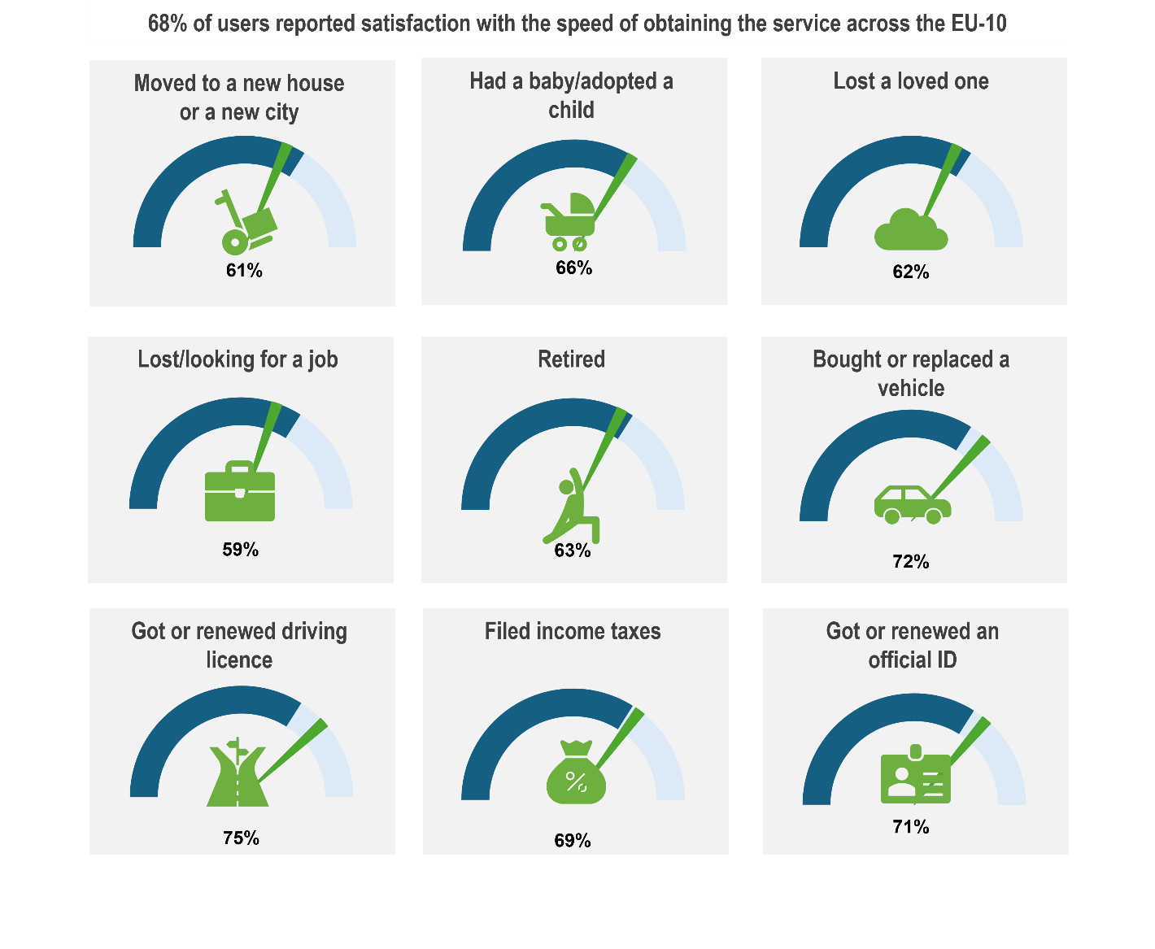

Note: The dark blue arch represents the average satisfaction level with this driver for users of all Life Events across the EU-10. The green pointer represents the satisfaction level of the user for this driver when experiencing the specific Life Event. The pointer position shows whether satisfaction for the specific Life Event is higher or lower than the overall average.
- Similar satisfaction levels remained across education levels, genders and living areas. Respondents over 50 years old are, on average, 12 percentage points more satisfied with the speed of getting the service, compared to their younger counterparts aged 18-29. This difference in satisfaction between age groups is present in 7 out of 10 surveyed countries, with the exception being Austria, Estonia and Finland.

Country practices and lessons learned
The speed of obtaining the service is intrinsically linked to some of the other drivers of satisfaction analysed by the TSI Satisfaction Survey. The figure below presents how addressing some of the other nine drivers of satisfaction can contribute to the overall speed of public services.
Figure 4.1. Contribution of other drivers of satisfaction to the speed of obtaining the service
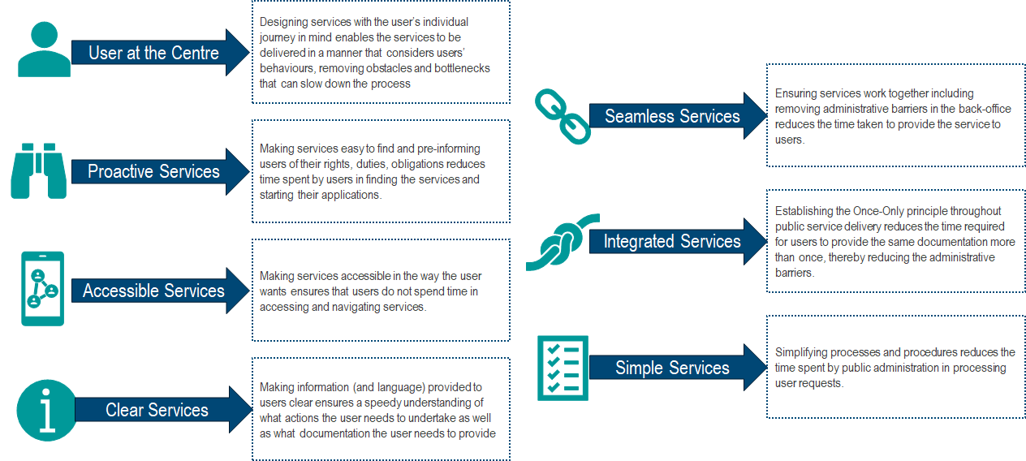
Source: Authors’ own visualisation.
Speed is not only a matter of perception but also of commitments made by the administration, that then shapes the expectations of citizens. For instance, if countries have set a timeline to provide a specific service to users, for instance the obtention of an ID document, and displayed it as a commitment on digital platforms or physical offices. This encourages the administration to respect the timing communicated and deliver in a fast manner. This is the case, for example, in Croatia (Box 4.7) where three different procedures are applied for requesting an ID document.
Box 4.7. Croatia - Clear definition of processing times for ID cards
Clear processing times have been communicated to citizens requesting an identity card in Croatia. To adapt to different user needs, particularly in relation to time constraints, Croatia has developed three procedures for the issuance of ID cards.
- An ordinary procedure of 30 days
- An accelerated procedure of 10 days
- A fast procedure of 3 days
By developing different procedures with different delays for receiving the identify card, the public administration commits to a maximum delay for issuing the ID card to the user. It is important to note that different fees are charged for each of the three procedures, ranging from 13.27 EUR for the ordinary procedure to 66.36 EUR for the fast procedure. The user’s reason for requesting a fast procedure is not required by the public administration at the time of the request. This differs from other countries where a fast procedure can only be applied in exceptional circumstances.
Source: Data collected through TSI Country Mission to Croatia, May 2025.

Achieving results that are fair and treat everyone equally
Users expect that services treat them fairly and in the same manner as everyone else. This means everyone can receive the same quality and extent of services regardless of their individual characteristics. This requires fair service design and delivery at all government levels with the service providers upholding the principles of good governance (OECD, 2024_{[9]}).


Spotlight on results from the TSI Satisfaction Survey
Fair Services
- 69% of users are satisfied with service fairness across the EU-10.
- A slight variation in satisfaction level for the fairness of services exists in relation to the Life Event experienced by users. 60% of users who lost/were looking for a job were satisfied with the degree to which the services treat everyone equally. While most Life Events are close to the average, users who got or renewed an ID were nine percentage points more satisfied than the average. This higher level of satisfaction can be attached to the delivery of an ID to users regardless of their background as long as they are a citizen in the country.

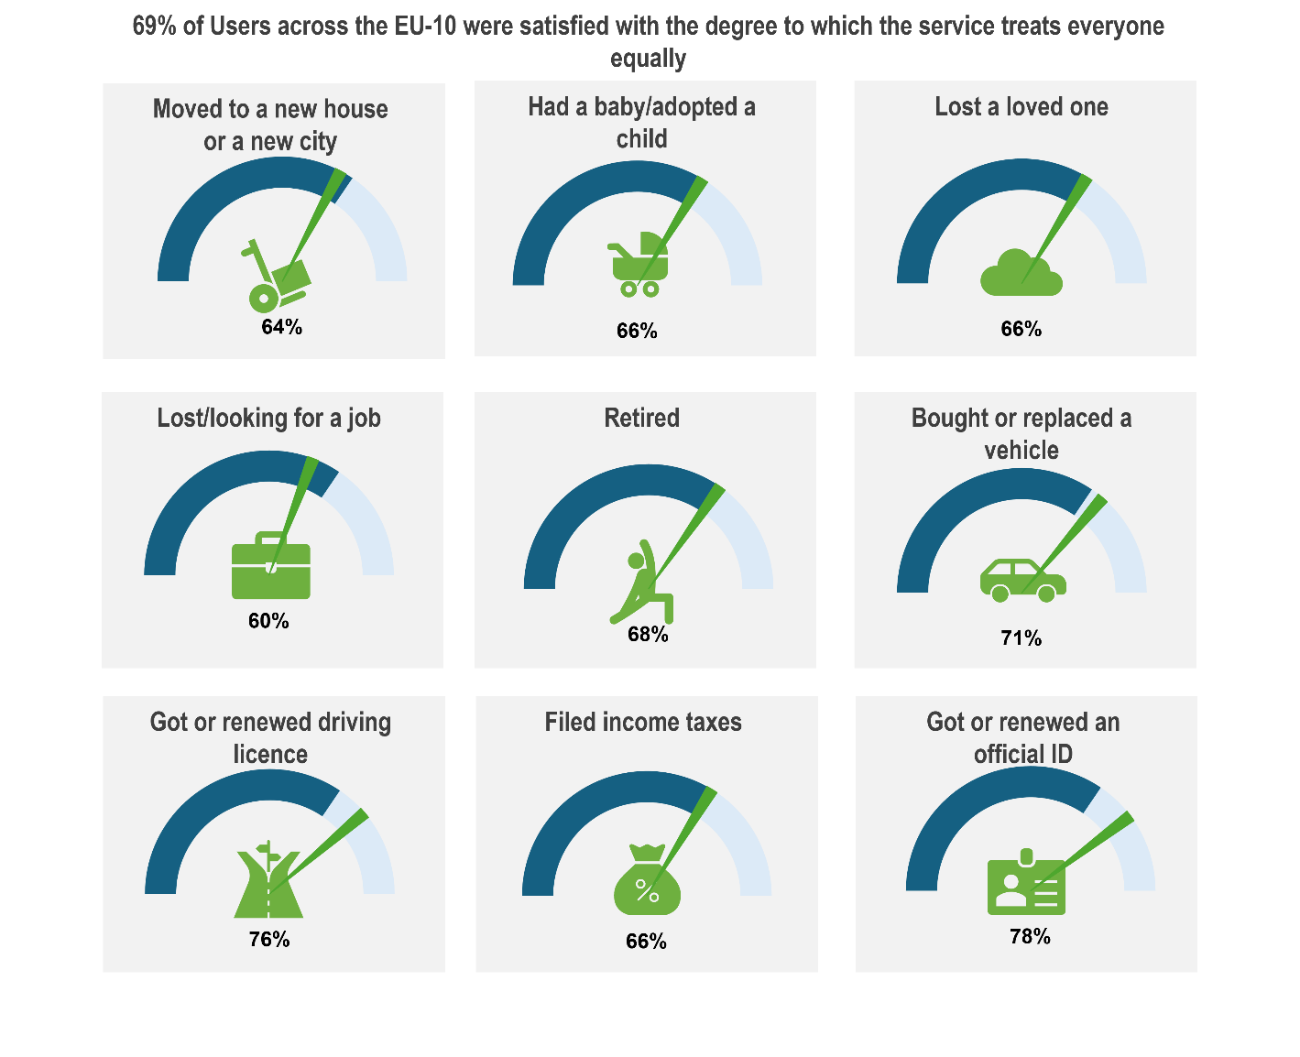
Note: The dark blue arch represents the average satisfaction level with this driver for users of all Life Events across the EU-10. The green pointer represents the satisfaction level of the user for this driver when experiencing the specific Life Event. The pointer position shows whether satisfaction for the specific Life Event is higher or lower than the overall average.
- Older users on average across the EU-10 tend to report higher satisfaction with the degree to which the service treats everyone equally. As such, 71% of those aged 50 and above are satisfied, compared to 64% for the 18-29 age group and 68% for the 30-49 age group.

Country practices and lessons learned
EU-10 countries are working to improve their strategies to foster equitable service outcomes across the entire territory of the country, and for society’s most vulnerable groups. The Serving Citizens Survey has shown that only 4 out of 10 EU countries include consultation with vulnerable groups in their public service strategy (Figure 4.2). Equitable service design and delivery require certain adjustments to remove barriers that exist for vulnerable groups but not others, reinforcing equal treatment and service outcomes.
Figure 4.2. Aspects included in service strategy, Serving Citizens 2024
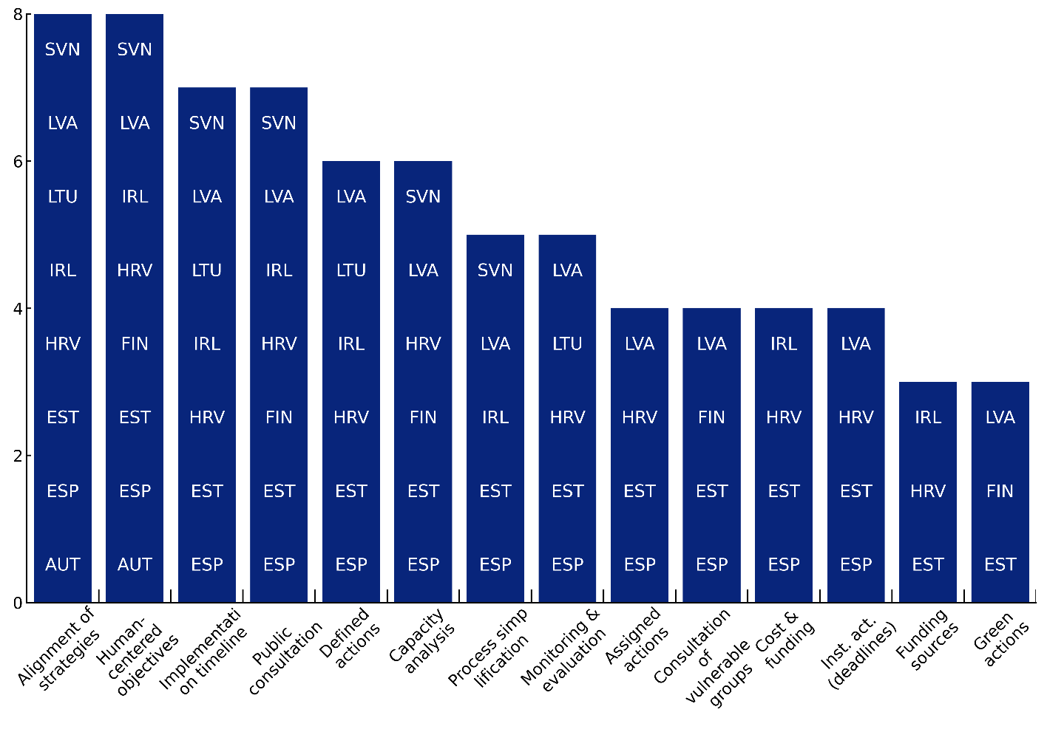
Source: OECD Serving Citizens (Forthcoming).
The provision of fair services also requires users to be informed of the decision taken. When users request public services through Life Events, for example child benefits, unemployment benefits, it might not always be the case that they receive what they requested due to eligibility requirements. On average, 69% of all users across the EU-10 agreed that they received clear information about why the decision was made (Figure 4.3).
A variation exists with regard to the level of satisfaction depending on the Life Event. A lower percentage of users agreed that they received clear information as to why the decision was made when they experienced the Life Event (i) Moved to a new house or to a new city (61%), (ii) lost a loved one (63%) and lost/looking for a job (64%). A higher number of users agreed with this statement when they experienced the Life Event (i) Got or renewed an official ID document (75%), (ii) retired (75%) and (ii) got or renewed a driving license (76%).
Ensuring the access of services to vulnerable population groups is a cornerstone of the fairness of services. Finland has for instance created a specific service design and delivery approach for young citizens (Box 4.8). This can also include the need to develop platforms and procedures in specific languages depending on the audience. For instance for the Life Event ‘I became a student’, Slovenia has included different languages, in addition to Slovenian and English, in its online enrolment procedure for higher education (eVŠ web portal) as many students from neighbouring, non-EU Member States also apply and pursue their studies in Slovenia’s higher education system (Slovenia's Ministry of Higher Education, Science and Innovation, 2025_{[25]}).

Figure 4.3. 69% of users across EU10 agree that they received clear information about why decision was made
Share of users who agree or disagree that information on why decision was taken was clear, on a scale 1-5.
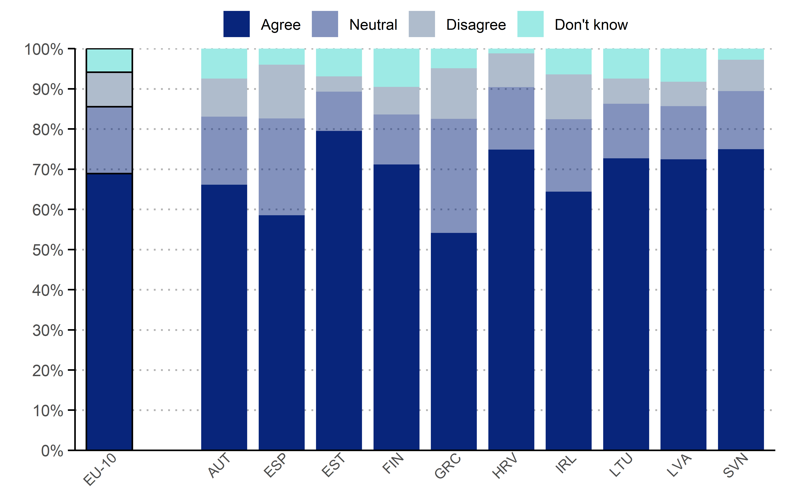
Note: The question asked was “Thinking about your experience with [Life Event], to what extent do you agree with the following statement: I received clear information as to why the decision were made”
Source: (OECD, 2024_{[15]}).
Box 4.8. Finland - Service design and delivery for vulnerable groups
Finland’s Social Insurance Institution (Kela) has developed a tailored service model for young people with persistent income-support needs. Although this group represents only about 1% of all Kela customers (around 67,000 individuals), it accounts for almost a quarter of total costs and uses over a quarter of Kela’s services. Roughly one-third of this group—about 21,000 people—are young adults, forming the focus of the pilot.
The model offers a single-entry point for 18–29-year-olds who have received basic social assistance for at least six months. It begins with an assessment of the young person’s overall situation, followed by a structured evaluation of functional capacity, life circumstances and motivation, carried out in collaboration with partner services. Based on this, Kela provides personalised guidance, ensuring access to appropriate benefits and coordinated referrals.
The customer journey includes clear checkpoints and continuous follow-up, ending when the individual’s circumstances improve, and they no longer meet eligibility criteria. The model relies on shared data, coordinated processes and agreed principles of customer interaction to deliver consistent, targeted support.
Source: Data collected through TSI Country Mission to Finland, 2025.

In relation to the Life Event ‘I became a student’ in Ireland, different personas were developed for students in order to consider the vulnerable situations they may find themselves in (Box 4.9).

Box 4.9. Ireland - Adapting personas to the Life Event ‘I became a student’ to factor in students in vulnerable situations
Becoming a student is a significantly complex Life Event. Many processes are involved: being accepted to a third level institute is only the beginning. New students will also have to complete government processes for the first time, such as moving home and registering for local taxes, applying for benefits or loans from the government, and registering for healthcare services. This can be especially difficult when young people are using administrative services for the first time, without prior experience of how they operate, while also moving away from home and losing the benefits of support from parents, family and friends. Those who have difficulty using administrative services while becoming a student may have knock on effects on their education.
As such, Ireland has focused extensively on ‘becoming a student’ as a critical Life Event affecting both long term life outcomes and having a significant impact on how many people form their views of public institutions. Ireland undertook an extensive journey mapping of this life event, using different “personas” to understand the steps and difficulties different students may face those moving away from home, those arriving from overseas to study in Ireland, those applying for government benefits or support to help pay for their education. This has allowed a more fine-grained mapping of individual “pain points” to be addressed by different government agencies, such as making benefit applications less complex.
Source: Data collected during TSI country mission to Ireland, March 2025.
Fair services also imply the delivery of services with the same level of quality across the territory. Slovenia has for instance established local administrative units in each district, that deliver deconcentrated services closer to citizens while respecting national standards and procedures on service delivery (Box 4.10). The renewal of the central government’s service and premises network in Finland also aims to deliver fair services regardless of the location of the user through the access to physical centres within one hour of the user’s home.
Box 4.10. Slovenia - Local administrative units, closer to user needs
Slovenia has established 58 local administrative units in each district of the country, that constitute deconcentrated services of the Ministry of Public Administration. They perform administrative tasks and services that need to be organised and delivered at the territorial level, including ID documents, residence registration, or driving licenses.
These administrative local units have increasingly modernised their operations through digitalisation, which has helped them enhance their efficiency, share information and data, and track progress on applications and on their processing and duration (through the SKRINJA unified digital platforms). These digital tools have also supported the measures of citizen satisfaction and the collection of feedback and enhanced transparency through the publication of selected statistics.
Slovenia records higher use of in-person channels, compared to other EU member States, with high satisfaction rates, and the use of local administrative units by citizens has contributed to these positive results. Local administrative units have ensured that citizens can reach services close to their residence, that their situation and requests are well understood by the administration, and that they are delivered in a fair and transparent manner that is consistent across the country.
While the competencies and courtesy of employees is also highly rated in Slovenia, further efforts on the working conditions and training of employees in local administrative units, in addition to further deployment of digital solutions, remain priorities for the Ministry of Public administration.
Sources: Ministry of Public administration of Slovenia (presentation during the TSI workshop in June 2025; OECD-EU TSI survey results.
The fairness in the treatment of users is also measured by the perceived courtesy of civil servants to all citizens that are asking for a service. 65% of users on average across the EU-10 are satisfied with the courtesy of the employees they interacted with. Slovenia has the highest level of satisfaction, with 75% of users satisfied with the courtesy of employees they interacted with. This high level of satisfaction may be associated with the large proportion of users who access services through face-to-face contact. Users expect to be treated with respect by civil servants, which requires paying attention to the behaviours and competencies of citizens that are interacting with the general public. This can be promoted through training and educating civil servants. In turn, users also need to treat with respect civil servants, including in situations of tensions and complexities. Reciprocal obligations and expected behaviours can be displayed and reminded to employees and users in public places where services are delivered.

Tools for achieving results from simple, fast and fair public services
Several tools have been identified that can support countries in achieving results for (i) simple (ii) fast and (iii) fair public services. Some tools can be grouped and address a number of different drivers. The definition of performance targets for public service delivery and the subsequent monitoring of these targets can support countries in delivering simple, fast and fair services. The user of user surveys and feedback loops can contribute to the collection of data to feed into these performance targets. It is also important to note that standards and principles for the design and delivery of public services, a tool outlined under tools supporting Access (Section 2.4) can support the definition of common targets across different services.
The tools presented in Section 2.4 and 0 supporting drivers falling under Access and Navigation can also support the delivery of fast services. Moreover, the automation of internal processes and communication with users can contribute to ensuring that users obtain what they need in a timely manner and reduce the administrative burden on both users and government sides.
Several tools can contribute to the development of fair services. Ensuring physical and digital platforms are inclusive from their design supports the equal treatment of users. The development of standards and principles, outlined in Section 2.4 can contribute to ensuring the streamlined approach for the development of inclusive services. The inclusion of the ombudsman in public service design can also support the development of fair services, by receiving feedback on the overall level of inclusion of users through the service delivery. Moreover, including language variation in public services as well as raising awareness among staff of the importance of inclusive services contributes to an overall level of fairness.
Figure 4.4. Grouping of tools to support achieving results
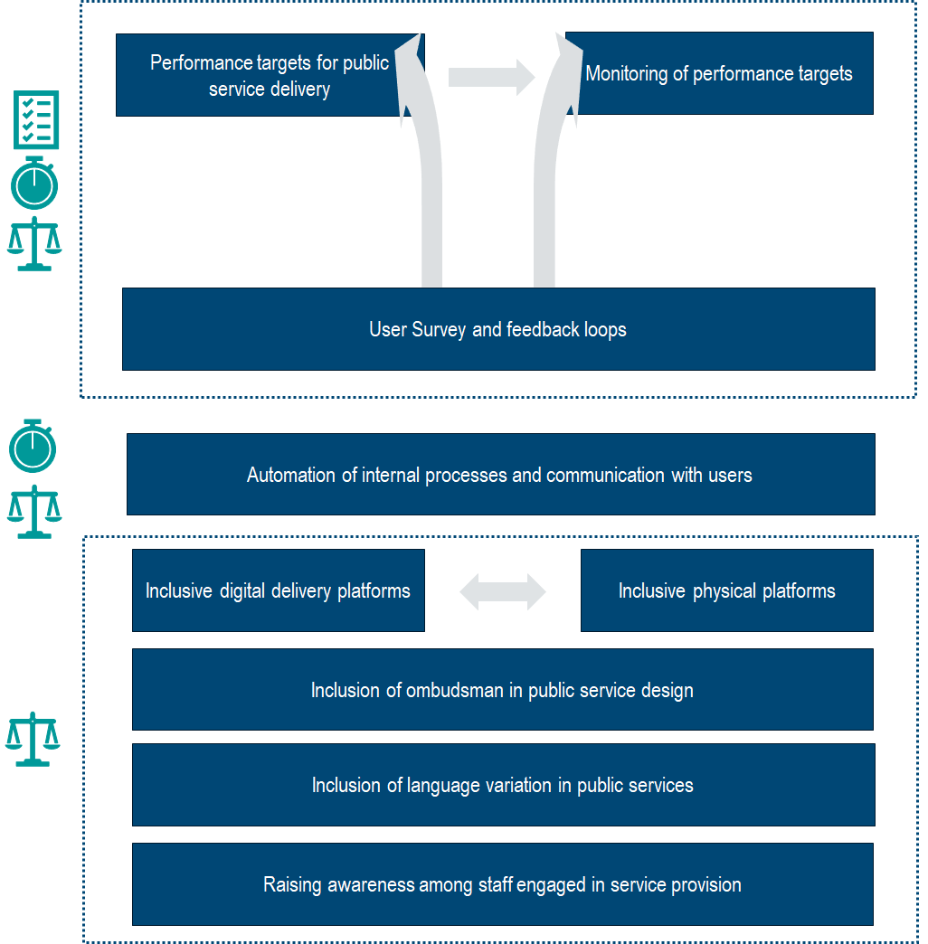
Source: Author illustration.

Table 4.1. Tools for Achieving results from Public Services
Tool | Description | Types of Actions
Performance targets for public service delivery | Performance targets for service delivery are essential tools for measuring service quality and tracking improvements over time. These targets can include metrics related to the speed and efficiency with which users navigate services and achieve their desired outcomes. They can also include specific targets for sub-groups (regional, vulnerable) | - Integration of performance targets into a public service strategy  - Define sub-targets and cascade down indicators (by region, sub-group)
Monitoring of performance metrics | Monitoring performance of different services and analysis of the obtained information can provide insights on how fast users proceed with different services and obtain the result. This can in turn feed into and support policy decisions for service improvements. | - Embedding mechanisms that monitor user overall time spent on service obtainment  - Monitor metrics at national, regional and sub-regional levels  - Create performance dialogue and reporting mechanisms at regional level and sub-regional levels  - Identify and address bottlenecks and issues through actions at the regional / sub-group level
User Survey and Feedback Loops | User Surveys and feedback loops can support in collecting data for the definition of performance targets, by identifying what in relation to simplicity, speed and fairness are of priority for users. Moreover, the collection of data from users can support in monitoring the performance targets set | - Embedding user surveys in performance monitoring  - Integration of user panels and feedback loops in the monitoring of performance.
Automation of internal processes and communication with users | Automation of certain public service elements can ensure that users obtain what they need in a timely manner and reduce the administrative burden on both users and government sides. Using unified digital platform for centralised and concentrated services is essential to ensure data sharing, consistency of procedures and to track and compare processing times and performance. | - Usage of templates and user data for automatic generation of documents  - Development of automated and/or AI chat boxes for simple inquiries and service requests from users  - Ensure the development and use of unified platforms
Inclusive digital delivery platforms | Inclusivity in digital platforms ensures equitable access and use of services online for all users to take into account their individual characteristics and needs. | - Embedding features (e.g., brightness, colour modes, text size etc.) for users with diverse needs  - Also take into account different languages when needed
Inclusive physical platforms | Physical service access points must be designed and operated with diverse needs in mind to ensure all users, regardless of their individual characteristics, can easily access, navigate and successfully achieve their desired service outcome. | - Identify the targets and different sub-groups that require specific developments  - Development of inclusive, safe and available infrastructure  - Testing of infrastructure (e.g., together with targeted communities through representative entities, such as NGOs)
Inclusion of Ombudsman in public service design | Building on its practical experience in defending human rights and interests, the Ombudsman can introduce new insights for service design. This entails capturing real life user experiences and addressing the gaps and challenges in equitable service provision. | - Consultation (through, e.g., regular meetings) with the Ombudsman  - Establishment of a direct communication line between an entity supervising public service delivery and the Ombudsman office
Integration of language variation in public services | Offering services with language options allows users to achieve their needs using the language they find most convenient and effective. | - Development of service websites in different languages  - Language course provision for staff in service delivery
Raising awareness among staff engaged in service provision | Staff that understands diverse user characteristics is key to delivering personalised support that meets the distinct needs of every service user. | - Training provision on different needs of users and ways to adjust service delivery  - Simulation exercises
Source: Author illustration.

Country approaches to measuring, engaging and improving public services
The OECD recommends that governments undertake regular surveys and consultations of public administrative service users to understand needs and to examine the aspects of user experience which influence satisfaction (OECD, 2024_{[1]}). User feedback mechanisms, such as user panels and feedback loops embedded in digital platforms, are also useful sources of information on the experiences of users and can help reshape services to make them more human-centered.

User experience surveys
User experience surveys collect direct feedback from users who have recently interacted with a public administrative service, offering valuable insights into how people perceive the quality, accessibility and responsiveness of the services they rely on. Respondents are typically invited to reflect on specific elements of their experience as well as their overall satisfaction, allowing governments to identify what works well and what may require improvement.
Across the EU10, these surveys are carried out through both national-level and agency-level initiatives (Figure 5.1). Spain, Greece, Croatia, Ireland and Lithuania implement national surveys that collect information from users across a broad range of public services. These efforts offer a comprehensive view of service delivery within each country, making it possible to compare experiences across different administrative domains and highlight areas where targeted action could strengthen service quality.
Figure 5.1. Existence of user satisfaction survey, Serving Citizens 2024
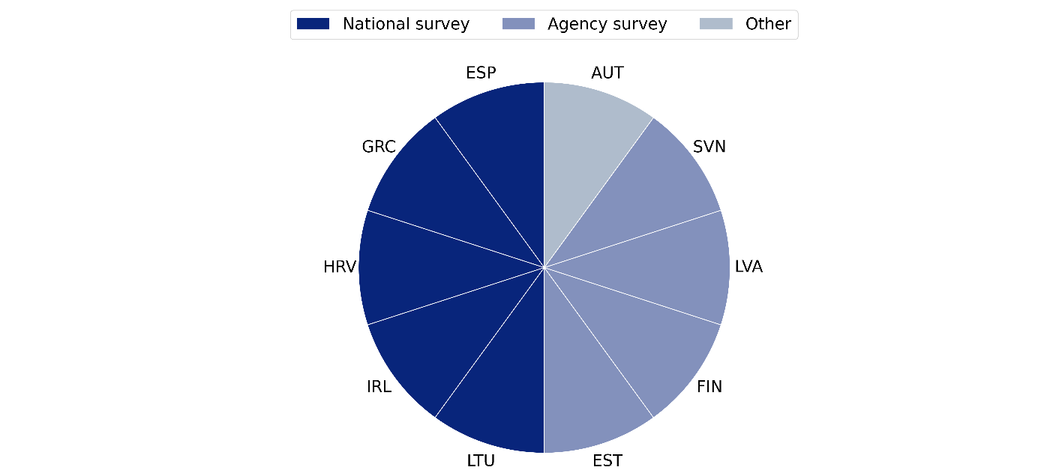
Source: (OECD, Forthcoming_{[17]}).
In Estonia, Finland, Latvia and Slovenia, user experience data is gathered predominantly through agency-level surveys. These are led by individual ministries or agencies and often focus on specific services or administrative processes. While narrower in scope, agency-led surveys provide detailed and operationally relevant insights that can be quickly translated into service improvements. As such, these different forms of evidence can be strong complements to each other.
The Serving Citizens survey has surveyed 12 public administrative services that are commonly covered through user experience surveys (Figure 5.2). Among the EU-10 countries, nine out of ten countries conduct surveys on filing income taxes, and on birth, marriage, and death certificates. Similarly, 8 out of 10 countries conduct user satisfaction surveys on the issuance of national ID cards and drivers’ licences. Old age pensions and unemployment benefits (both covered in 7 out of 10 countries) are also common.
Figure 5.2. Existence of user satisfaction surveys by service, Serving Citizens 2025
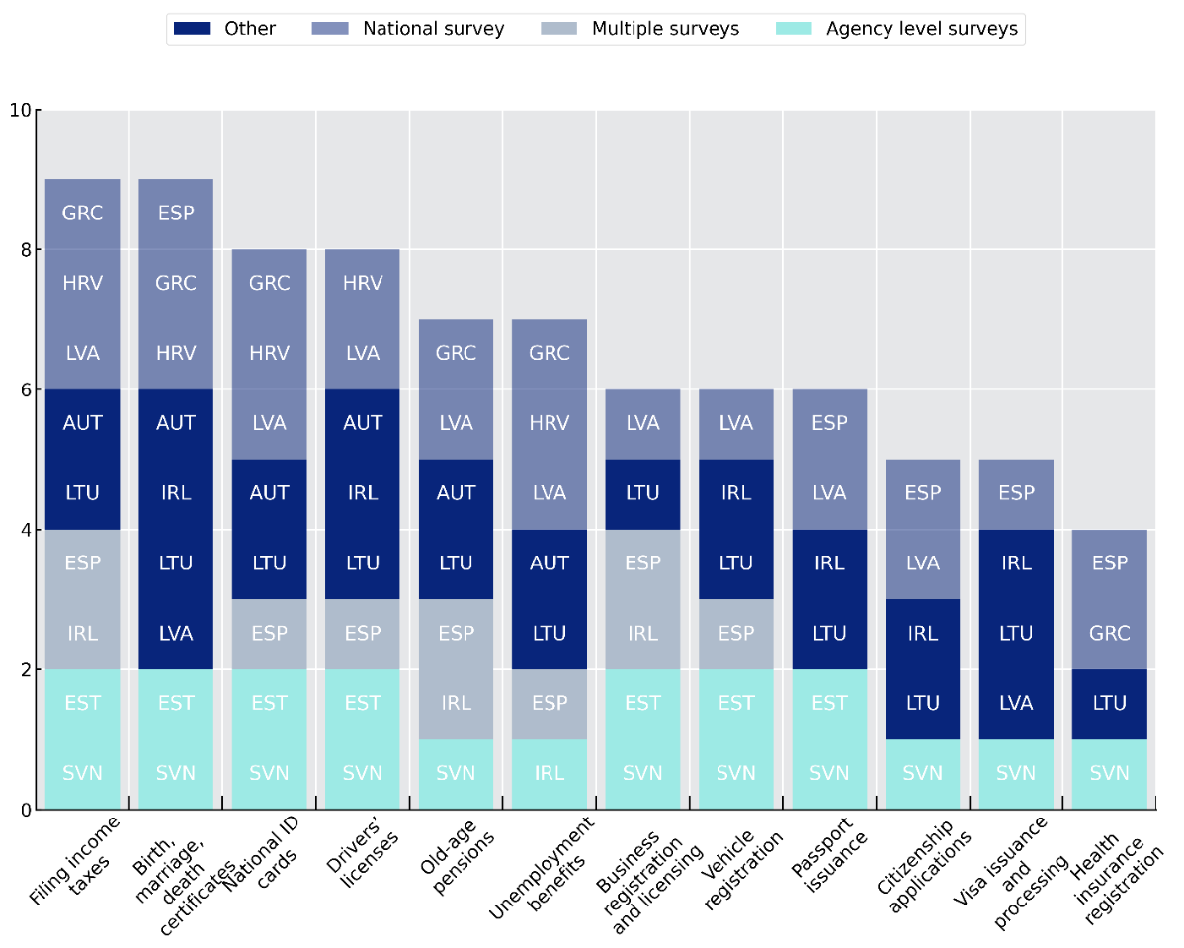
Source: (OECD, Forthcoming_{[17]}).
The usefulness of user satisfaction surveys is often limited by not collecting detailed demographic data about service users. As a best practice, user satisfaction surveys should be designed to allow for comparisons between subpopulations. That is, the surveys should collect data that can be disaggregated by basic characteristics among survey respondents, such as age, gender, level of education and income. In addition, respondents’ geographical position, or channel used to access services can provide important insights and deeper understanding about differentiated service experience among vulnerable user groups. All 5 countries that conduct national surveys – Spain, Greece, Ireland, Lithuania, and Croatia – collect information that can be disaggregated by age and gender. Four out of 5 countries also collect data on level of education, 3 on geographical location, and 3 on channels used. Less frequently, only Greece and Lithuania collected data on disability, and only Lithuania collected data on income (Figure 5.3).
Figure 5.3. Demographics collected in national user experience survey, Serving Citizens 2024
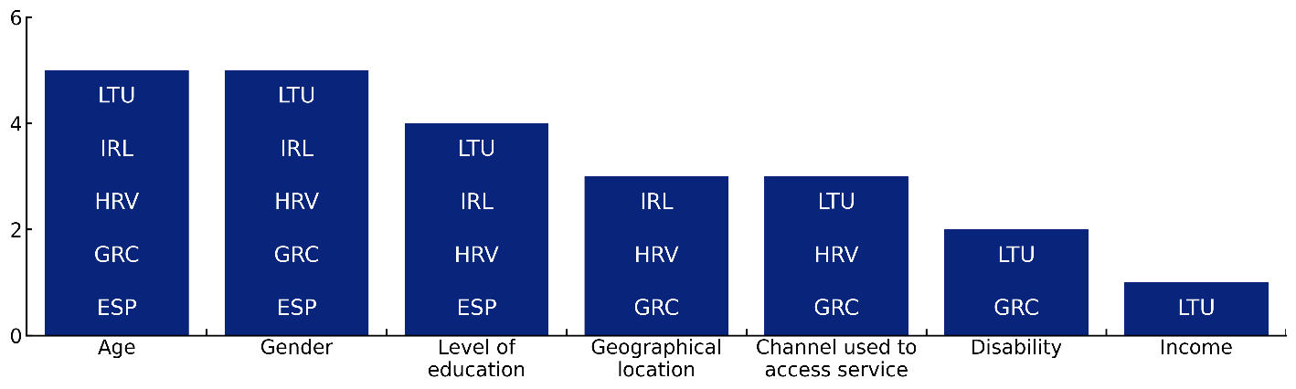
Source: (OECD, Forthcoming_{[17]}).
Stakeholder engagement is a significant factor in enhancing service performance, and the publication of data from user experience survey and on public services performance is essential in ensuring transparency, accountability, and the continual improvement of services. All five countries that conduct national satisfaction survey publish the results. Lithuania, Ireland, Croatia, and Spain publish their survey results in reports. On the other hand, Greece publishes its data on a public dashboard (Figure 5.4). This format can be effective in enabling feedback, as it allows for interactive exploration of findings and information.
Figure 5.4. User satisfaction data publication, Serving Citizens 2024
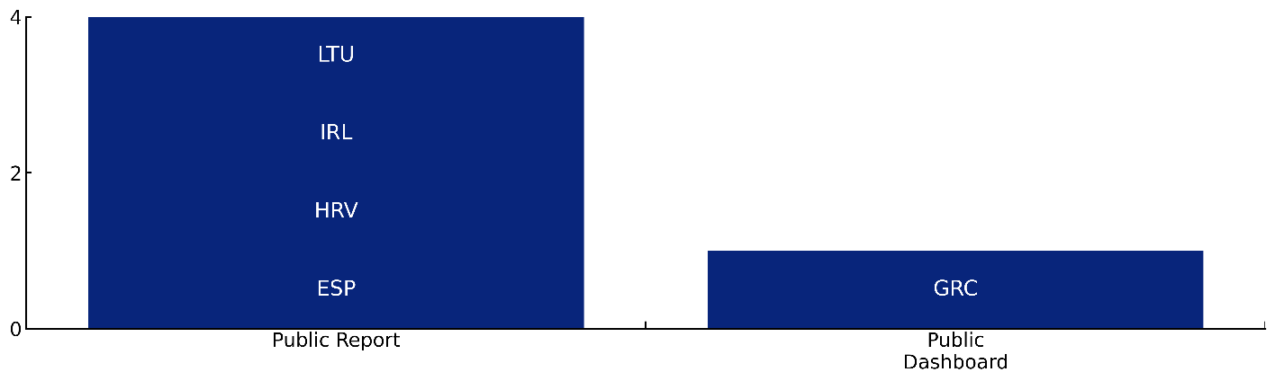
Source: (OECD, Forthcoming_{[17]}).

Specific country practices
Box 5.1. Estonia – Comprehensive approach to user satisfaction measurement
User satisfaction in Estonia is measured through short post-interaction surveys, with the Net Promoter Score adapted for public services as the preferred methodology. Surveys must include at least one open question, enabling institutions to capture the “why” behind ratings. Results are reported as a numeric score, while the central co-ordinator later converts all methodologies into a percentage scale to track progress toward the Digital Society Development Plan 2030. The Guidelines for the calculation and central listing of quality indicators for direct public services also account for edge cases: if fewer than 100 users access a service in a given year, a qualitative study supplemented by a numeric rating is recommended; where surveys are run biennially, institutions report results only in the measured year, with explanatory notes. This flexibility ensures methodological rigour without overburdening small-scale services or users.
The integration of direct feedback loops for users is observed through the eest.ee website. Each webpage presenting public services associated with a Life Event includes a direct feedback loop for users where they are requested to rate their satisfaction with the service on a scale of 1 – 5. Based on their rating, the user is requested to provide open text clarification to indicated what affected their rating. The use of direct feedback loops enables the public services owners in Estonia to monitor the user satisfaction with these services.
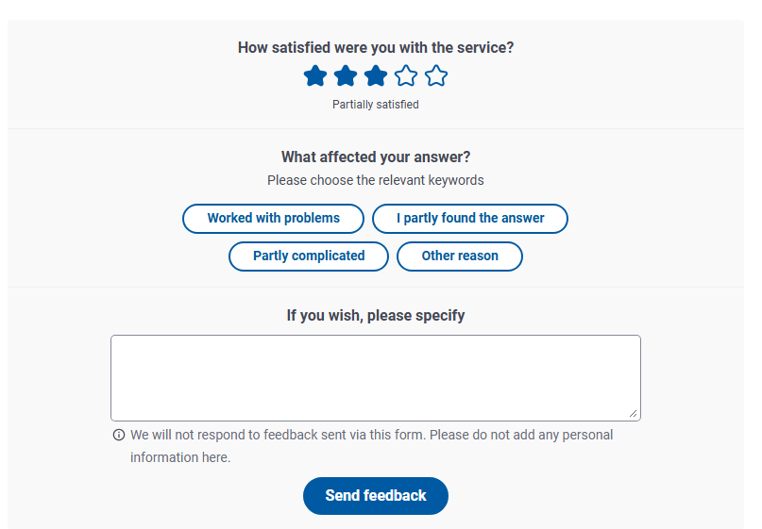
Source: Data gathered through TSI Country Mission to Estonia, October 2025.

Box 5.2. Latvia - Embedding citizen satisfaction with services indicators into a high-level national plan
In its highest medium-term plan – the National Development Plan 2021-2027 – (NDP), Latvia has established indicators and targets for citizen satisfaction with public services. These include general metrics, such as “awareness, experience and satisfaction with received public services”, and more specific ones pertaining to key sectors like healthcare.
The selection of satisfaction indicators is monitored on a general basis, with an interim report presenting the progress made. The State Chancellery, Latvia’s centre of government, is responsible for summarising service performance data and citizen satisfaction with them from different government entities. For example, the most recent progress report of the NDP, published in 2024, presented survey results of citizen satisfaction with 10 public services.
Source: (Cabinet of Ministers, 2024_{[26]}).

Other user consultation and feedback mechanisms
While user experience surveys offer helpful evidence, they only allow the small group of citizens who are contacted to complete them the opportunity to provide feedback on public administrative services. To complement them, governments can use other sources of feedback, such as complaints and user interviews. Countries can also set up user panels that will provide their experiences and feedback on specific life events along the cycle. These sources of information can assist governments in identifying priority areas for improvement and help explore possible solutions. Nine out of 10 countries have set up agency portals to collect complaints or feedback (Figure 5.5). These portals can provide valuable insights for policymakers. However, relying primarily on agency-level portals is likely to leave gaps in coverage, with no feedback channel available for some public administrative services. Lithuania, Estonia, and Spain also have national portals in place, which are less prone to leave these gaps. However, once feedback portals are in place, it is important to also actively promote their availability to ensure that users are aware of these channels and understand how to access them.
Figure 5.5. Availability of complaints/feedback mechanism, Serving Citizens 2024
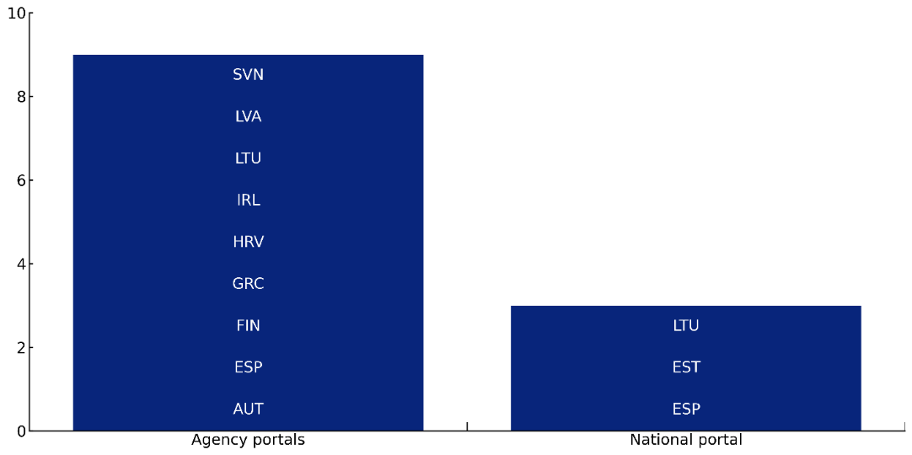
Source: (OECD, Forthcoming_{[17]}).

Definition of performance targets and key data to measure inputs, outputs and outcomes
To complement user experience information, the OECD also recommends that governments set service delivery standards. Performance targets are measurable, observable goals for service delivery, such as targets for waiting times. Targets can help public administrations to gauge whether improvements are taking place and to examine the efficiency and responsiveness of service delivery. Information on performance against targets is commonly collected by using administrative data from public sector agencies. In addition, delivery targets are a mechanism for evaluating the efficiency and effectiveness of public services and promote the country’s transparency. Among the EU10 countries, eight out of ten countries have service delivery targets (Error! Reference source not found.).
Figure 5.6. Existence of Service Delivery Targets, Serving Citizens 2024
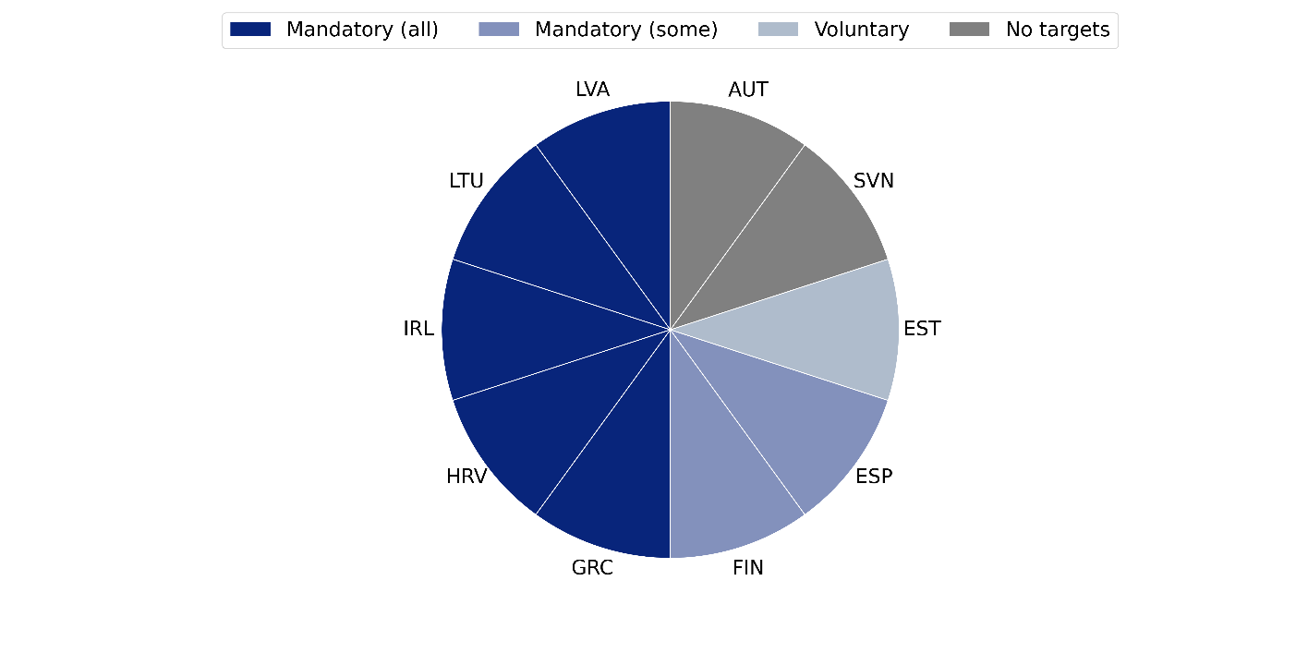
Source: (OECD, Forthcoming_{[17]}).
The departments that deliver administrative services are commonly also in charge of setting their targets. This is the case in five of the EU10 countries: Lithuania, Ireland, Greece, Finland, and Spain. In Ireland, the Ministry of Finance and Ministry of Public Administration jointly set the targets. In Estonia, the Digital Government Ministry is in charge of setting targets (Figure 5.7).
Figure 5.7. Agency in charge of setting targets, Serving Citizens 2024
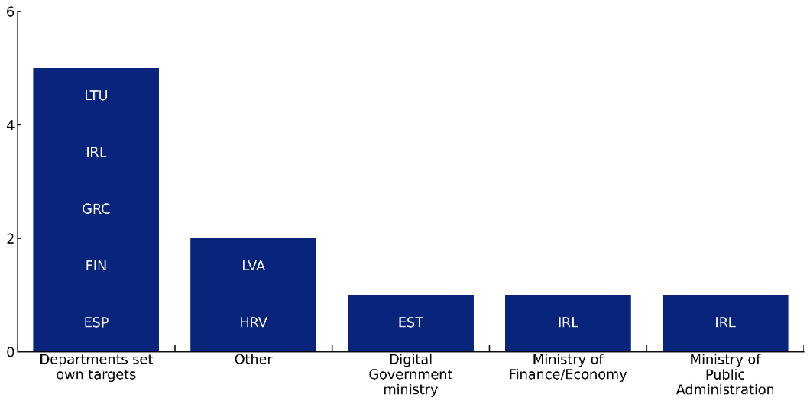
Source: (OECD, Forthcoming_{[17]}).
Performance targets are commonly linked to incentives for public officials to meet these targets. Among these, recognition or awards programmes for high-performing staff or teams is employed in Croatia, Greece, and Spain. Other approaches include promotions or career advancement (practiced in Croatia and Finland) and recognition awards (Spain and Greece). Countries can also adopt negative incentives in the form of penalties and sanctions. This is employed in Croatia, alongside the positive incentives also in place in the country (Error! Reference source not found.).
Figure 5.8. Incentives for meeting targets, Serving Citizens 2024
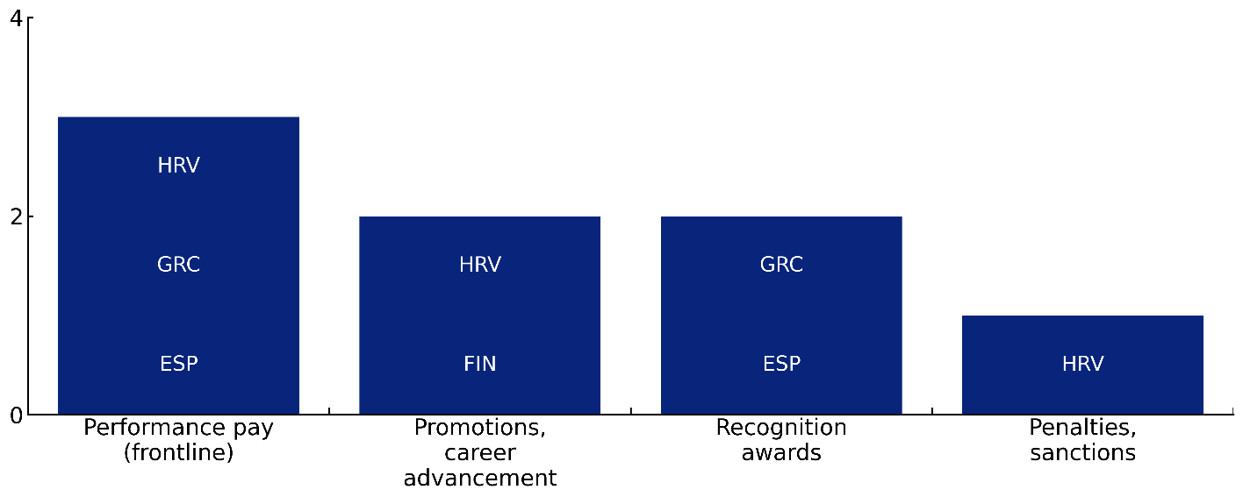
Source: (OECD, Forthcoming_{[17]}).
Responsibility for consolidating performance information varies across countries, with no single institutional model predominating. In several cases, digital government authorities or public administration ministries play a leading role, as seen in Lithuania, Estonia and Spain for the former, and Slovenia, Ireland and Spain for the latter. Other governments centralise this function within the centre of government, such as Latvia and Finland. Fewer countries rely on sectoral Ministries: Ireland channels this work through its finance ministry, while Lithuania assigns it to the ministry of interior (Error! Reference source not found.).
Figure 5.9. Agency in charge of centralising performance data, Serving Citizens 2024
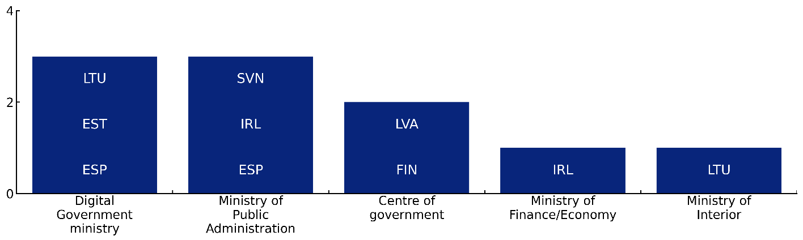
Source: (OECD, Forthcoming_{[17]}).
Like OECD countries, the EU10 countries can also improve in making service performance data available to the public, with only half making information on public services performance available in some form of published report so far. Greece is the only EU10 country that publishes its performance information in open data format (Error! Reference source not found.). More comprehensive and accessible publication of performance data would provide more transparency and accountability for government agencies delivering administrative services and would better enable the public and civil society to benchmark the performance of government agencies with others and identify areas to improve public service delivery.
Figure 5.10. Publication of performance data, Serving Citizens 2024
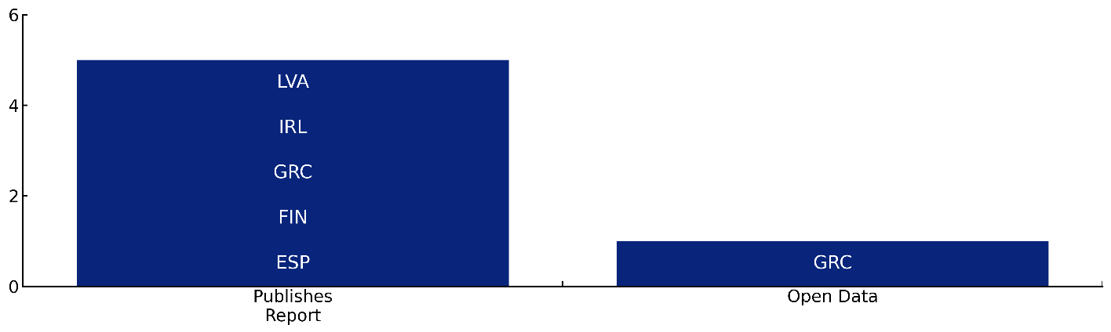
Source: (OECD, Forthcoming_{[17]}).
OECD countries may not fully exploit the potential of user experience and service performance data in processes to improve public services. Only Estonia and Lithuania report using the performance data to improve services and Finland is the only country that uses the data to measure impact of reforms. The most common usage of the data is to communicate the results. Although OECD countries have made progress to use user experience and performance data in various purposes, they should continue use such data to identify areas for improvement in public service delivery to enhance public sector efficiency and effectiveness.
Figure 5.11. Use of experience and performance data, Serving Citizens 2024
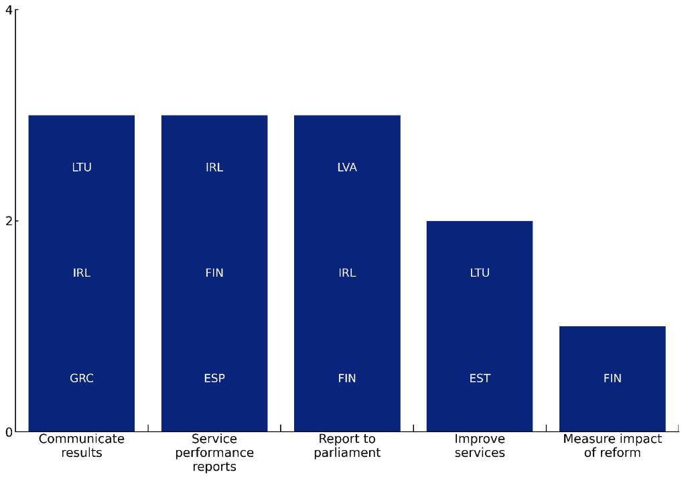
Source: (OECD, Forthcoming_{[17]}).
In addition to the definition of performance targets, measurement data can be defined to support simplification. By developing impact frameworks, countries can distinguish between inputs, processes, outputs and intermediate and final (or high-level) outcomes expected from public service delivery. Whilst impact frameworks can be specified to evaluate the delivery of individual services, it is also possible to integrate (or overlay) a perspective on burden measurement and simplification. The rationale for doing so is to enable service designers and administrators to clearly identify the overheads and cost drivers, to identify opportunities for simplifying the user experience or gaining efficiencies, and to measure and link simplification efforts to long-term value. Table 5.1 outlines how burden measurement and simplification can be integrated into existing impact frameworks and the rationale for its consideration.
Table 5.1. Measuring the burden stemming from complexity and the impact of simplification
Framework stage | Focus for burden measurement and simplification | Rationale
Inputs | Staff time, regulatory costs, financial resources associated with data handling, form processing, verification, documentation, etc. | Quantifies administrative overheads and cost drivers. Provides baseline and
Processes | Workflow efficiency, digital integration and interoperability, duplication of steps | Simplification has the strongest leverage here – it shapes user experience and internal efficiency. Assessment can lead to opportunity identification.
Outputs | Service completion times, number of procedures, accessibility of information, clarity of information | Measures tangible service improvements
Outcomes | User satisfaction, trust, compliance, social inclusion | Links simplification to long-term value and legitimacy
Source: OECD.
Measurement is most critical at the process and output stages, where design choices directly affect user and administrative effort. However, investigating process metrics (perhaps via comparative studies) is essential to identify opportunities to innovate and apply simplification tools, whilst measurement of key outcomes will show not only if the service is delivering its intended outcomes, but also ensure simplification and burden reduction does not result in unintended consequences (e.g., eroding fairness or accountability) (OECD, 2025_{[27]}).
A Standard Cost Model can be used to measure the cost of complexity. The International Standard Cost Model (SCM), originally developed to measure administrative burdens on businesses, can be adapted to quantify the burden stemming from complexity for both service users and administrators in public service design and delivery. In its traditional form, the SCM measures the time and resources required to meet information obligations arising from regulation. When adapted for public services, the same principle can be applied to citizen–state interactions, viewing each administrative step as an information obligation or procedural requirement that consumes time, effort, and money. Box 5.3 describes the core principles of the SCM, whilst Error! Reference source not found. illustrates how SCM categories can be linked to inputs in the service delivery chain, enabling the model to quantify not just burden but also design inefficiencies.
By adapting the SCM to include citizen and administrative effort, governments can measure the hidden costs of bureaucracy that influence both the efficiency and experience of public service delivery. Quantifying these costs gives an evidence base for simplification, clarifies design trade-offs, and anchors service reform in measurable improvements in time, effort, and trust. However, it is important not to rely entirely on the SCM, or quantitative metrics alone, in evaluating the effectiveness of simplification initiatives and the impact of service design and delivery choices. Qualitative sources of data are also essential for measuring impact at each phase of design and delivery, for example surveys, interviews, comparative studies. By blending quantitative measurement with qualitative insight governments can better cater to the diverse needs of citizens and businesses and the complexity of administrative processes.

Box 5.3. The Standard Cost Model
How is the SCM defined?
At its core, the SCM expresses administrative burden as: Administrative Cost (AC) = Price × Quantity
Where:
- Price (P) = unit cost of performing an administrative activity (usually the time × hourly cost of the person doing it).
- Quantity (Q) = number of times the activity occurs annually, multiplied by the number of people or organisations affected.
In the public service context, this can be applied to both sides of the service interaction:
- Users (citizens/businesses): time spent understanding, preparing, submitting, and following up on administrative requirements.
- Administrators (civil servants): time and resources required to process, validate, and manage information obligations.
Appling the model
Generally, there are 5 steps involved in applying the SCM:
- Mapping the process – Identify each administrative step from both the user’s and administrator’s perspective (e.g. applying for a birth certificate, student grant, or death registration).
- Identifying the activities and information obligations – e.g. reading instructions, providing ID, entering data, verifying eligibility, processing payment.
- Estimating time and frequency – through observation, user journey analysis, and staff logs.
- Assign unit costs – using average wage rates for citizens’ opportunity cost of time and administrative staff costs.
Table 5.2. Relevant SCM categories in the service design context
Cost category | Users (citizens/businesses) | Administrators (public bodies) | Measurement indicators
Time costs | Time spent understanding rules, completing forms, waiting for decisions | Staff hours to process applications, check data, respond to queries | Average minutes × hourly wage
Financial costs | Fees, postage, travel | IT infrastructure, training, maintenance | Direct expenditure data
Data handling/documentation | Gathering supporting evidence, uploading or mailing documents | Verification, cross-checking, re-entry, archiving | No. of records, systems, or rekeying steps
Learning and adaptation costs | Understanding eligibility, rules, system interfaces | Staff familiarisation with new tools/processes | Survey or observation
Error and rework costs | Resubmission or correction | Duplicate work, complaint handling | % of cases requiring rework

References

(n.a.) (n.d.), OECD Legal Instruments, https://legalinstruments.oecd.org/en/instruments/OECD-LEGAL-0503 (accessed on 23 October 2025). | [28]
(n.a.) (n.d.), OECD Legal Instruments, https://legalinstruments.oecd.org/en/instruments/OECD-LEGAL-0503 (accessed on 18 November 2025). | [29]
(n.a.) (n.d.), Staff working document on the policy programme: a path to the digital decade | Shaping Europe’s digital future, https://digital-strategy.ec.europa.eu/en/library/staff-working-document-policy-programme-path-digital-decade (accessed on 28 November 2025). | [30]
Cabinet of Ministers (2024), National Development Plan of Latvia for 2021-2027, https://www.mk.gov.lv/lv/latvijas-nacionalais-attistibas-plans#:~:text=Nacion%C4%81lais%20att%C4%ABst%C4%ABbas%20pl%C4%81ns%20nosaka%20liel%C4%81kos%20valsts%20bud%C5%BEeta%20ieguld%C4%ABjumus,virzienus%2C%20k%C4%81%20ar%C4%AB%20pl%C4%81not%C4%81s%20reformas%20un%20politikas%20izmai%C5%86as. | [26]
Department of Public Expenditure, I. (2025), Better Public Services: Service Design Resources, https://www.gov.ie/en/department-of-public-expenditure-infrastructure-public-service-reform-and-digitalisation/publications/better-public-services-service-design-resources/. | [8]
Digital Austria (2025), Committee of the Federal Government, the Länder, Cities and Municipalities (BLSG) and the ICT Federation, https://www.digitalaustria.gv.at/verwaltung/gremien/gremium-bund-laender-staedte-und-gemeinden.html. | [18]
European Commission (2022), “DECISION (EU) 2022/2481 OF THE EUROPEAN PARLIAMENT AND OF THE COUNCIL of 14 December 2022 establishing the Digital Decade Policy Programme 2030”. | [31]
European Commission (2021), “Staff working document on the policy programme: a path to the digital decade”. | [14]
Government of Ireland (2025), Digital Public Services Plan 2030, https://www.gov.ie/en/department-of-public-expenditure-infrastructure-public-service-reform-and-digitalisation/publications/digital-public-services-plan-2030/. | [24]
Government of Ireland (2023), Action Plan for Designing Better Public Services: A Roadmap for Embedding Design in the Public Service, https://assets.gov.ie/static/documents/action-plan-for-designing-better-public-services.pdf. | [7]
Government of Ireland (2023), Minister Donohoe launches Public Service Innovation Fund, https://www.gov.ie/en/department-of-public-expenditure-infrastructure-public-service-reform-and-digitalisation/press-releases/minister-donohoe-launches-public-service-innovation-fund/. | [20]
Government of Ireland (2022), Designing our Public Services: Design principles for Government in Ireland, https://assets.gov.ie/static/documents/designing-our-public-services.pdf. | [6]
Government of Slovenia (2024), Digitalizirana registracija rojstev v Sloveniji, https://www.gov.si/novice/2024-04-02-digitalizirana-registracija-rojstev-v-sloveniji/. | [13]
Ministry of Economic Affairs and Communications (n.d.), Toolbox for designing digital public services, https://digiriik.eesti.ee/. | [5]
Ministry of Finance (n.d.), Programme to promote life-event-based digitalisation, https://vm.fi/en/programme-to-promote-life-event-based-digitalisation. | [16]
Ministry of Smart Administration and Regional Development (2025), State and local government unified customer service center network, https://www.varam.gov.lv/lv/vpvkac. | [19]
OECD (2025), Best practice principles for licensing and permitting: How to manage risks while supporting growth, OECD Publishing, Paris, https://doi.org/10.1787/5f63586d-en. | [23]
OECD (2025), Better Regulation Practices across the European Union 2025, OECD Publishing, Paris, https://doi.org/10.1787/6f007516-en. | [27]
OECD (2025), Governing with Artificial Intelligence: The State of Play and Way Forward in Core Government Functions, OECD Publishing, Paris, https://doi.org/10.1787/795de142-en. | [11]
OECD (2025), Government at a Glance 2025, OECD Publishing, Paris, https://doi.org/10.1787/0efd0bcd-en. | [3]
OECD (2025), Simplifying for Success, Insights from OECD Surveys, Background paper prepared for the OECD High-level Symposium, 17-18 November 2025, Paris. | [21]
OECD (2024), “2023 OECD Digital Government Index: Results and key findings”, OECD Public Governance Policy Papers, No. 44, OECD Publishing, Paris, https://doi.org/10.1787/1a89ed5e-en. | [4]
OECD (2024), OECD Survey on Drivers of Trust in Public Institutions – 2024 Results: Building Trust in a Complex Policy Environment, OECD Publishing, Paris, https://doi.org/10.1787/9a20554b-en. | [2]
OECD (2024), Recommendation of the Council on Human-Centred Public Administrative Services, https://legalinstruments.oecd.org/en/instruments/OECD-LEGAL-0503. | [9]
OECD (2024), Recommendation of the Council on Human-Centred Public Administrative Services. | [1]
OECD (2024), Survey on Measuring Citizen Satisfaction with key Government Services. | [15]
OECD (2020), The OECD Digital Government Policy Framework: Six dimensions of a digital government, OECD Publishing, Paris, https://www.oecd.org/en/publications/the-oecd-digital-government-policy-framework_f64fed2a-en.html. | [10]
OECD (2018), OECD Regulatory Enforcement and Inspections Toolkit, OECD Publishing, Paris, https://doi.org/10.1787/9789264303959-en. | [22]
OECD (Forthcoming), Serving Citizens Survey. | [17]
Slovenia’s Ministry of Higher Education, Science and Innovation (2025), eVŠ web portal, http://portal.evs.gov.si/prijava/?locale=en. | [25]
State Revenue Service (2025), Personal Income Tax, https://www.vid.gov.lv/en/personal-income-tax. | [12]

For the purposes of the TSI Satisfaction Survey, a ‘user’ refers to an individual who experienced one or more of the 15 Life Events over the preceding 12-month period and who undertook concrete actions to access and receive services. A ‘non-user’ refers to an individual who experienced one or more of the 15 Life Events over the preceding 12-month period but who did not undertake any concrete actions to access and receive services.
Questioning citizens on whether they are satisfied with how services work together may lead to differences in interpretation. Citizens may not have the same understanding of how services work together, depending on how they access services and how much interaction they had with different public service actors.
Available at: https://en.mitos.gov.gr/index.php/Main_Page.
Available at: https://www.gov.pt//
OECD (forthcoming, 2026) “Experimenting with digital tools to enhance regulatory delivery: case studies from Italian regions”, OECD Working Paper.

